Mt. Hamilton Optics Cleaning Trip
David Hilyard and Brian DuPraw
4/18/2012

Coating Samples
The protected silver coating samples we had made in Santa Cruz and mounted in the dome showed an overall layer of dust, as might be expected. They are mounted in a rack above the elevator, secured to a guardrail of the mezzanine. The disks on the upper half of the rack were the only ones easily inspected.
A few of them showed sparse nuclei of contamination around which deterioration appeared to have begun. A couple of the nuclei had a brownish color to them.

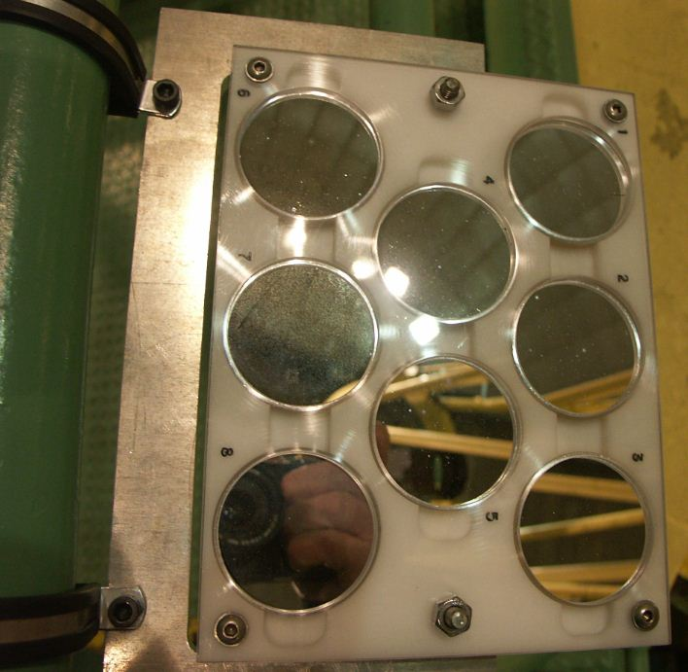
Possible nucleus of deterioration
Possible nucleus of deterioration

The disks on the lower half of the rack were not so easy to view unless we were to loosen the mounts securing the rack. We didn’t do that on this trip.
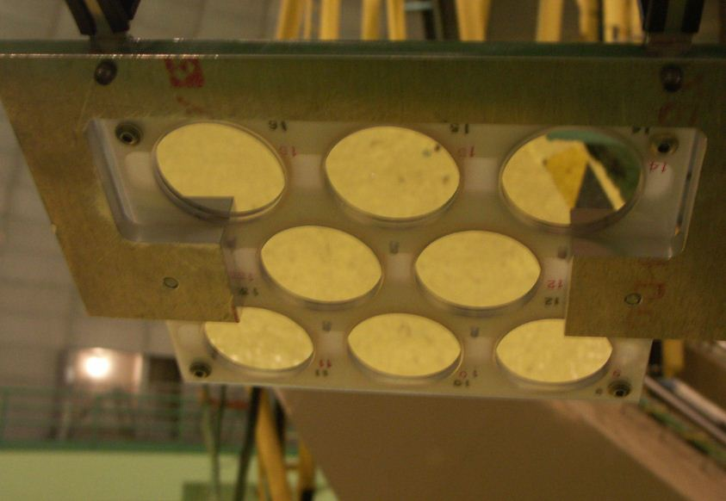
Contaminant
120” Shane Reflector Coude #4
The 4th mirror in the Coude chain was spotty. Donnie already had it lowered to where it could be reached by standing on a stepladder, and Dave cleaned it, although the cleaning had little effect. We measured the reflectivity to be 92% with the blue filter and 90% with the red.

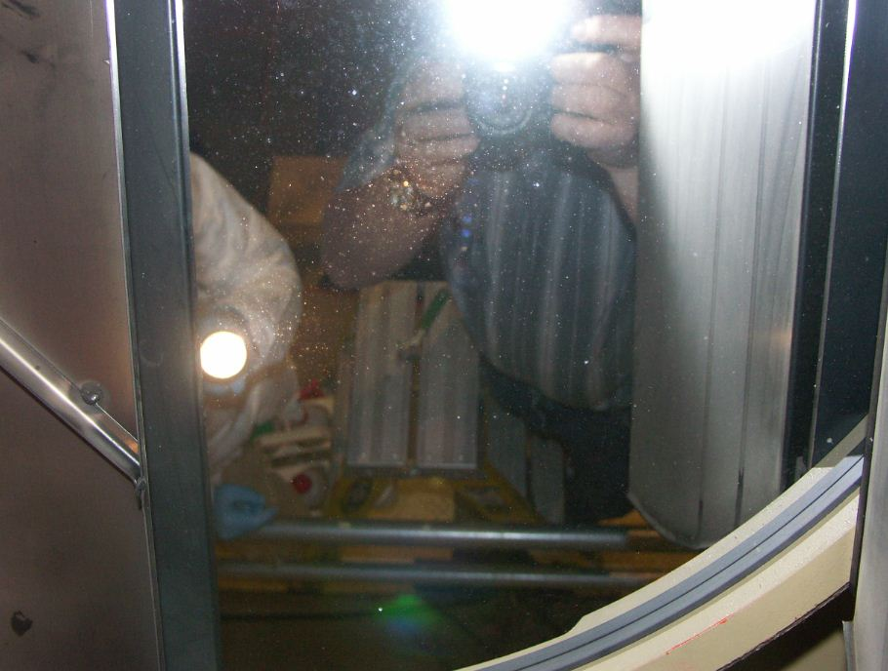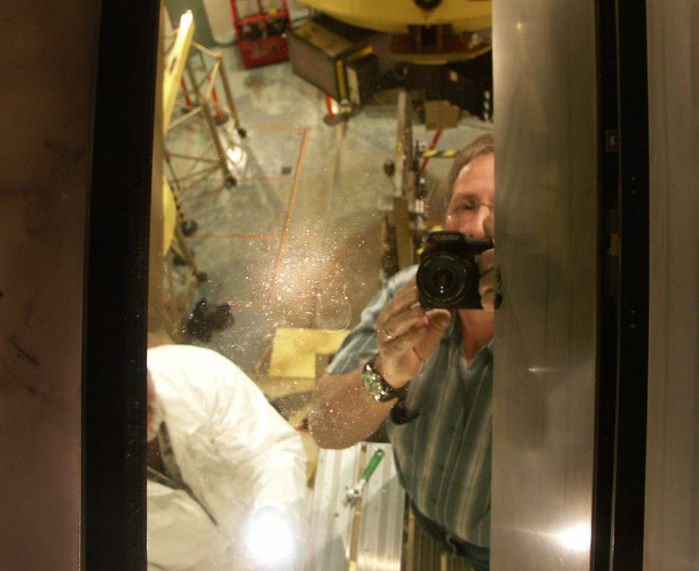

120” Shane Reflector Coude #5
The 5th mirror in the Coude chain is the one in between the forks of the 120” telescope’s mount. Dave cleaned a small area on the most accessible edge but found that it sleeked easily and since it wasn’t excessively dirty, it didn’t get cleaned (except for blowing it off with air). We measured 78% reflectivity with the blue filter and 84% with the red.

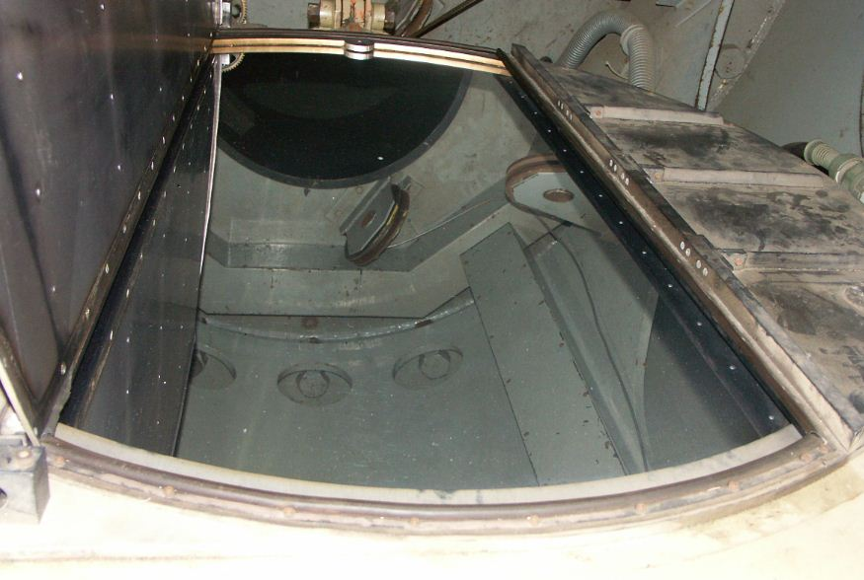

120” Shane Reflector Coude #3
The Coude’ Mirror #3 was on the dome floor. It didn’t appear that dirty, but Dave cleaned it to be sure. He blew it off with canned air and then sprayed distilled water. He next flooded it with ethanol then wiped it dry, also using ethanol. We measured 90% reflectivity with both the red and the blue filters before cleaning. Afterward the red increased to 92%.
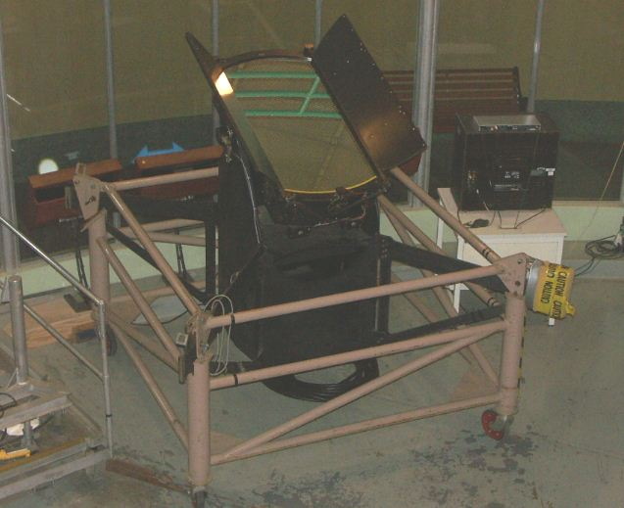

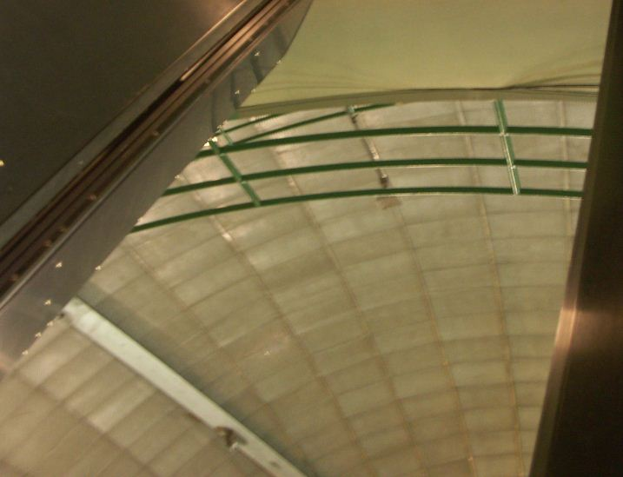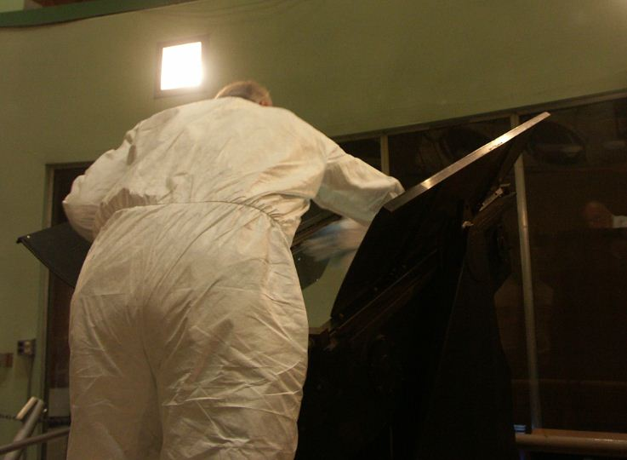

120” Telescope Primary
We inspected the 120” primary and measured its reflectivity (89% red, 86% blue). There were some spots that appeared to be water-based, rather than oil-based, but they could not be reached with the pie-shaped wedges of the cover forming a fence around the mirror. They were not very numerous or extensive in size. Overall, the primary looked pretty good since our last full cleaning a few months ago.

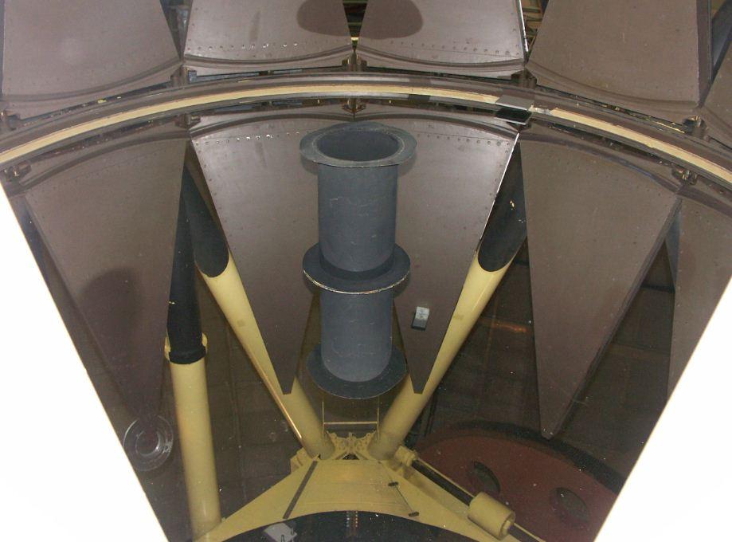

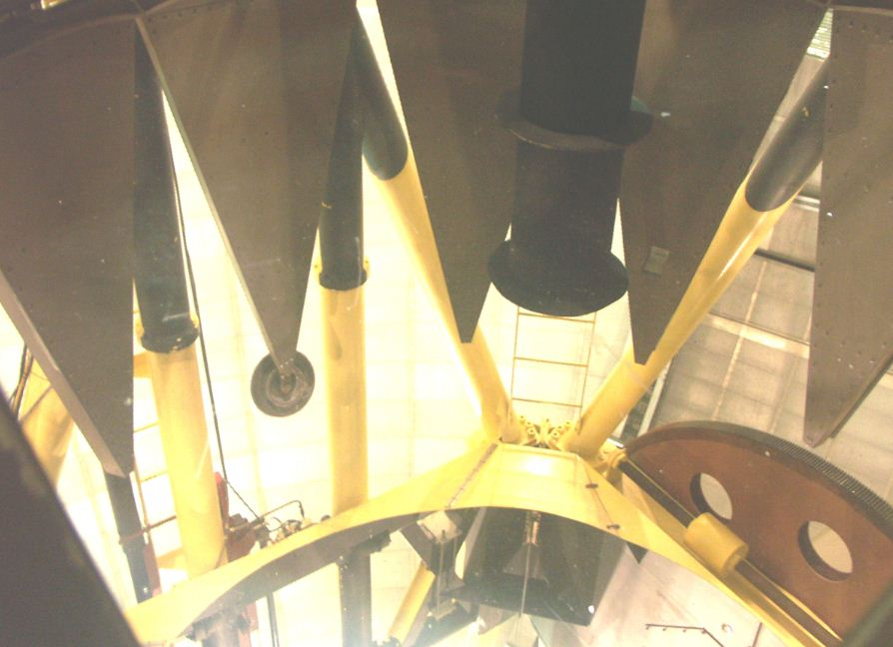

120” Shane Reflector Coude #2
The Coude secondary was not very dirty, although its surface was poor. This was already known not to be cleanable, so it didn’t get cleaned on this trip.

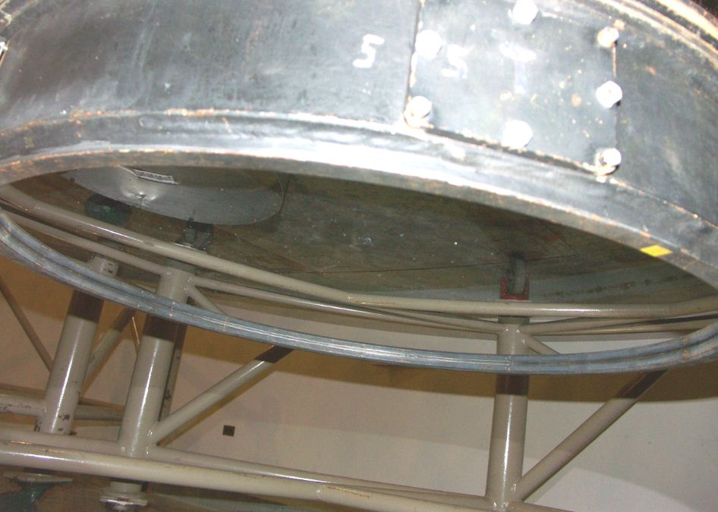

CAT Primary
Dave cleaned the upward-facing CAT primary by reaching through a hole in the metal shield. It’s robust enough to clean blindly, which is good since the shield prevents you from getting your arm in there and simultaneously seeing what you’re cleaning. He blew it off with air and followed that with a spray of distilled de-ionized water plus ethanol.

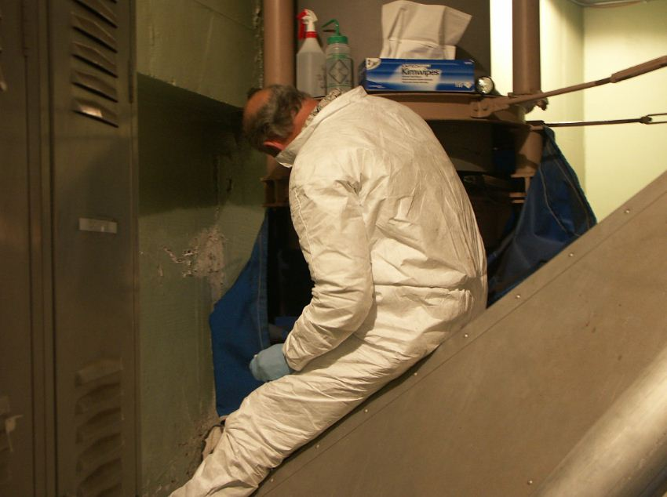

Slit Room Optics
We cleaned several of the optics in the slit room, including the filter wheel, image rotator, pick-off mirror, periscope mirror and aperture plate.

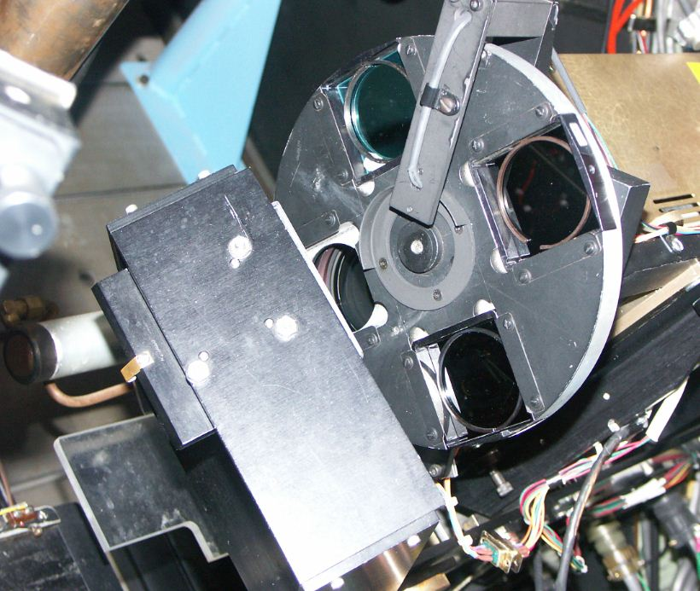
Flat Mirror behind this mount
Filter Wheel

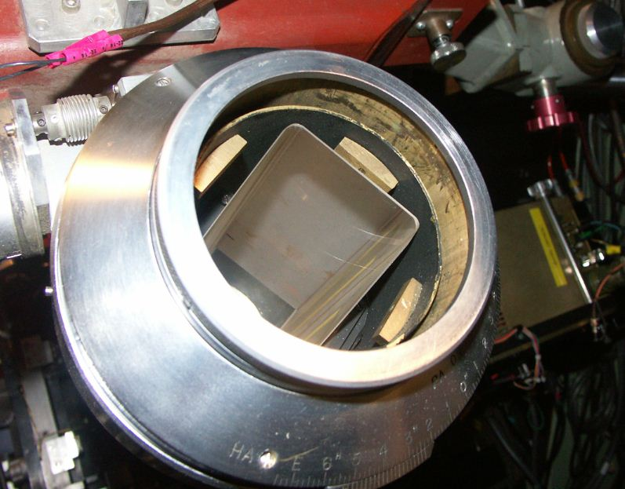
Image Rotator Prism

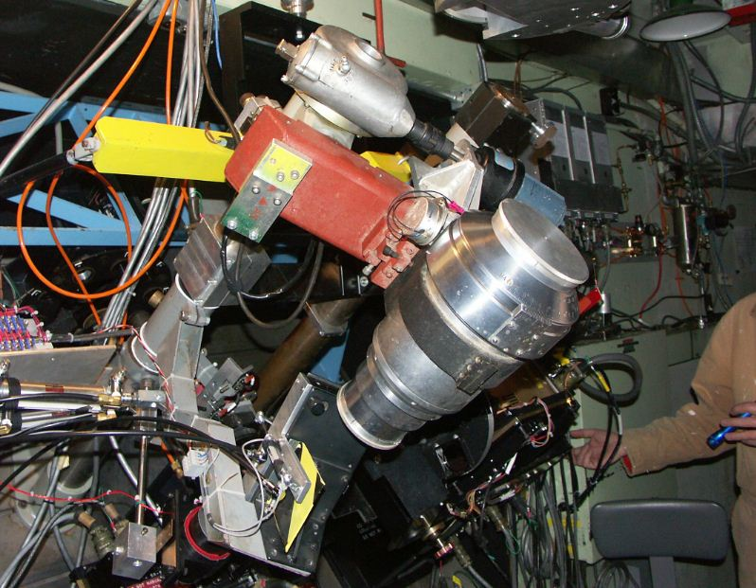
Image rotator mid-travel
Image rotator motion switch

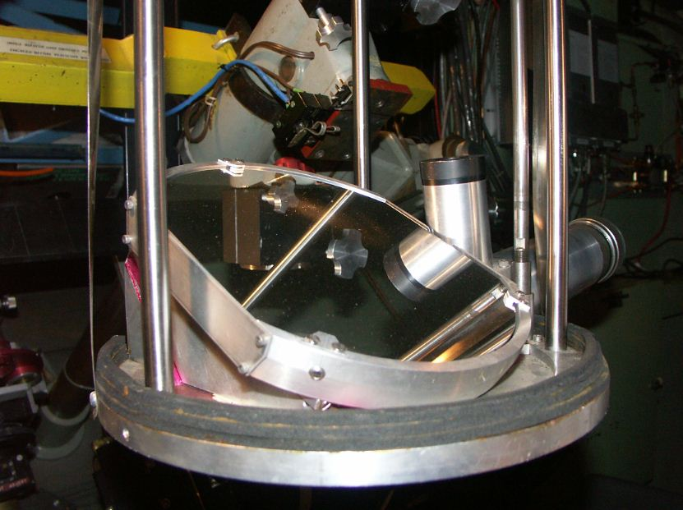
Periscope mirror

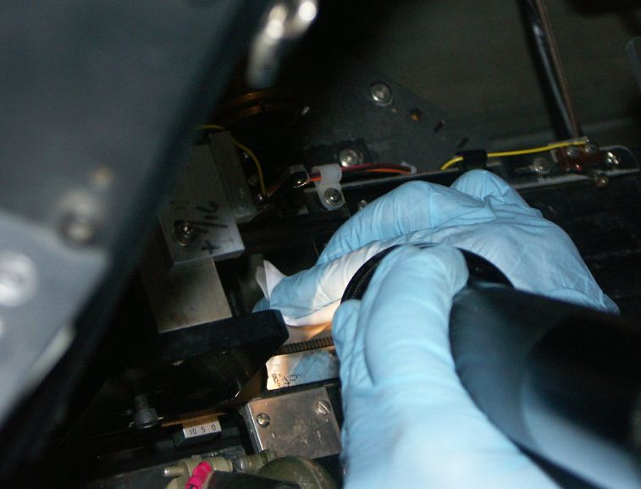
Cleaning aperture plate

Hamilton Collimator
We opened the magnetic cover on the Hamilton Collimator mirror but didn’t clean it, except for blowing it off with air. We had previously brought it down to Santa Cruz for cleaning, but once it was there it was determined not to be so bad after all, at least in terms of reflectivity.
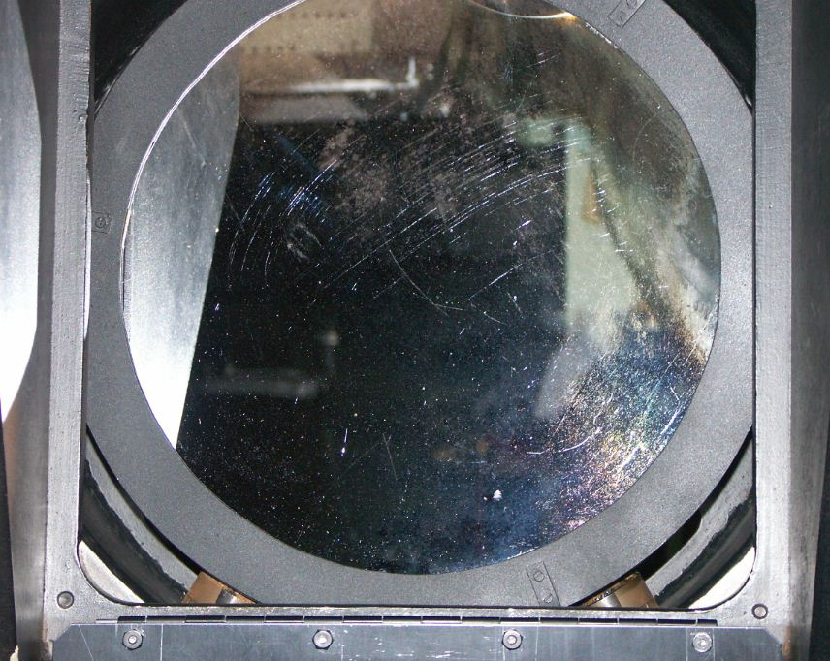

Dave also blew off the prisms and some other optics mounted near the prisms, including the easily-sleeked lens:

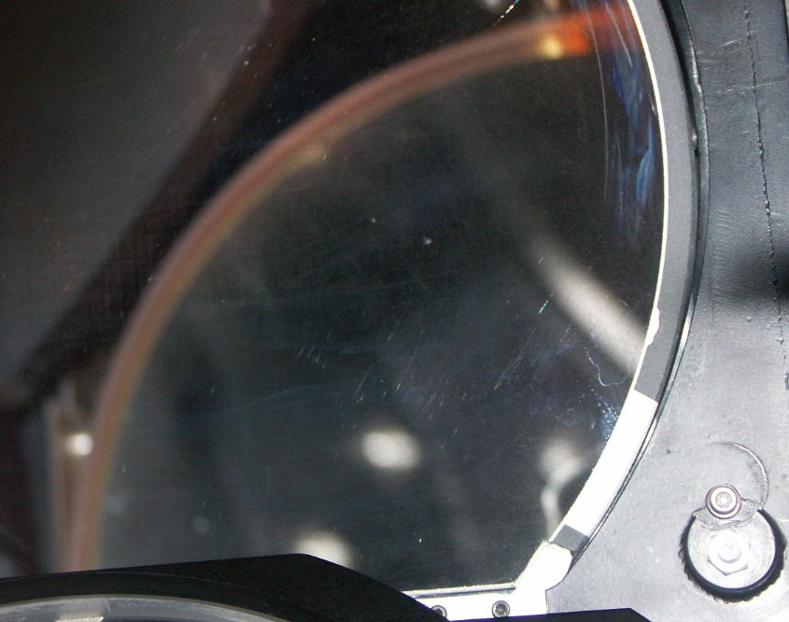

40” Telescope
Dave was able to climb inside the tube of the 40” primary to clean it and measure the reflectivity. Before cleaning it was 78% blue and 80% red… afterward it was 85% blue and 95% red. There was a large watermark that had pitted the coating so was not cleanable. The rest was very dusty beforehand. Access was very difficult but Dave was able to spray it with distilled de-ionized water and ethanol, then blot and wipe to get a large improvement.

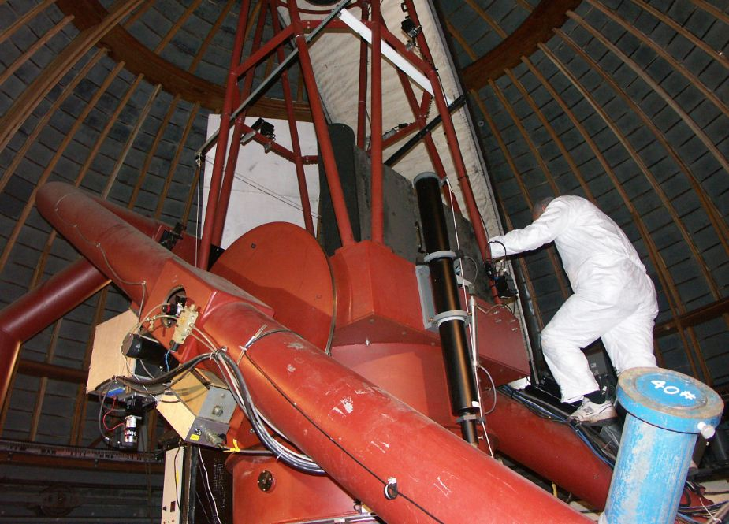

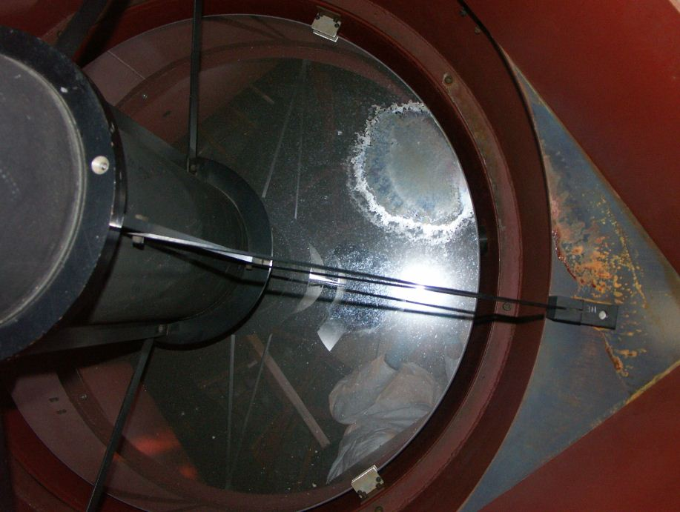
Water spot etched
Into coating

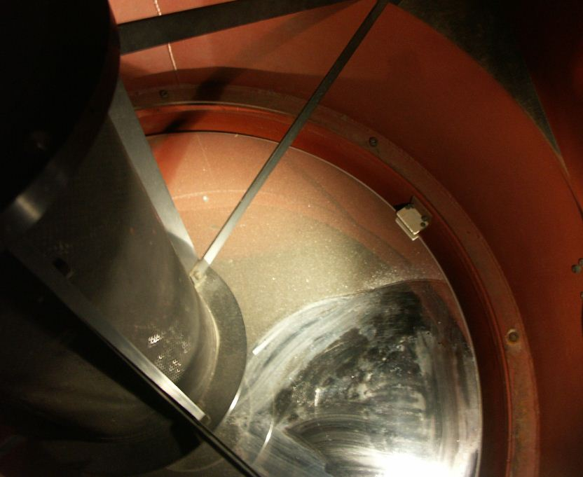

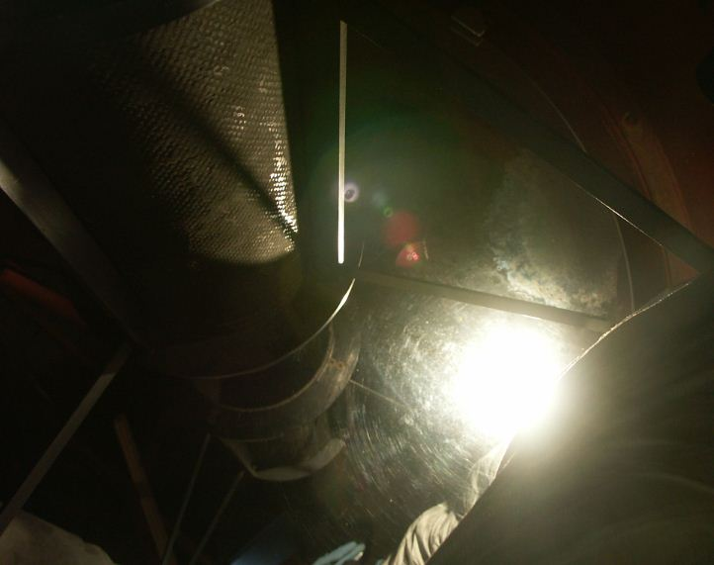
Much cleaner overall but water stain remains

Donnie lowered the telescope angle so we could examine the secondary mirror. It had long had a haze over it, but that layer was found not to be cleanable, so we didn’t attempt it this time.

