K1DM3 – Technical Note
Maintenance Manual

Introduction
This document is intended to cover the unique nature of the custom assemblies and parts of the K1DM3 module. Although attempting to cover all aspects it is not a substitute for common sense and standard maintenance practices and observations of conditions that require close review or immediate attention.

Critical Spares List

The spares list can be found in Reference 1. A view of the spreadsheet is shown in Figure 1.

Tool list

872-LM8343 Level Pad Spanner Tool – This tool is used to adjust the piston, tip, and tilt of the mirror assembly. The mirror assembly is locked to the groove plate thru kinematic couplings. The groove plate is supported on the swing arm by three leveling pads. The Spanner Tool is used to both loosen the lock nut and to also adjust the leveling pad.

General

Maintenance procedures and schedules can be found in Table 1.

Consumable parts - Swing-arm hinge pin o-rings. Duty cycle and load are benign on these components. It is unlikely that they will be subjected to any wear for the life of the instrument

Expected life – The items listed in the spares table are those components that may not have an infinite life. Mean time to failure (MTTF) is unknown for these components. For those with long lead times spares should be maintained on hand. Components with only a couple weeks or less will not have spares due to their quick turnaround.

Mechanical

Actuators – lubricate planetary lead screw as needed and replace seals as per manufacturer’s recommendations, Reference 10. Check shaft and pins yearly for wear.

Clamps – check, wipe down and grease M2 steel contact surfaces yearly.

Hinge – check yearly for excessive or unusual compliance.

Bearing – due to environment and duty cycle the manufacturer claims no maintenance will be required. Inspect yearly. Grease only if the seals or grease is contaminated. Monitor drive and rotation motors for changes in current loads.

Inner drum rotation

Oil – Some machine and cutting oils used in fabrication and assembly leaked onto surfaces between the inner and outer drums. Check periodically and clean up all traces. Use KimWipes or other absorbent tissues or cloths. Do not spray any cleaning fluids or grease cutters on drum surfaces. Apply fluids directly to tissues first before wiping. After cleaning surface areas wipe dry with a tissue or cloth.

Docking system
Inspect the tang and the clevis entry edges at the scheduled maintenance intervals. Check for surface wear, scratches, and any deformations. Note and document any conditions new since the last inspection. Check attachment hardware of the tang to the swing-arm. Make sure the sub-assembly is tight and rigid.

Ring gear inner drum positioner, V-blocks, and engagement wheel.
Check v-blocks and wheel for cleanliness. Wipe down with alcohol wipes if needed.
Check limit switches on the air cylinder. Check strain relief on wiring. Check retracting spring for deformation, wear or damage.

Kinematic & defining points inspection/maintenance

Instrument Module defining points – Inspect the defining points whenever the module is removed from the tower and parked on the handling cart. Add grease at fitting and at the acme screws. Clean defining point interfaces (cone, groove, flat) and apply a thin coat of grease to them.

Deployment kinematics – wipe down interface surfaces prior to installation - then grease contact surfaces yearly as in Section 5.8.1.

Mirror assembly kinematics

Inspect canoe spheres and v-blocks when mirror is removed for recoating. Check all kinematic surfaces for wear and deformation. Note and document any conditions new since the last inspection. Clean and grease the contact surfaces is above. An infinite lifetime is expected due to the extended coating frequency.

Axial and lateral pucks – check pucks and glue bonds yearly for chipping and discoloration.

Flex blocks

Inspect flex blocks, Figure 1, for cracks, deformations, or unusual appearance in the flexure or at the ends in the filets. If there is anything out of the ordinary or changes from the previous inspection the module should be removed from service for a more thorough review and inspection.

Mirror support flexures

On a yearly basis check all flexures for looseness or rattling. Check rod centricity with the outer flexure housings (Figure 6).

Earthquake clips – check yearly for binding or contact with mirror.

Clamps & air cylinders
Check contact surfaces for cleanliness. Wipe down with alcohol wipes if necessary and apply a thin coat of grease. Check limit switches on the air cylinders. Check strain relief on wiring along with signs of wear or abrasion.

Outer drum plumbing - Check tubing and fittings for scratches and wear. Note azimuthal location so that clearance thru the tower can be reviewed and inspected.

Hardware tightness – Reference 13 covers all the HW securing procedures. Check for loose HW and re-apply Loctite if necessary.

Electrical

Overview and troubleshooting – For general K1DM3 electronics information see the electronics overview (872-LE0001) and the top level schematic (872-LE0000).

Monthly maintenance

Fan, 48V power supply (M1eBox) - verify proper rotation of fan

Fan, heat exchanger (M1eBox) – verify proper rotation of fan

Heat exchanger coolant (M1eBox) – verify proper flow of coolant, check for leaks
6.2.4 Heat exchange fins – check for dust, clean as needed

Quarterly maintenance – monitor and record motor voltages and currents, report any significant changes

Annual maintenance (or at mirror re-coating)

Brush contacts – Clean contact blocks. Inspect contacts and brushes for excessive wear.

External cables - inspect for damage

Drum wiring – inspect for loose cable strapping

LEDs – inspect light coverings on inner drum Galil RIO (PLC) and Galil DMC (motor controller) LEDs. Replace as needed.

Rewiring events – For cables and wiring connected to moving components check for proper and unrestrained motion of the moving component. Make sure there is no rubbing or abrasion of the wiring. For lines that are static make certain that they are free and clear of any moving or rotating parts.

Optical

Surface quality

cleanliness – Check mirror quarterly for accumulated debris and particulate matter on the surface. Blow off particulate matter with compressed N2 or filtered dry air. Do not use canned air, which can spit propellant residue.

Inspect the surface quality, looking for scratches, dings, water spots, blemishes or other signs of degradation in the coating. Note and record any significant changes or cracks since the last inspection. Document locations and take photographs.

Cleaning of K1DM3 should be performed on a yearly basis. The module should be removed from the tower and parked on the handling cart. See Reference 15 for cleaning instructions.

Axial & lateral puck bonds
The epoxy bonds will not be visible due to their size relative to the pucks. Inspect the gap at the edge of the puck; look for any material or debris in the area. With a gloved hand or suitable mechanical probe check the rigidity of each puck. It should be solid to and with the mirror.
Inspect the each flex rod and make sure the center node is symmetric with the housing, see Figure 6.

Handling - Never touch the mirror with bare hands. Wear gloves specified for this purpose. Procedures and practices when working with and around the mirror should follow the same rules and requirements as applied to all primary mirrors and other optics. Specific handling of the mirror assembly which includes removal for re-coating is covered in Reference 11.

Coating – See Reference 2 for requirements and documentation

Glycol cooling

M1 Box coolant flow – The recommended flow rate is 1.75 to 2.00 liters/min. Figure 7 shows the location of the valve in the M1 Box. When facing the enclosure it is in the lower right corner of the box.

Temperature – The temperature difference between inlet and outlet is less than 1°C during full scale steady state electronic operation.

Pressure – line pressure should not exceed 150 psi, which it the rating for the heat exchanger in the M1 Box. Check monthly.

Flowmeter – Refer to the user manual, Reference 3

Heat-exchanger

Check fan for excessive noise or imbalance Check exchanger air intake for dust and debris build up; remove and clean as needed.

Plumbing – check for leaks among the fittings and abnormal noises in the lines. Check on a monthly basis.

Pneumatic

Flow
Air flow on all clamp systems is adjusted and controlled by needle valves on each line. Adjust as needed for proper operation without excessive noise or violent action.

Pressure
Air pressure on all lines should be within 100 and 120 psi.

Air cylinders
Check limit switches on cylinders. Make sure the sensors are snug and do not move when wires are tugged. Check strain relief on wiring. Make sure any snagging cannot effect switches.

Fittings
Check fittings for noise and leaks.

Inner drum air delivery – clean the sealing surface on the inner drum. Wipe down quarterly. Check and inspect the (Viton) O-ring on the outer drum; replace annually.

Special operations and considerations

Come-along operation and other manual control – If there is a loss of power or any other reason the swing-arm cannot be operated by the actuators, see Reference 11 for manual operation.

Responses and actions due to earthquake – Remove K1DM3 from the tower and secure it to the handling cart. Perform all maintenance tasks listed in Table 1.

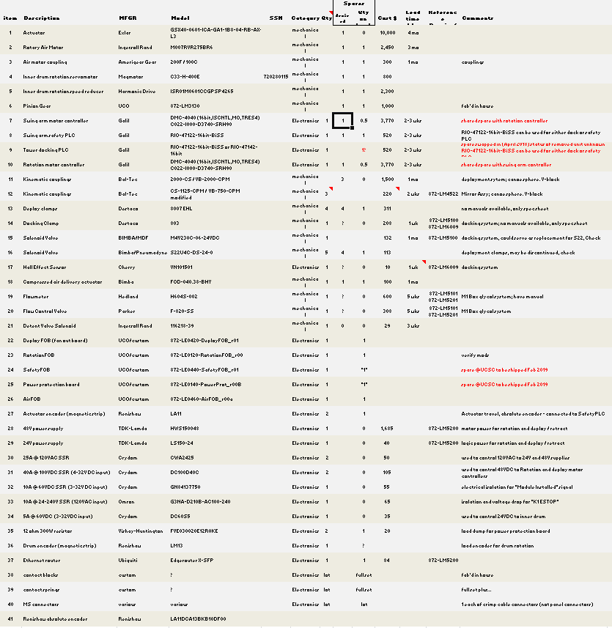
Figure 1 - Spares list. Example print out from the Spares tab in the project spreadsheet.
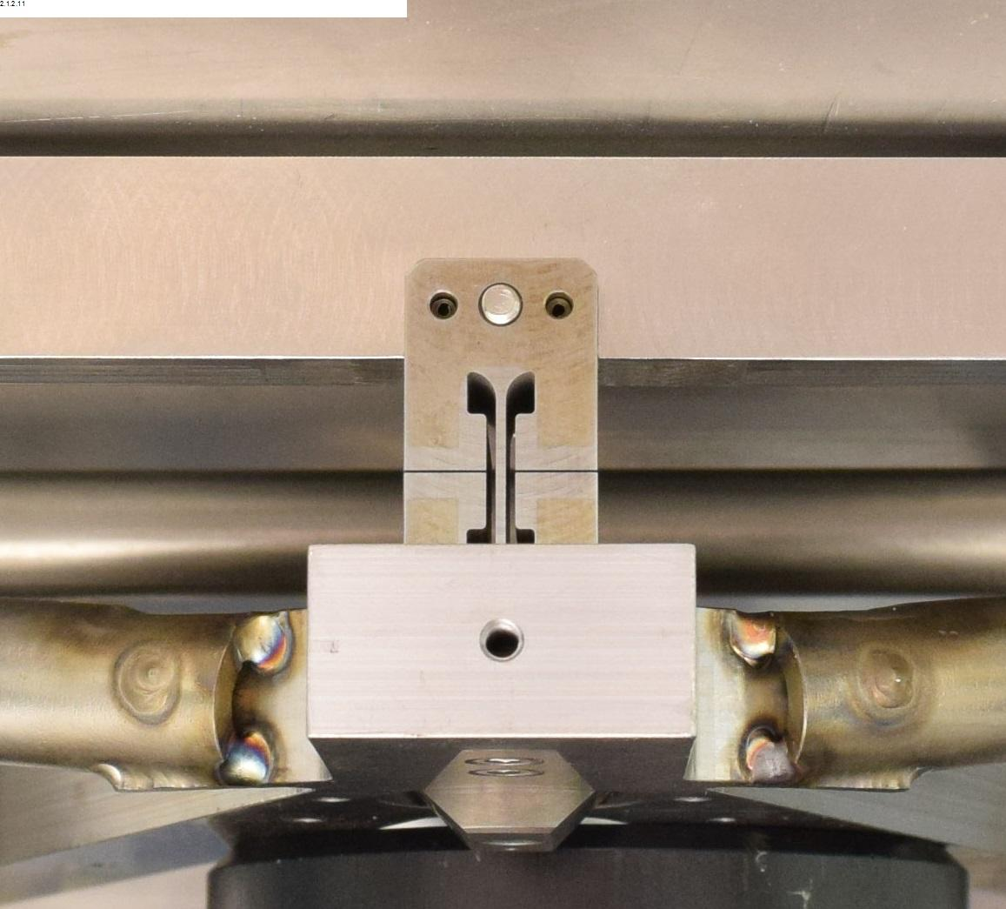
Figure 2 - Flex block, one of three, one for each whiffle tree.

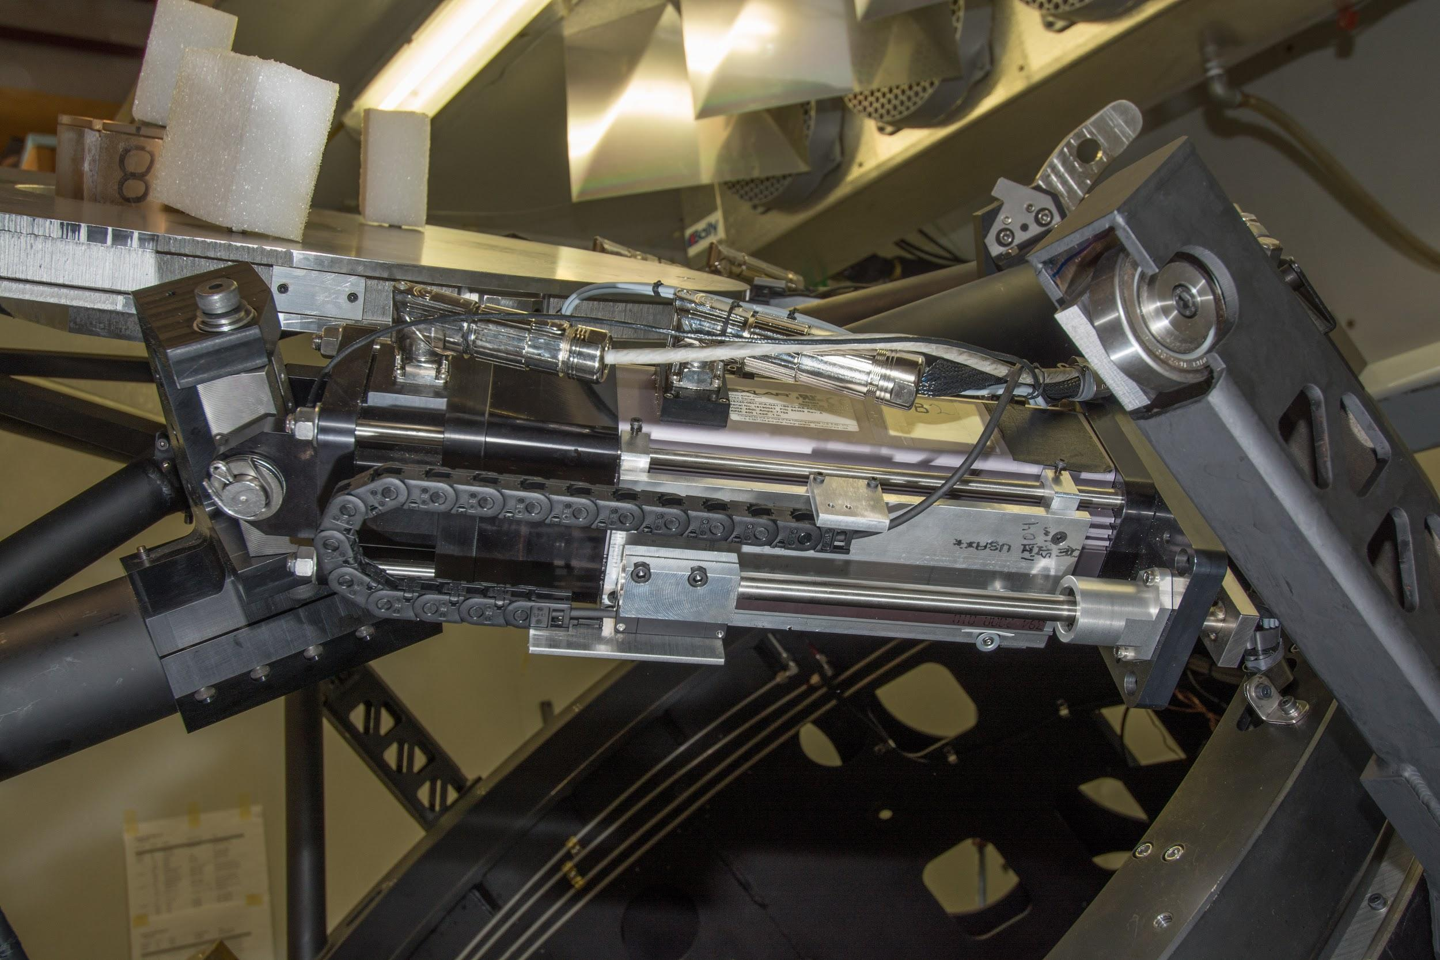
Figure 3 - Actuator with incorporated encoder.
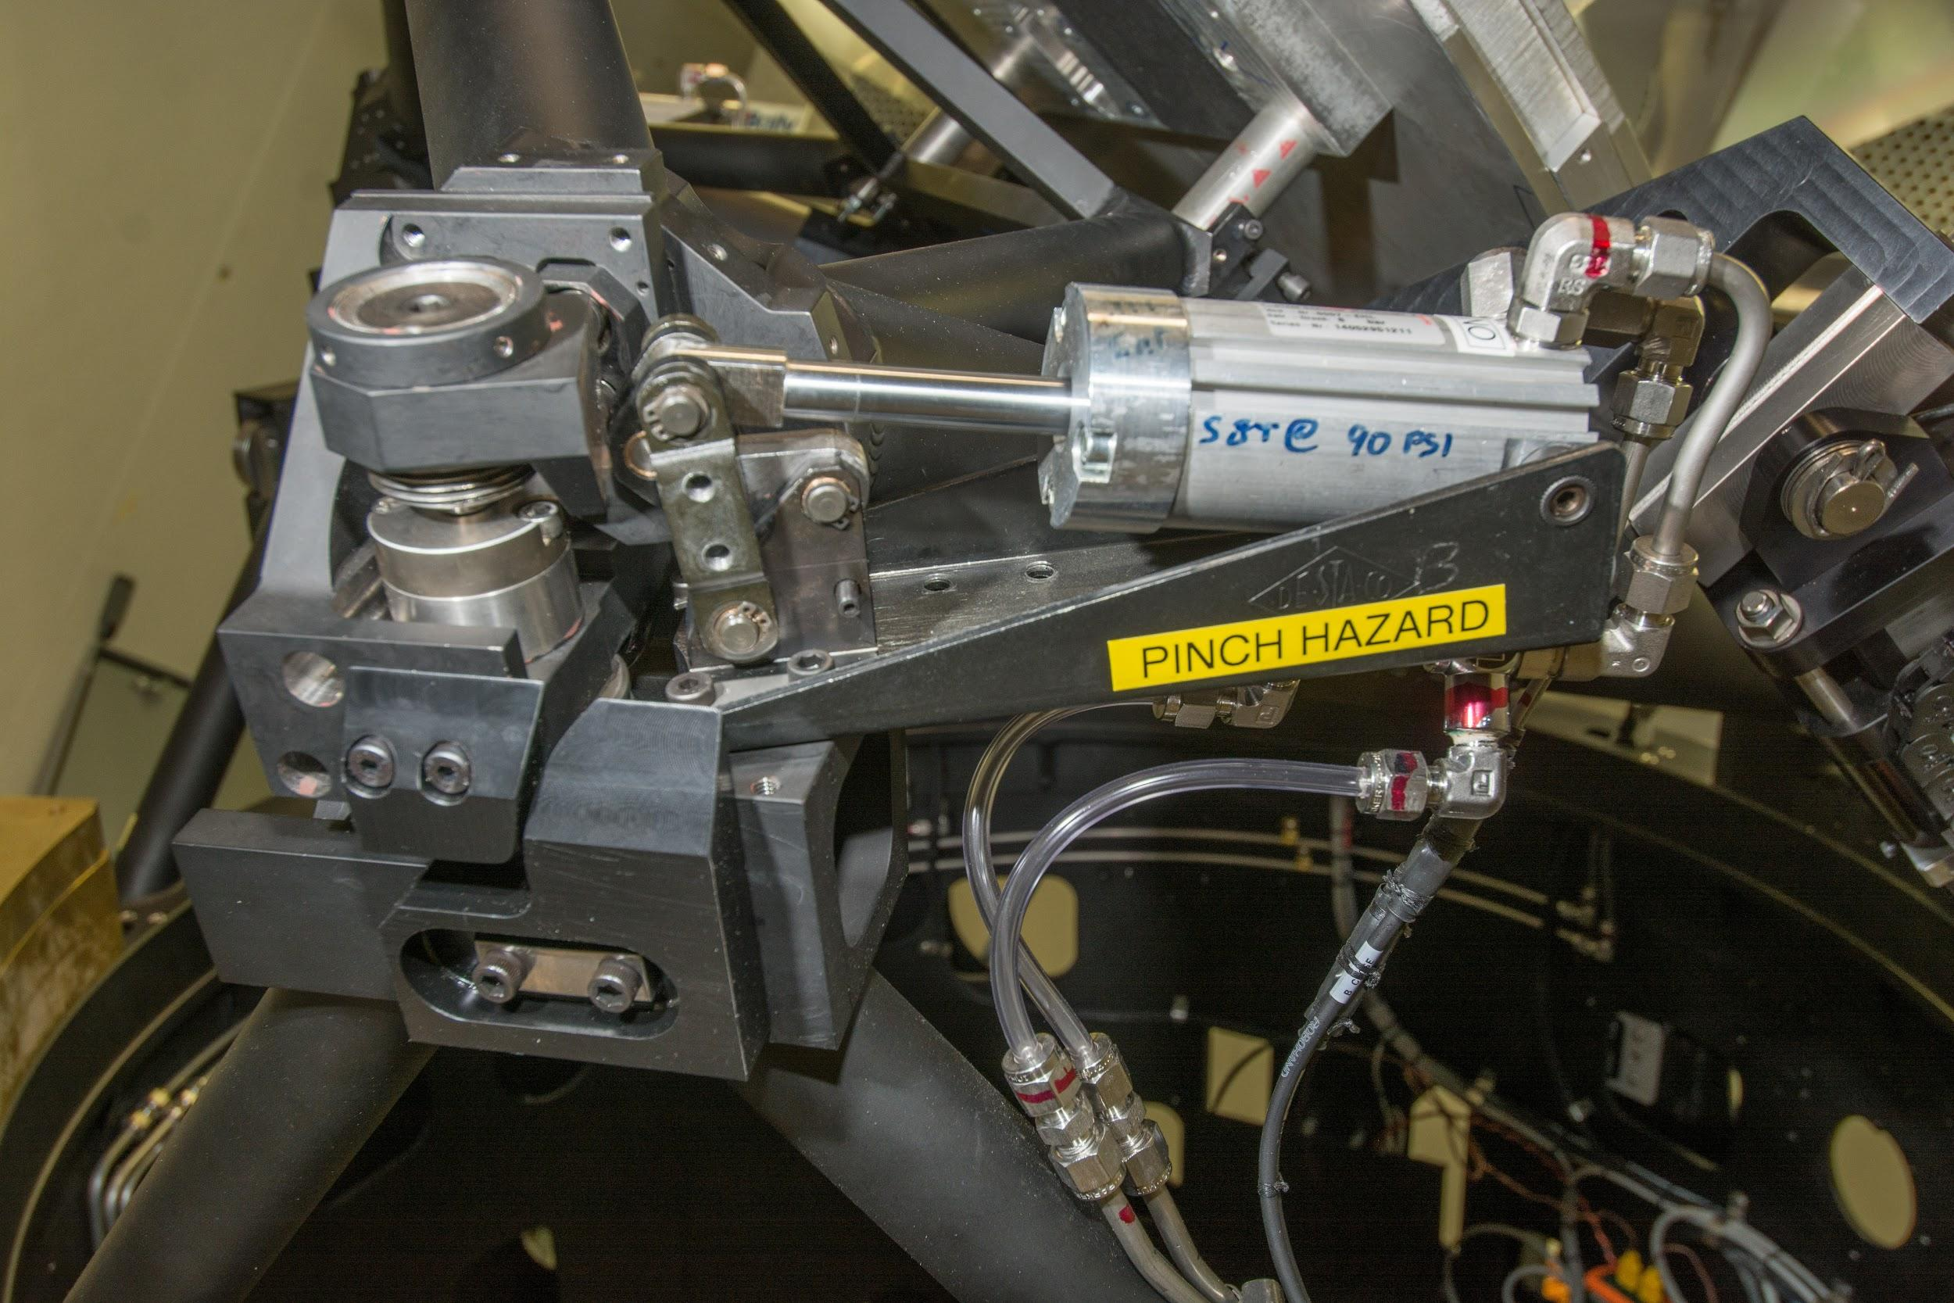
Figure 4 - Clamp/Air Cylinder at one of the two bipod locations

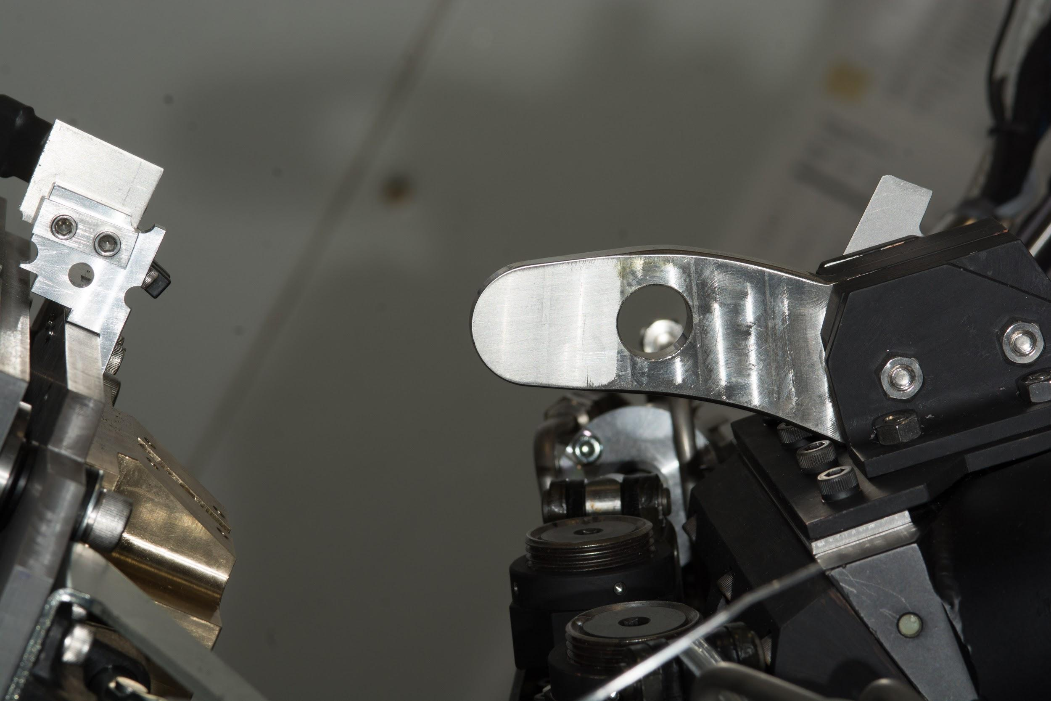
Figure 5 - Docking system

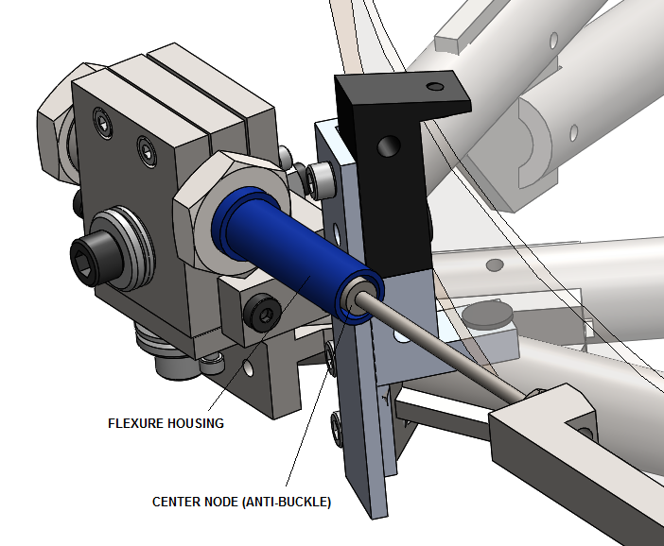
Figure 6 - Flex rod showing centration between the flexure housing and the center node on the flex rod.

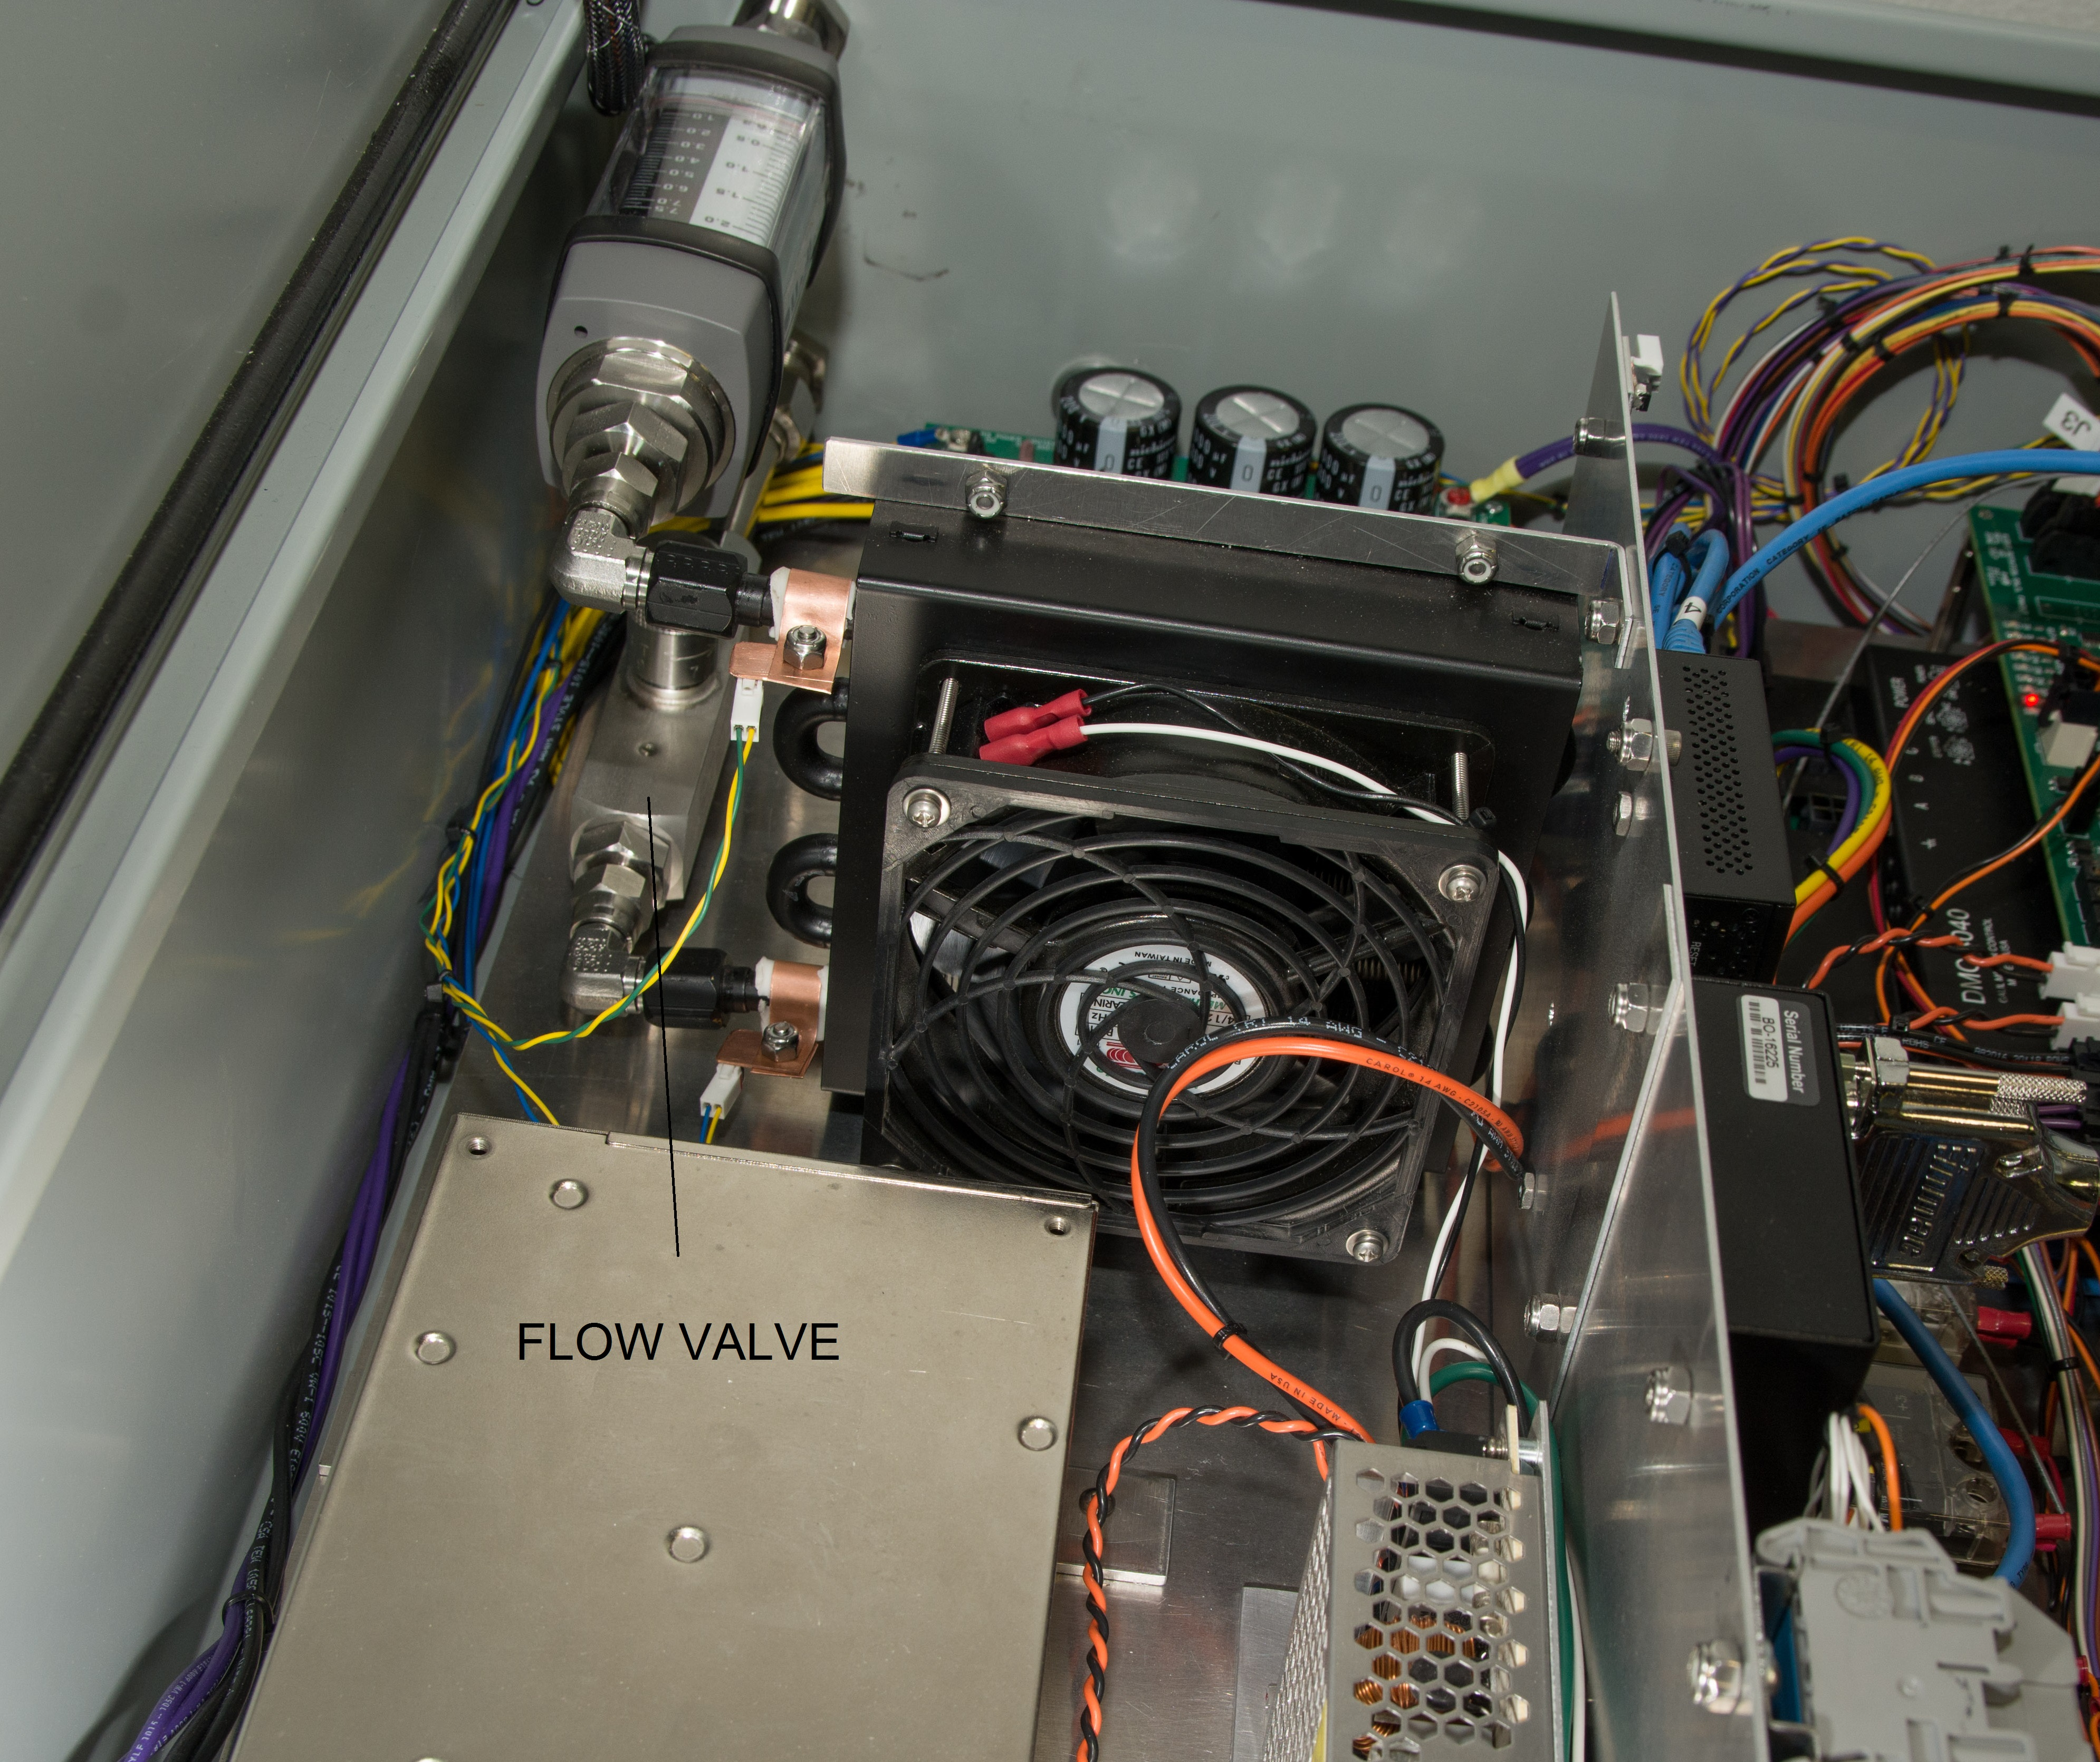
Figure 7 - Flow control valve for the coolant in the M1 Box, located in the lower right hand corner of the enclosure.

Table 1 - Maintenance Schedule
Item | Section | Description | Frequency | Action | Comments
1 | 5.1 | swing arm actuators | yearly | lubrication and seal inspection | manufacturer's recommendations; Reference 10
2 | 5.2 | clamps | yearly | clean & grease contact surfaces
3 | 5.3 | swing-arm hinge | yearly | check compliance of hinge
4 | 5.7 | detent motor | yearly | check for proper operation of clamps | check pressure
5 | 5.8 | kinematics & defining points | yearly | check surface wear and for birnelling; clean & re-grease surfaces | Note 3
6 | 5.8.1 | acme nut | Note 3 | grease fittings and screw
7 | 5.8.3 | mirror lock-down HW | re-coating | check for loose HW and proper torqueing
8 | 5.9 | axial & lateral pucks | re-coating | inspect bond line and surrounding area for cracks | Note 1
9 | 5.10 | flex blocks | yearly | inspect for cracks/deformations
10 | 5.11 | flexure rods | yearly | inspect
11 | 5.12 | clip clearance | yearly | adjust clip to remove interference | earthquake clip clearance
12 | 5.15 | loose hardware | yearly | adjust and tighten to assembly specs and torque document | Reference 13
13 | 6.3 | motors | yearly | note and record current loads
14 | 6.3.1 | brush contacts | re-coating | check contacts for corrosion and wear
15 | 6.3.2 6.3.3 | wiring | yearly | check strain reliefs and wear on wiring
16 | 6.5 | restraint of natural movements | yearly | check wiring interference with motion
17 | 7 | mirror cleanliness | yearly | inspect and clean as needed | mirror quality related to dust, debris, & oil deposits
18 | 7 | mirror quality | yearly | Note 2 | degradation of reflective surface
19 | 7 | mirror cracks | re-coating | inspect mirror for scratches and cracks | Note 1
20 | 8 | M1 box plumbing | yearly | check box plumbing, all fittings for leaks
21 | 9 | air lines | yearly | check or air lines for proper operation | check pressure
22 | 9 | clamps | yearly | check for proper operation of clamps | check pressure
23 | 9.5 | air connect | quarterly | clean surfaces and check o-ring | Note 4
Notes
- Perform first PM after a year, then at every re-coating thereafter
- Refer to existing M3 PM practices regarding mirror coating and cleaning
- Refer to existing M3 PM practices for defining points, perform yearly
- Replace o-ring yearly
References
- Spares List, project main Excel spreadsheet, K1DM3.xlsx, Tab – Spares List, copy also at http://k1dm3.ucolick.org, under documentation.
- Technical Note 925, Deployable Tertiary Mirror Removal & Installation Procedure, WMKO
- User Manual, Hedland Variable Area Flow Meters, VAM-UM-00551-EN-04, September 2014, Badger Meter
- Level Pad Spanner Tool, 872-LM8343
- Mirror Assembly, 872-LM4200
- Mirror & Swing-Arm Assembly, 872-LM4700
- Compressed Air Clamps Schematic, 872-LM2237
- Air Motor and Detent Compressed Air Plumbing Schematic, 872-LM3136
- Clamping System Pneumatics, 872-LM6100
- GSX and GS Series Linear Actuator Installation and Service Manual, GS/X Manual.doc, PN 10278, Revision KK, 02/17/14, Exlar Corporation, 952-500-6200
- K1DM3 Coating Procedure, Keck document
- MULTI-VANE Air Motors, M007 Series, Operation and Maintenance Information, Form P6877, Edition 6, June 2016 CCN: 03536968, Ingersoll Rand
- Technical Note 872-LTN2003, Hardware Lockdown Specifications, Procedure, Screw Tightening and Loctite Application Slides, PowerPoint file
- Technical Note 872-LTN2004, Come-along Procedure
- Technical Note 872-LTN2005, Mirror Cleaning Procedure

Revisions
A Dec18 Initial release
B 29Jan19 Electronics section updated, Figure 7 added, Reference 1 updated.
C 4Feb19 Optical cleaning, schedule table updated, Reference 15

