Mt. Hamilton Optics Cleaning Trip
David Hilyard and Brian DuPraw
5/22/12

Coating Samples
The protected silver coating samples we had made in Santa Cruz and mounted in the dome for long-term exposure predictably showed an overall layer of dust. That was blown off as much as possible with a can of dry air. Some had spots that appeared to be degradation of the surface, but other spots were certainly just dirt particles that would be cleanable with solvent.
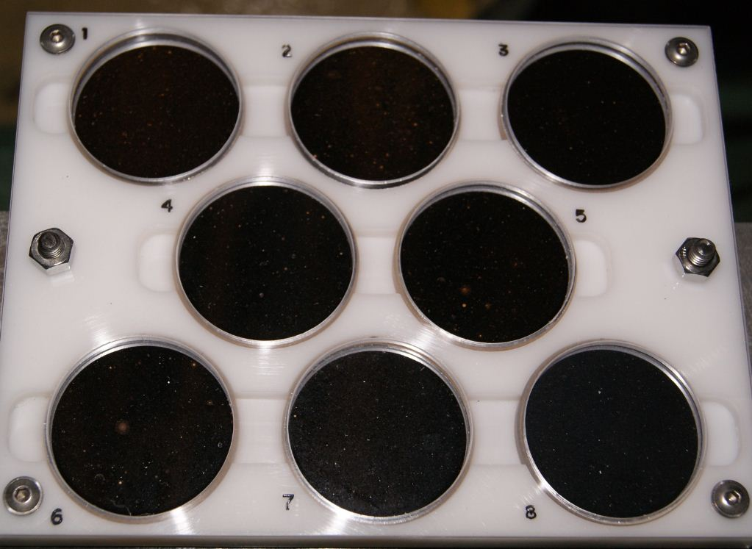

They looked pretty good, for the most part…#2 was probably the most degraded of the eight disks on the top side of the rack. #5 had a couple of nuclei beginning to grow.
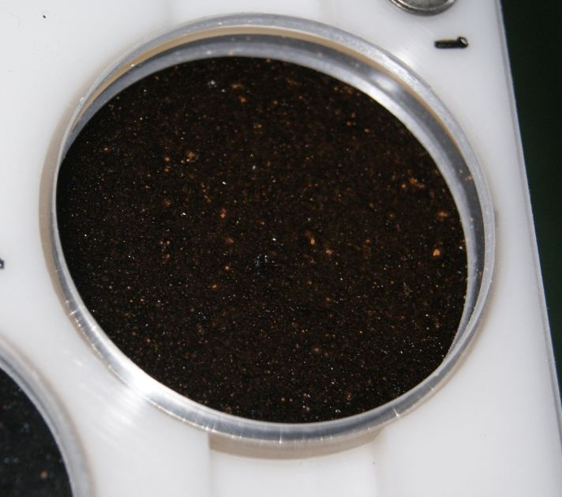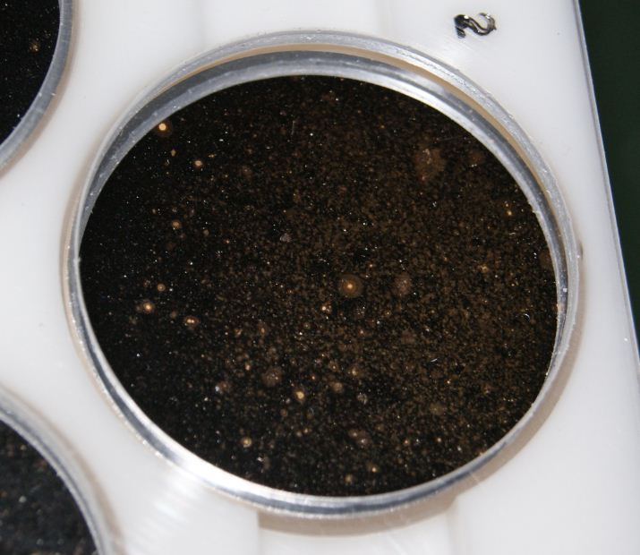
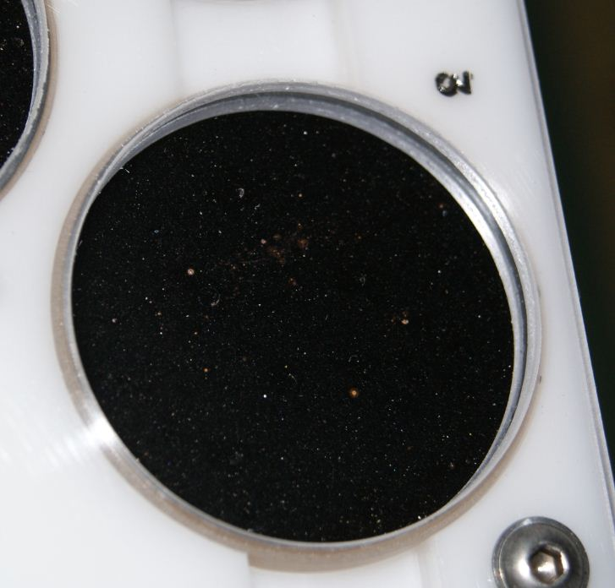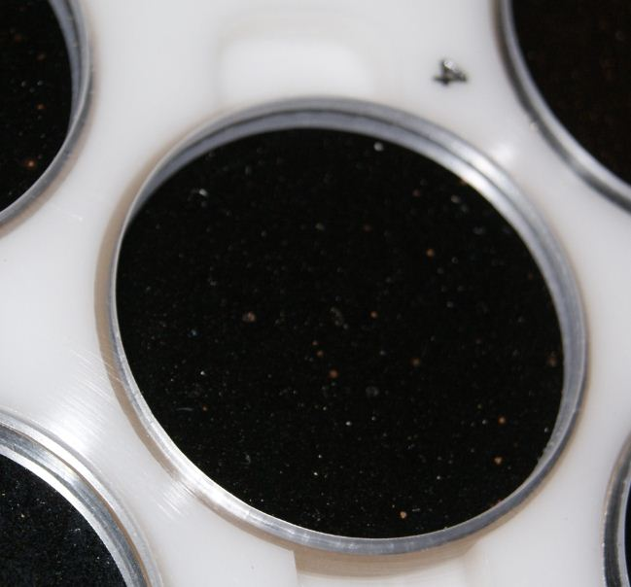

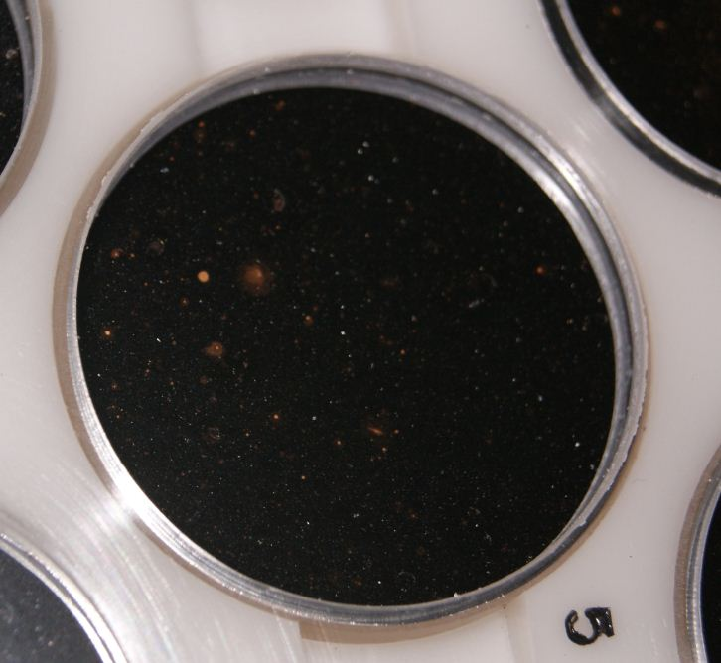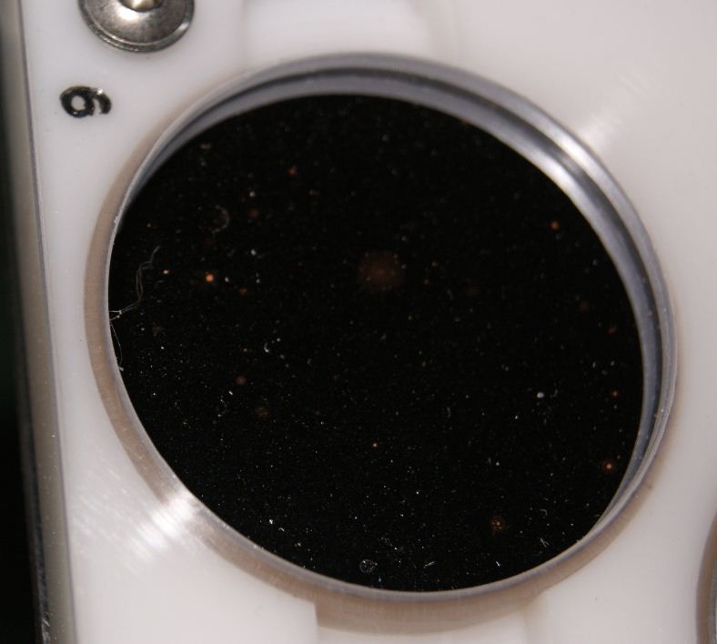

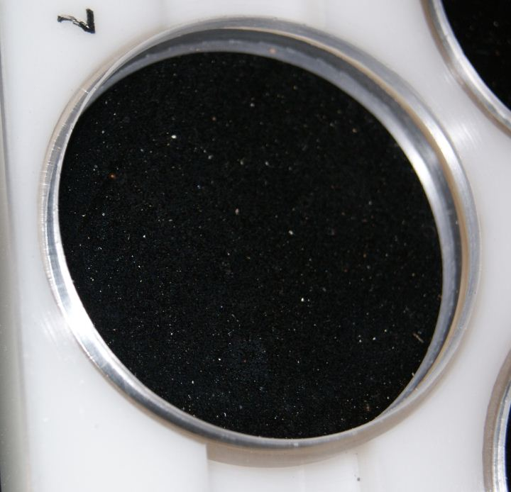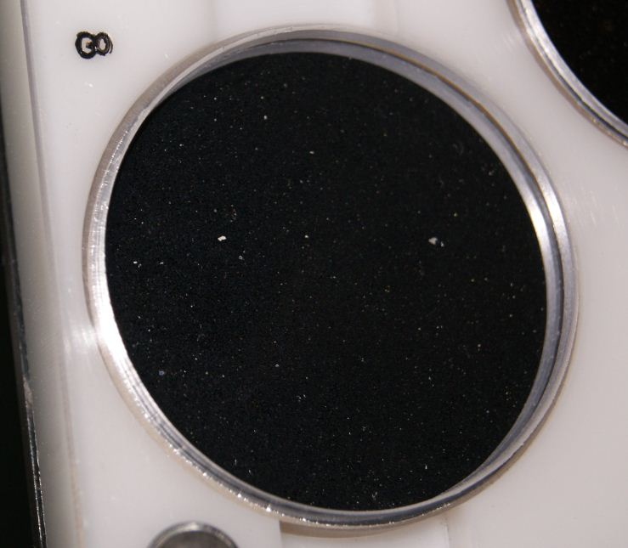

Of the disks on the bottom side of the rack, the one that stood out for its large spot of degradation was #15. #10 had some interesting spots forming, but still subtle compared to #15.
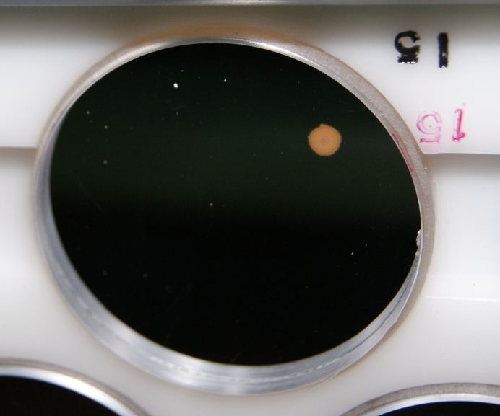

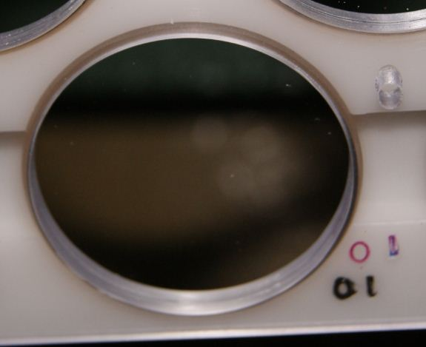

KAST Dichroics
The astronomers had had problems recently with a particular combination of grating and filter so we were on the lookout for anything on them that might have caused an aberration. The 4600 nm filter was just dusty, no apparent smudges or scratches. It was blown off with dry air and cleaned with ethanol. The 5500 nm filter was dusty but also had a film of some sort on it. It was cleaned with breath and ethanol. There was a circular-shaped scratch 1/3 of the way from one end. We didn’t find anything that we believed would be responsible for aberrant imaging system behavior.

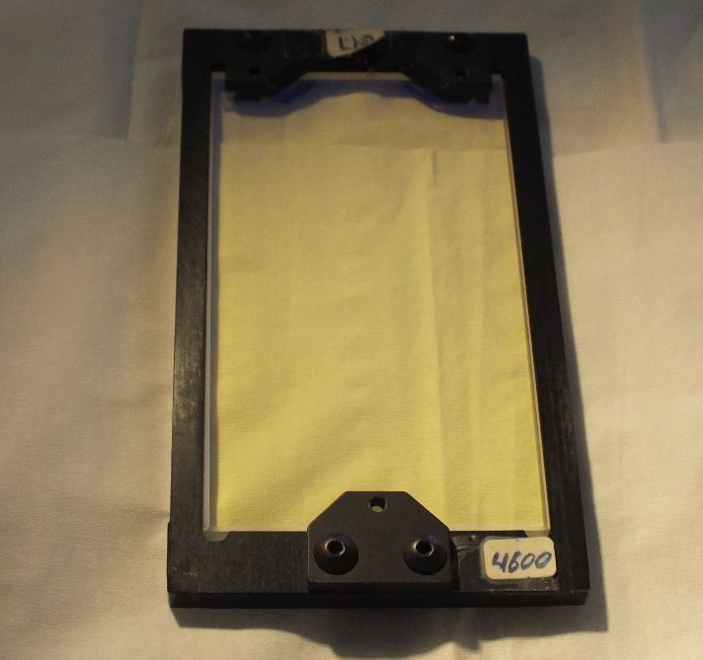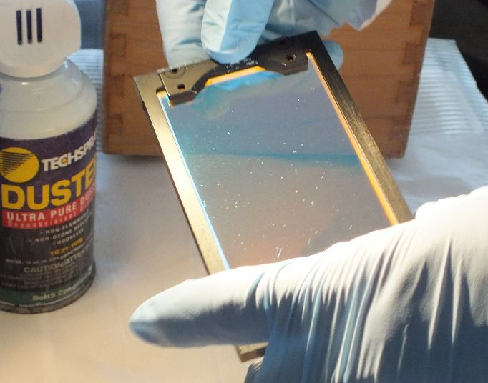

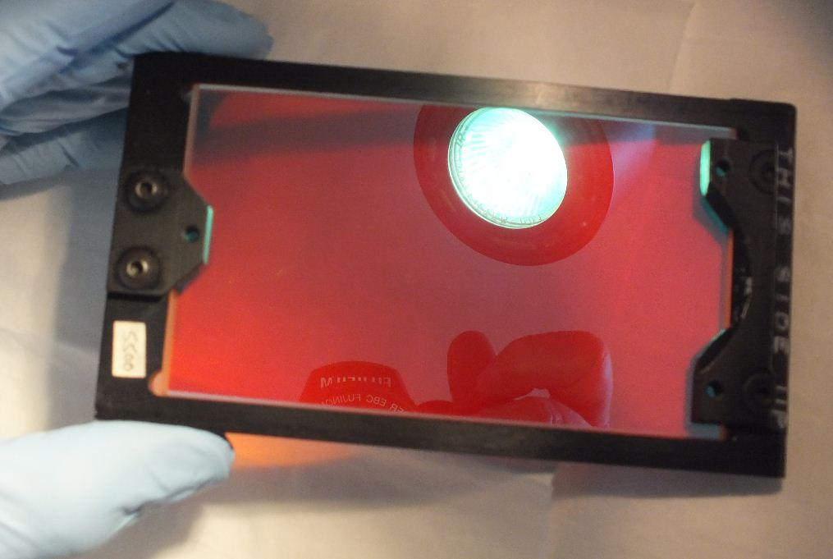
Circular scratch
location
(can’t see it in photo)

120” Cassegrain Secondary
Lots of surface degradation spots, but unable to clean the mirror due to its being easily sleeked. The spots don’t come off with solvent anyway. We measured 90% reflectivity in both the red and the blue.

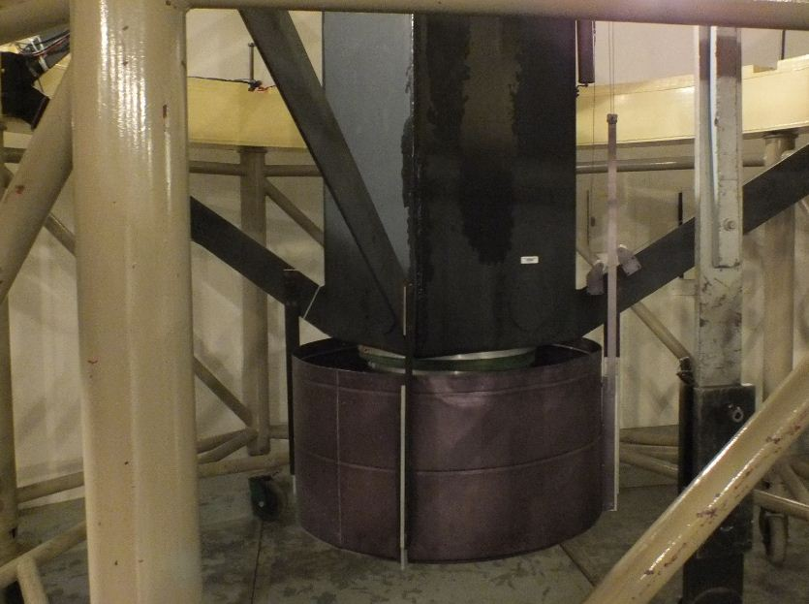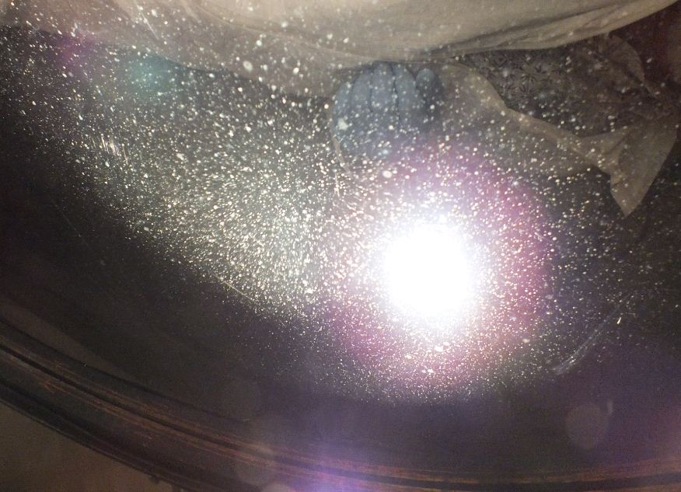

120” Primary
The 120” primary mirror had an overall dusty look but was scheduled for a CO2 cleaning soon. There were more small spots on the mirror since the last time we visited, but they didn’t look like oil and they weren’t streaks, such as from water. Dave saw 6 to 8 small older sleeks.

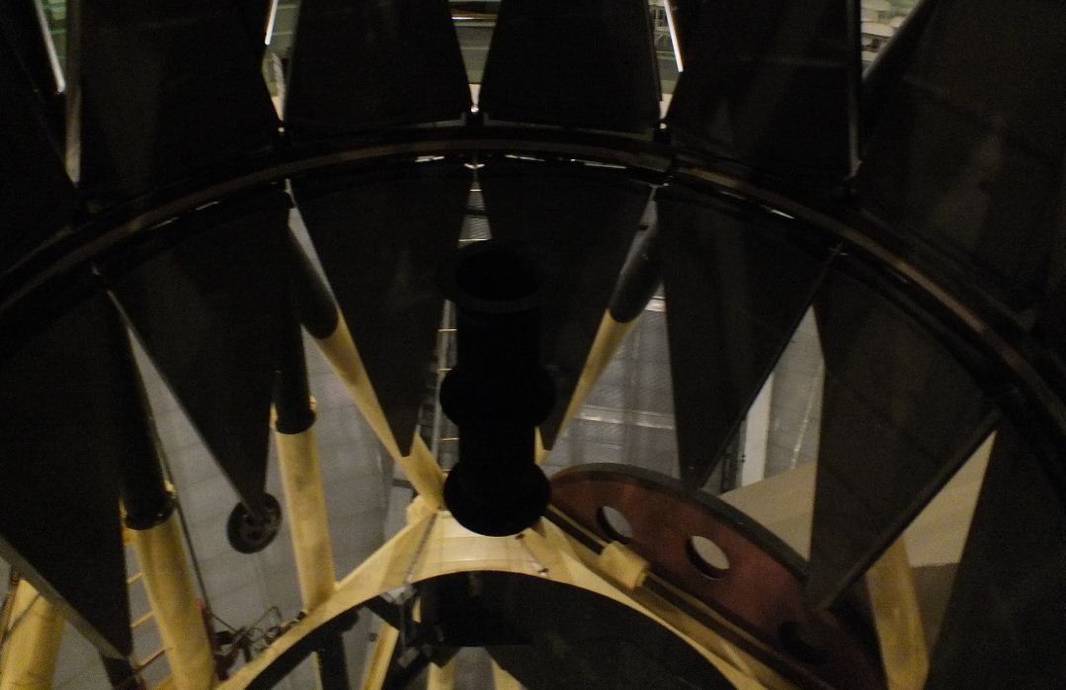

Dirty area of 120” mirror:
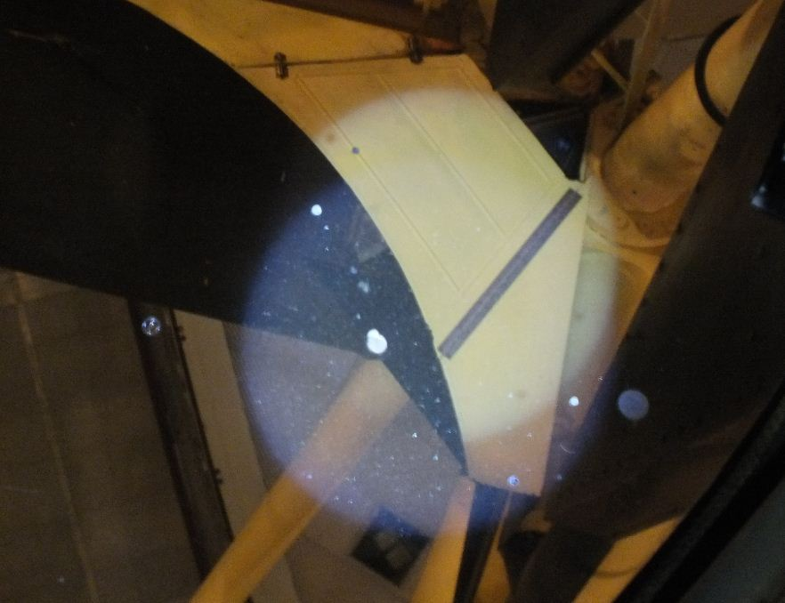

KAST Blue Side Camera
The Dewar was off of the KAST blue side camera, making the lens accessible once a cover was removed from what would have been the Dewar location. Dave cleaned it with ethanol.
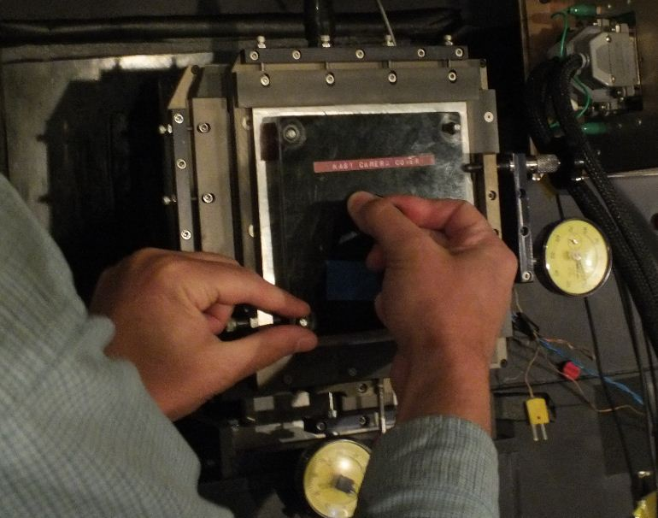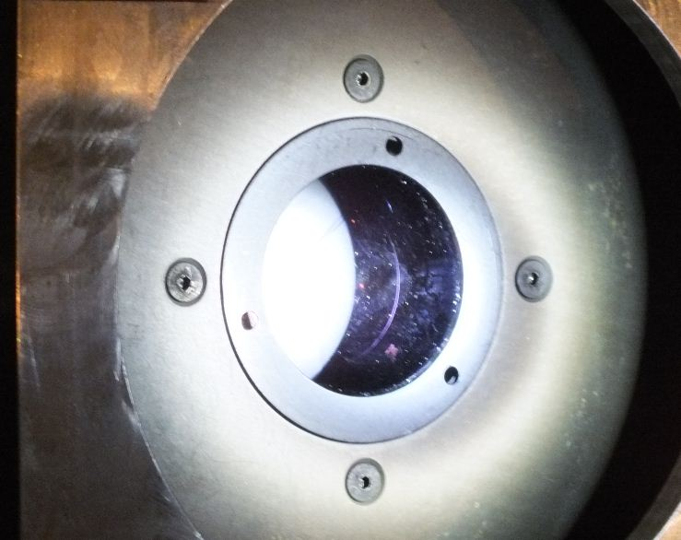

KAST Red Side Camera
The red side camera was also dusty and had a small scratch on the outer surface. There was dust on the inner surface but it was inaccessible.

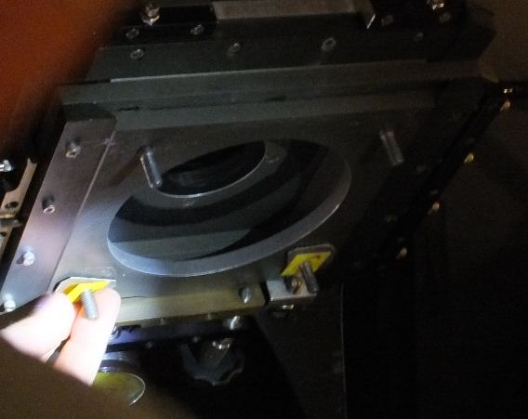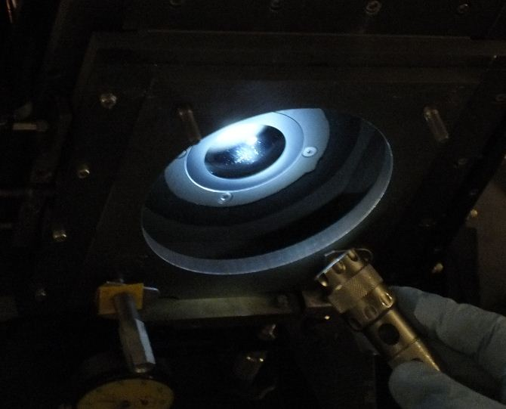

KAIT Telescope
The primary mirror of the KAIT (Katzman Automatic Imaging Telescope) was very dusty, with rivulets in the dust from previous moisture. We measured 81% reflectivity in the blue and 94% in the red. Dave cleaned it with a soapy mix of Orvus/ acetone/ H2O, then cut the soap, first with ethanol and then with acetone. After that it measured 88% in the blue and 100% in the red (relative to the reference mirror).

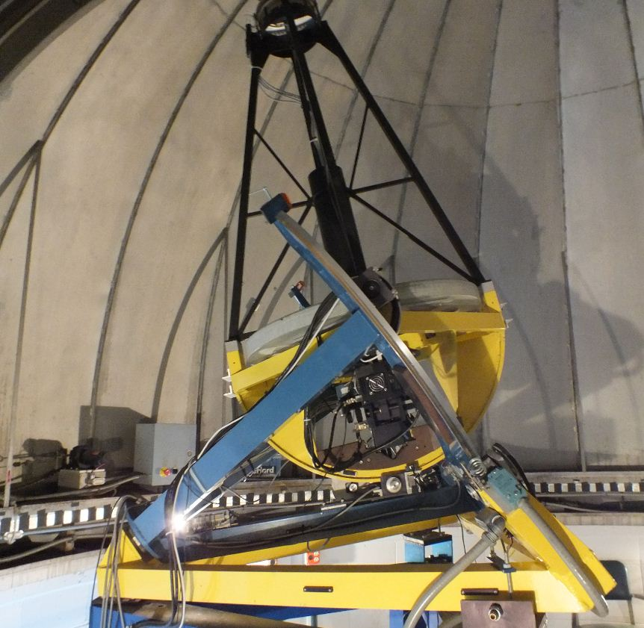

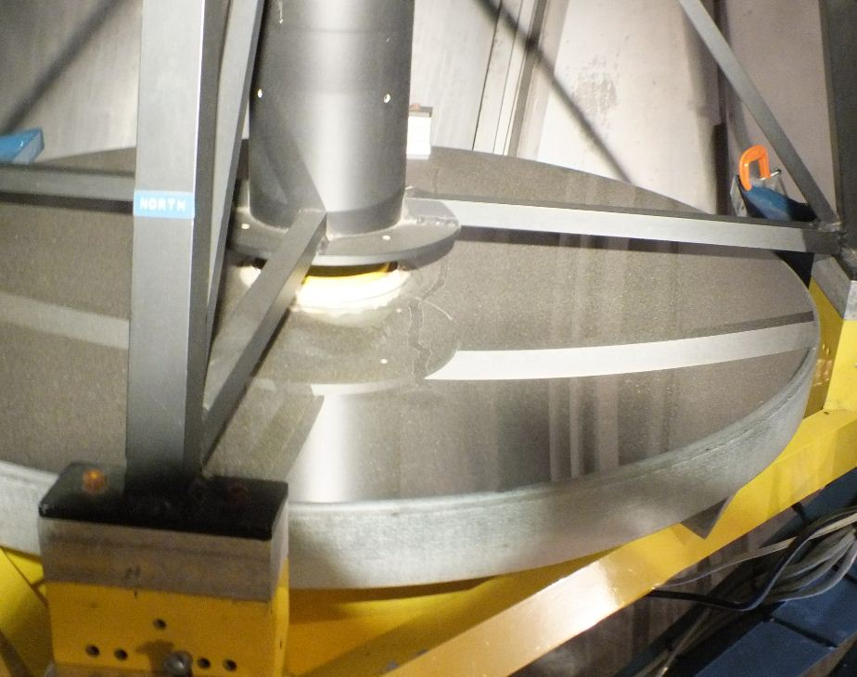

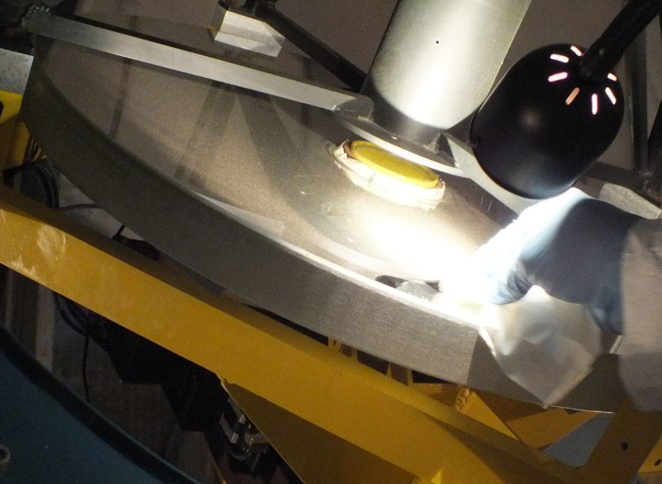
Test cleaning small area
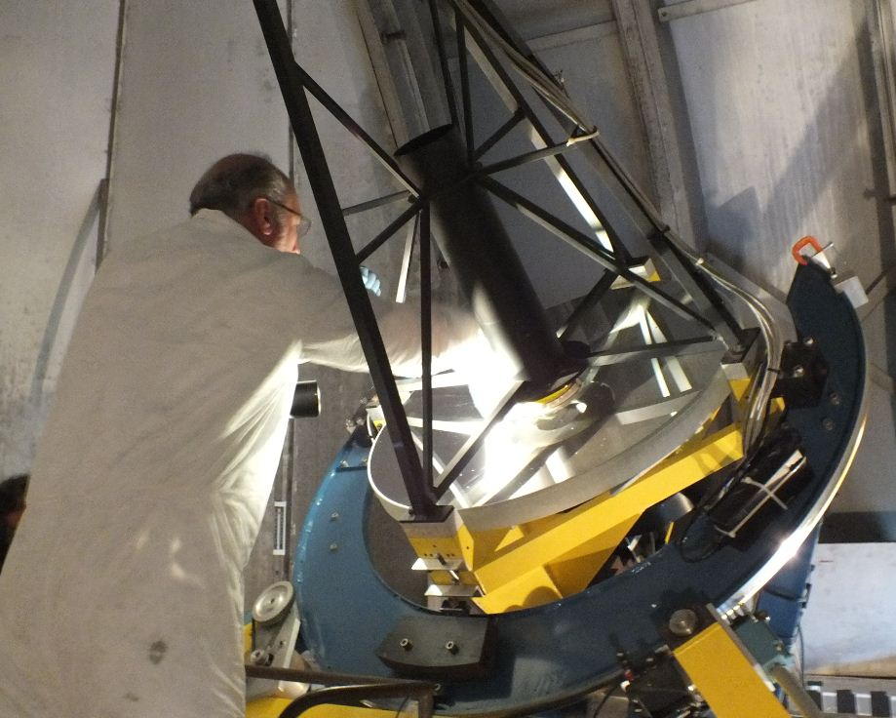

The secondary was downward-facing so wasn’t as dusty as the primary. However, there were numerous small spots that were uncleanable, so it will need recoating before long. There were sleeks from prior cleaning attempts already on the mirror.
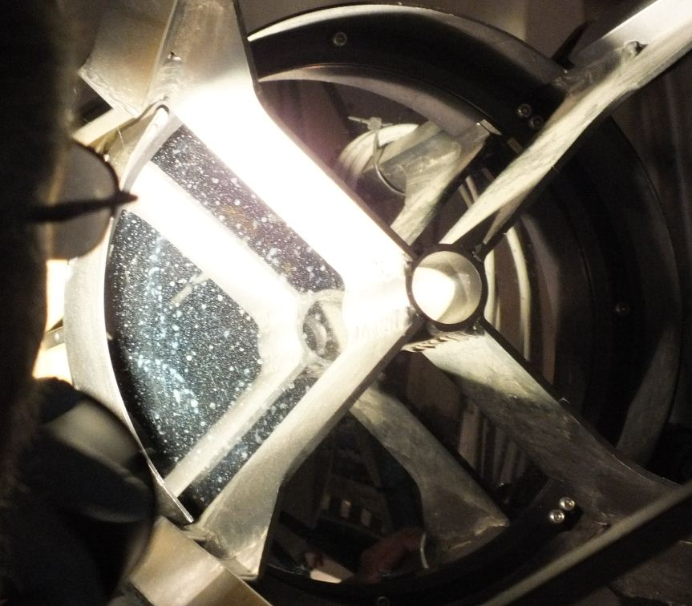

36”Refractor
There were streaks such as from water on the outer surface of the lens and an overall haziness on the inner surface. The outside was cleaned with Orvus/ acetone/ H2O on a tissue plus extra distilled water sprayed onto the tissue and the lens. The inside was cleaned with ethanol by reaching through the armholes around the perimeter. It appeared much improved.
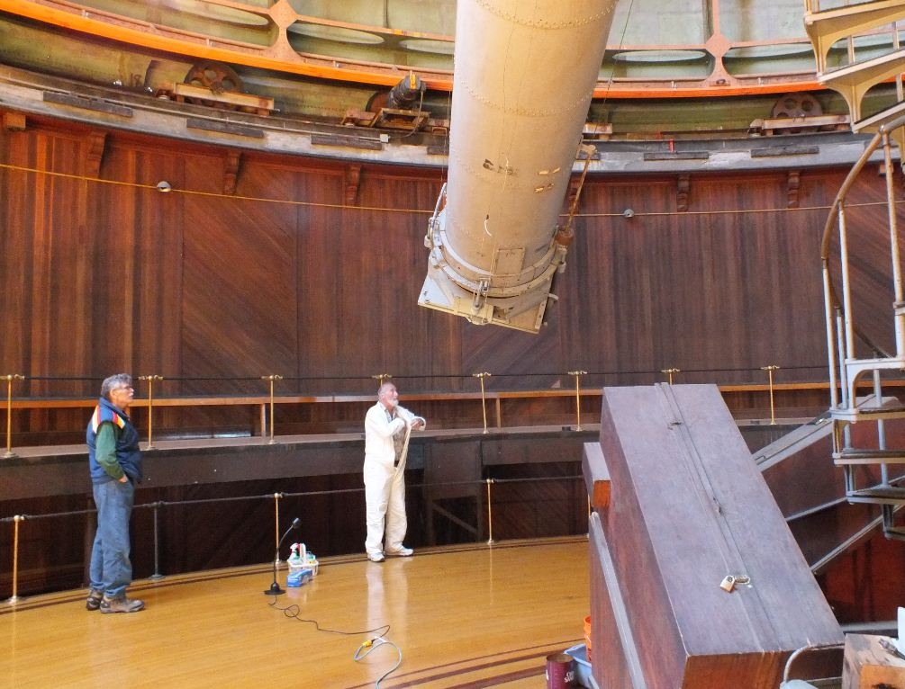

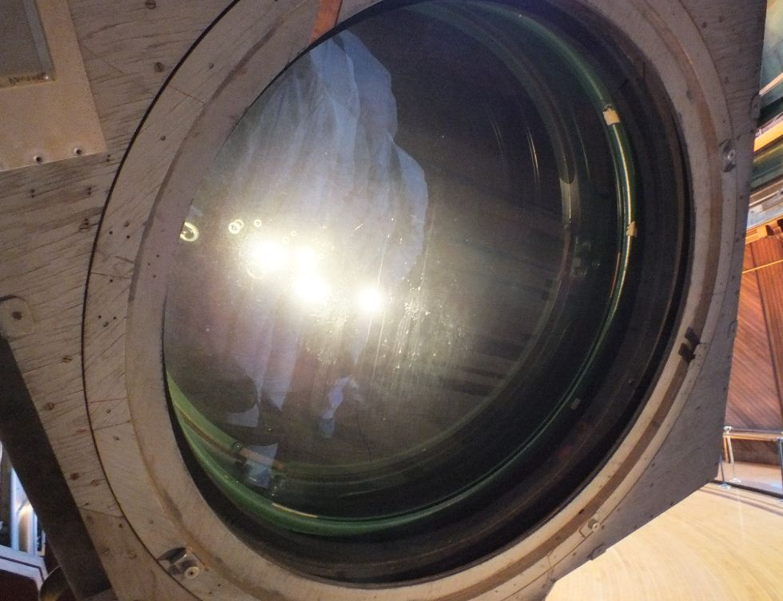

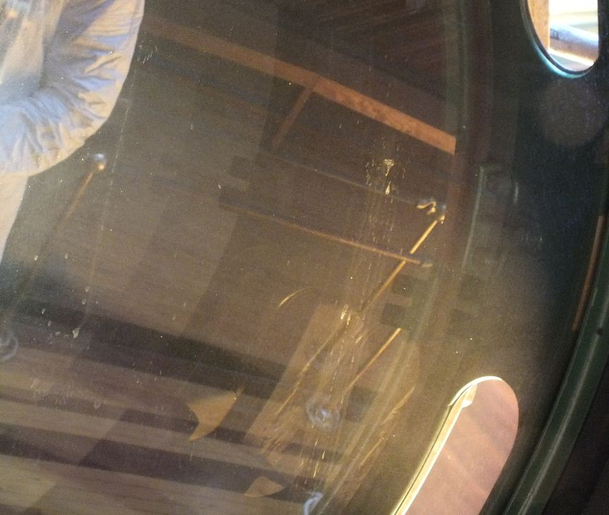
Needed
cleaning

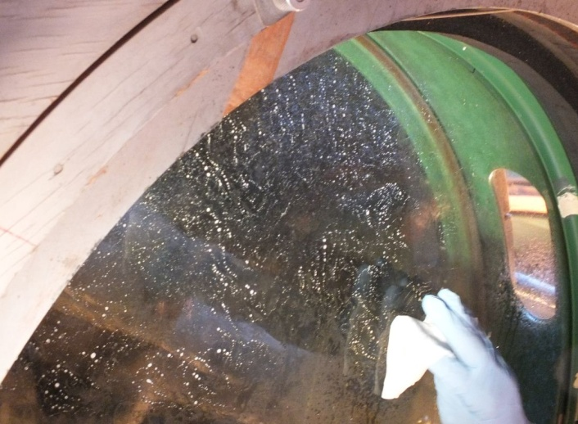
Soap bubbles

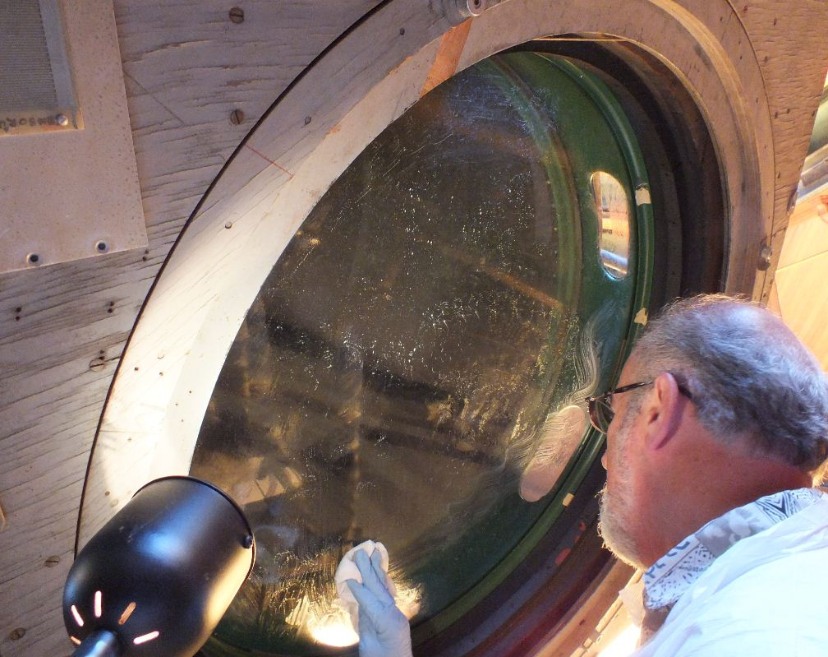

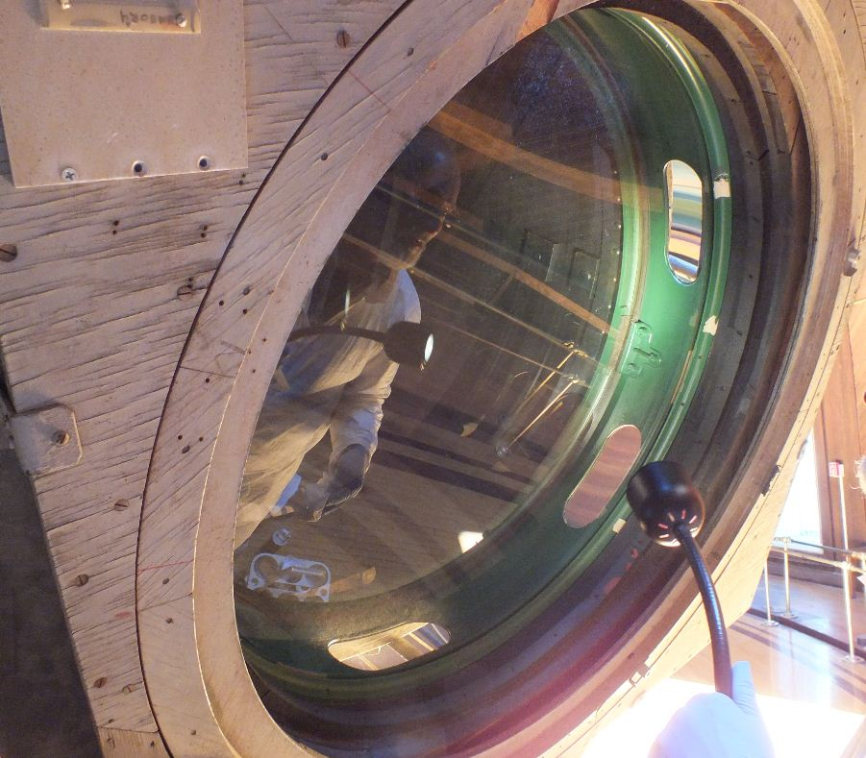

The finder scope on the 36” refractor body was dirty until it was cleaned with Orvus/ acetone/ H2O, followed by distilled water and then ethanol.

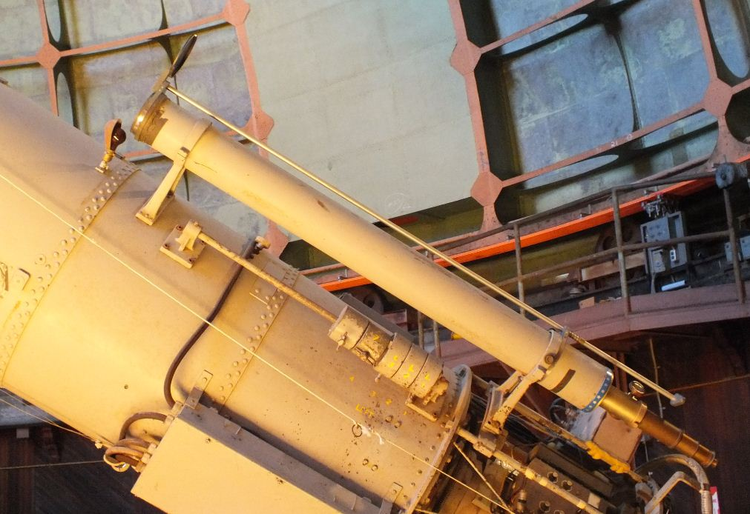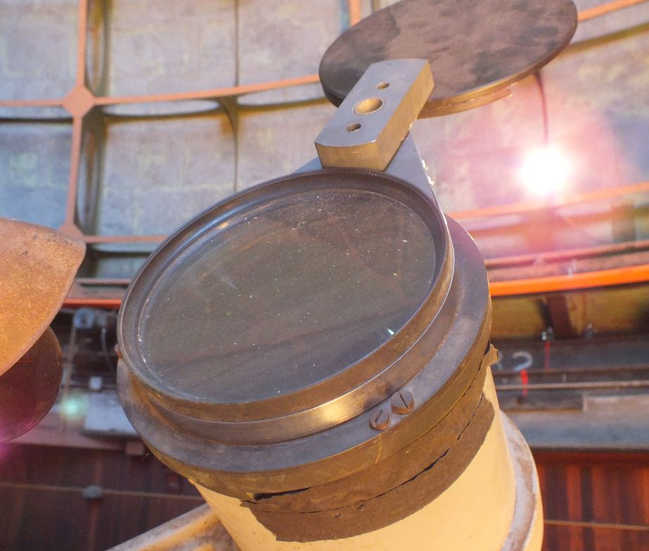

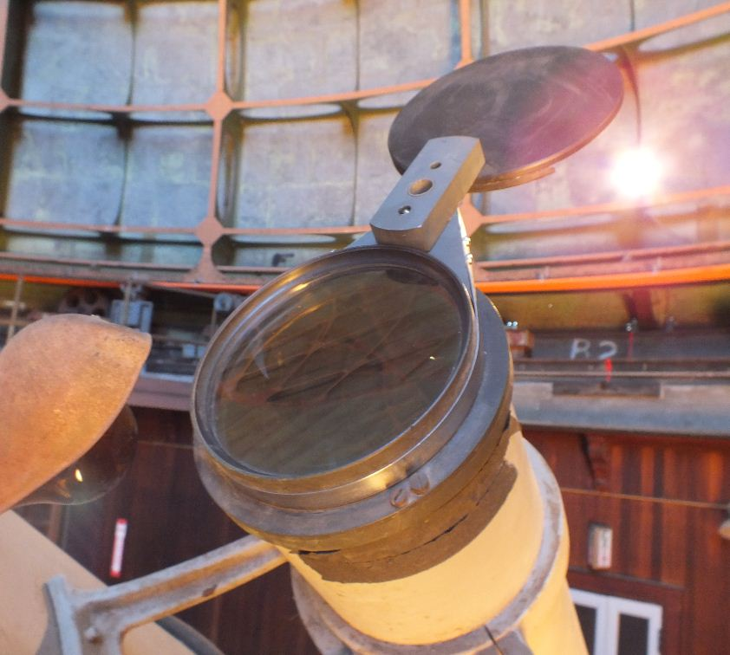

40” Telescope
When we got to the 40” telescope the offset diagonal mirror was out on the desk, in a wooden box. It was dirty and smudged but was not cleanable due to easy sleeking. The large diagonal mirror was also out in a box and was likewise too easily sleeked to clean.

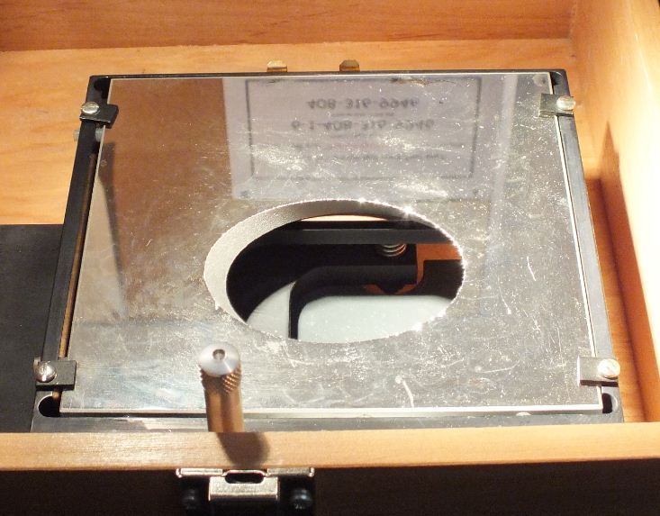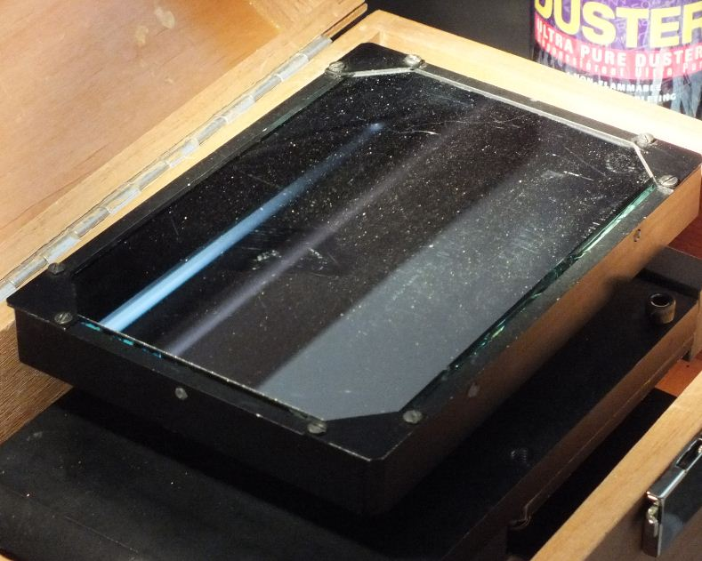

The eyepiece and a special solar viewer eyepiece (to be used on the 36” refractor for the transit of venus) were cleaned with ethanol.
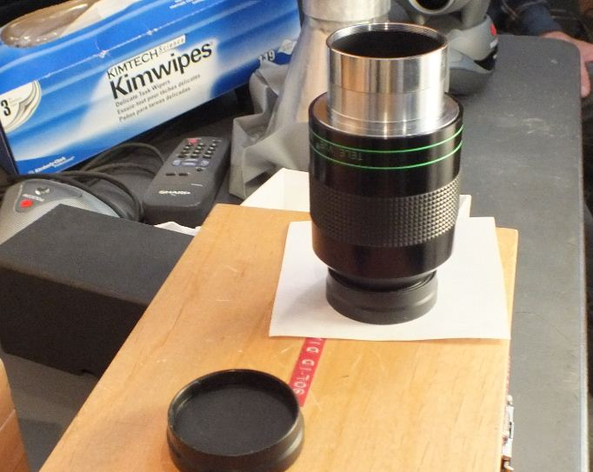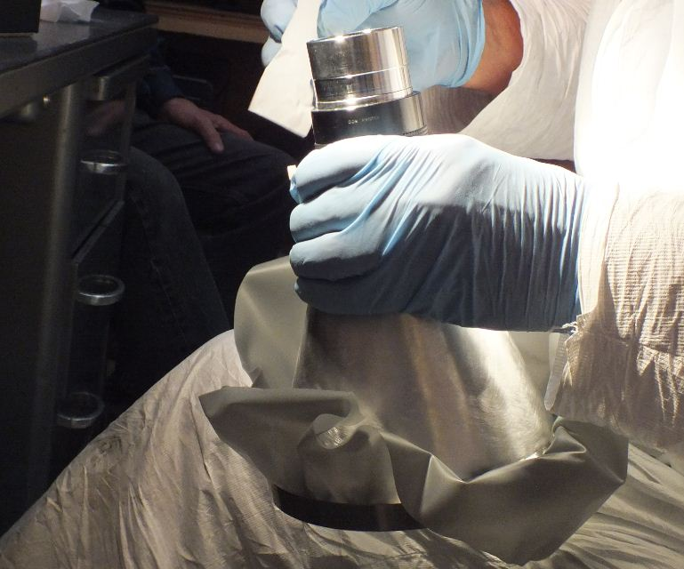

There were some flat mirrors in the tub beneath the 40” primary that were difficult but not impossible to access for cleaning. One was a narrow (1” x 5”) mirror that was dusty before cleaning. Dave had cleaned the primary mirror on our last trip, so we didn’t address it this time. It was discovered on that trip to have a large area of water damage on the coating surface.

