Mt. Hamilton Optics Cleaning Trip #12
David Hilyard and Brian DuPraw
2/2/12

Sample Rack
One of the tasks we wanted to accomplish was mounting a rack of coating samples in the dome of the 120” telescope so we could see how they fared over the months or years in a real-life environment. It had previously been determined that putting them on the mezzanine, over the elevator was a good out-of-the-way spot, so we mounted the rack to a railing, sticking out towards the center of the dome. The assembly that Jim had constructed held the samples at the preferred angle, with samples installed on both sides of the rack.

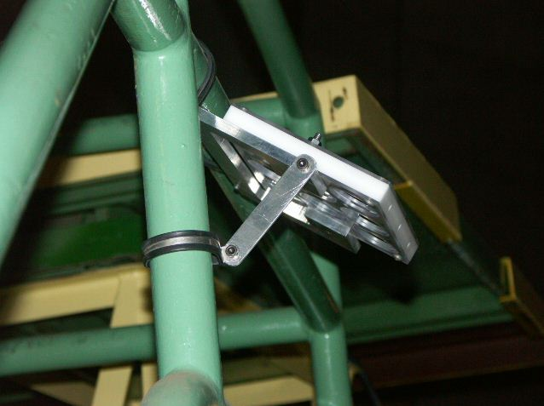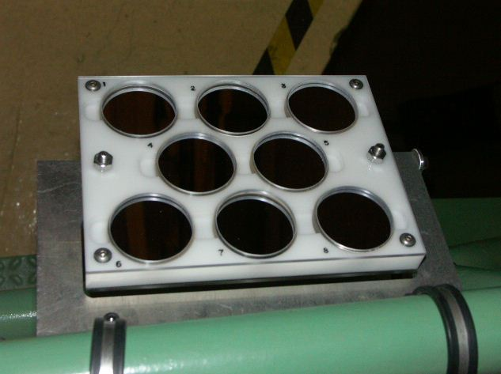

Coude Secondary
This is definitely on the list of optics needing to be re-coated. We measured 87% reflectivity in both the blue and red (relative to the reference mirror) but the surface is clearly degrading, rather than just being dirty.
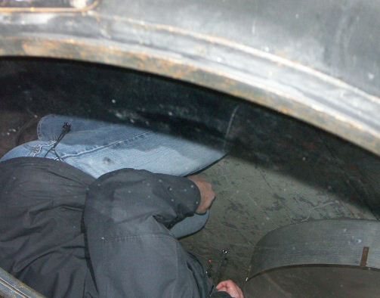
120” Primary
The Shane 120” Primary had developed a large oil spot (1’ diameter). Dave was able to clean it with ethanol while stepping on an earthquake clamp and holding on to one of the wedge-shaped cover pieces. The reflectivity was measured to be 96% Red and 94% Blue, compared to the reference. It was measured in an area that hadn’t been covered with oil.

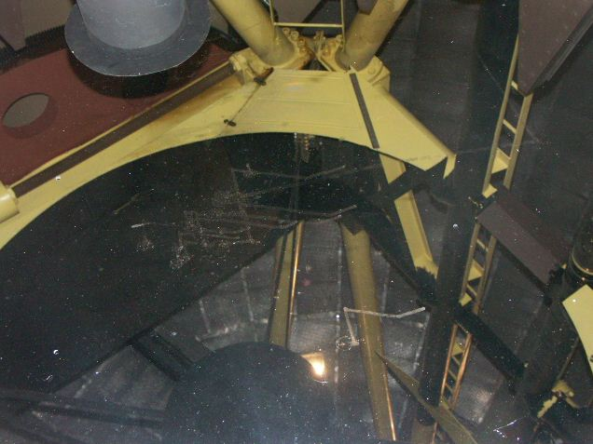
Oil Spot

Dewar #9
This was the only Dewar in the “nursery” and was dusty but Dave cleaned it with ethanol and acetone.
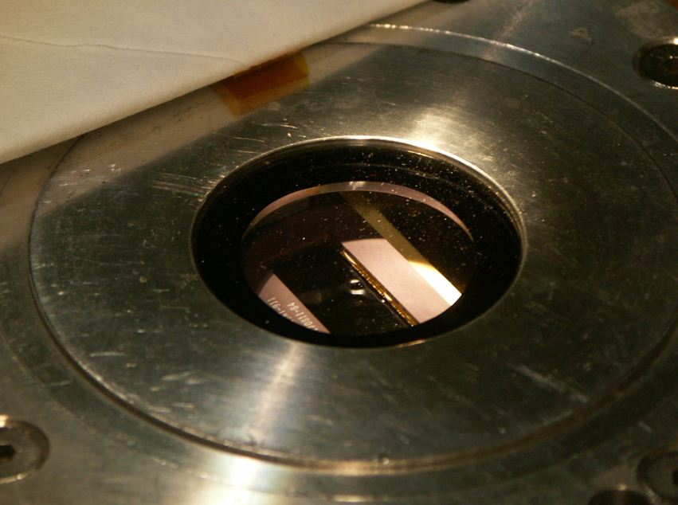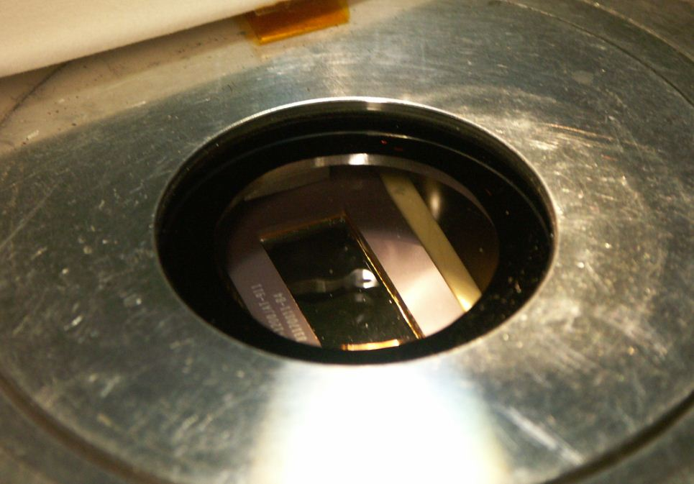

CAT Optics
Dave cleaned the Coude Auxiliary Telescope mirrors. As usual, the primary was very dusty since it is an upward-facing mirror. Dave cleaned it by first blowing it off with canned air, then spraying and dabbing with distilled water followed by ethanol. After cleaning the reflectivity was greater than that of the reference mirror in both the red and the blue. The fold-flat, at a 45 degree angle, was cleaned in select spots, not the whole surface. Afterward it measured 86% reflectivity in the blue and 88% in the red.

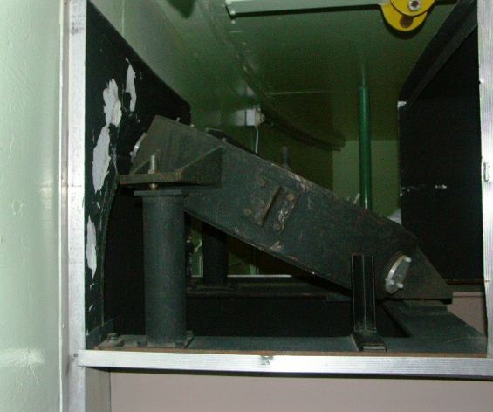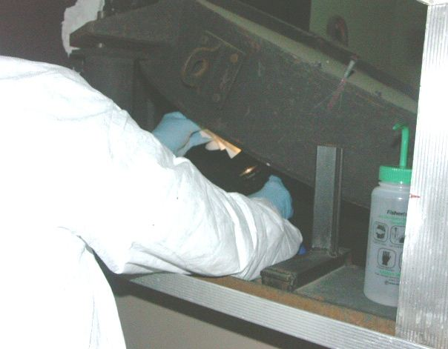

While the downward-facing secondary was not too dirty, it nevertheless has a historically-low reflectivity, this time measured to be 70% in the blue and 51% in the red.

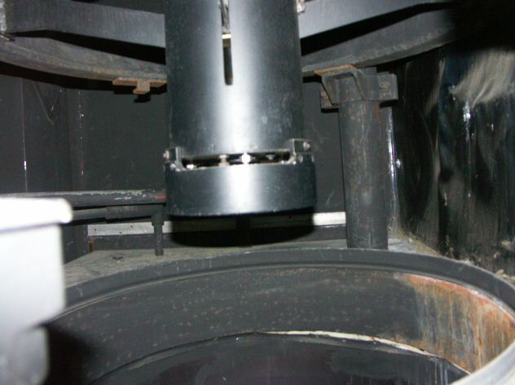

The siderostat, outside in the shed, was dirty and showed rivulets from dried condensation. Dave cleaned it by dabbing at the sprayed-on distilled water, followed by an ethanol wipe. After cleaning the reflectivity was 92% in the blue and 88% in the red.

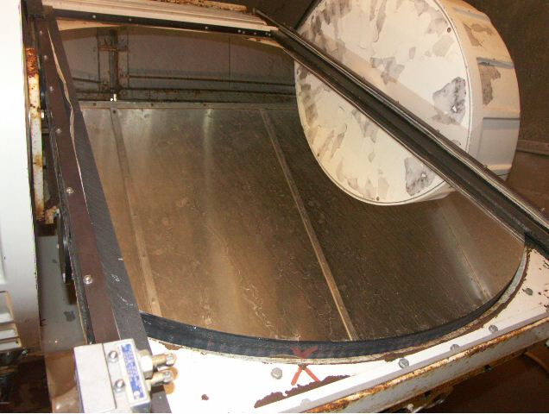
Dried Condensation

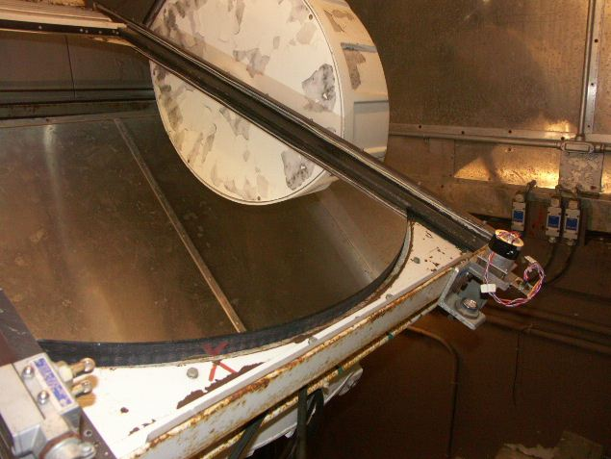

KAST Gratings
The gratings all had scratches of varying severity, but all that could be done was to dust them off with canned air due to their fragile nature.
Box 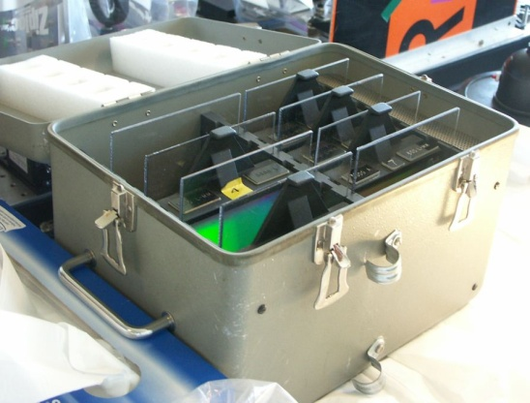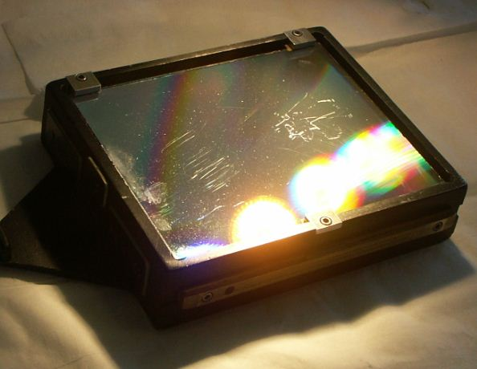 Grating 1

2 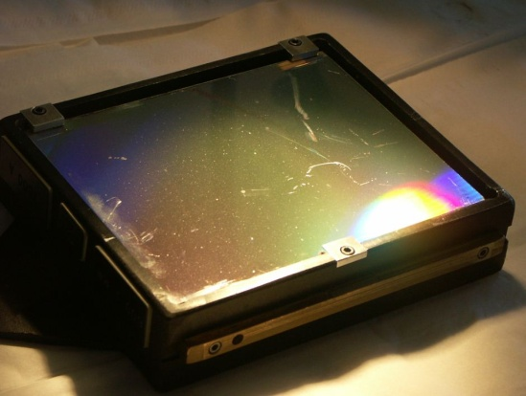 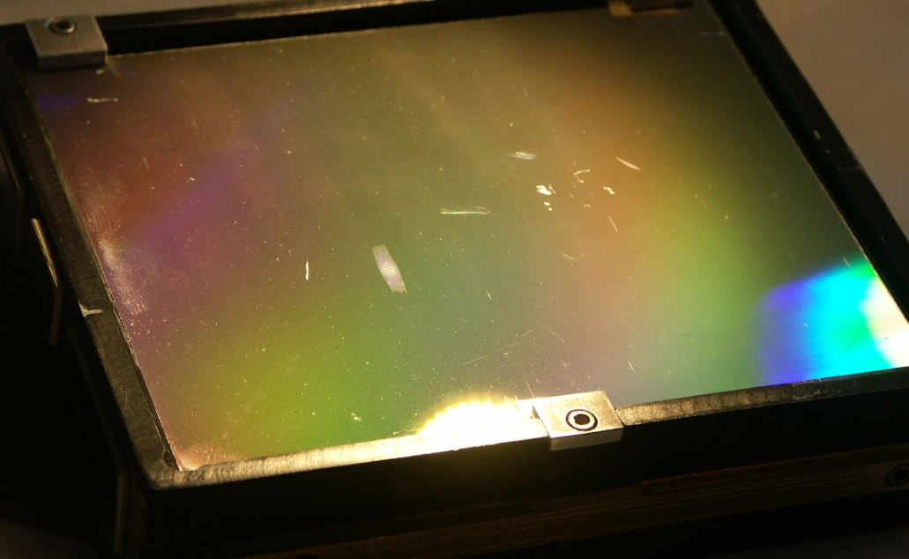 3

4 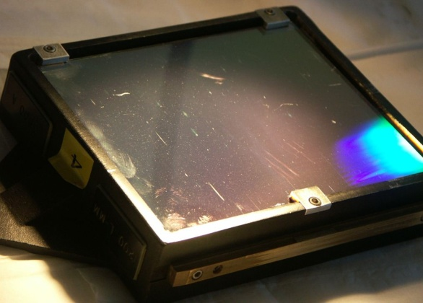 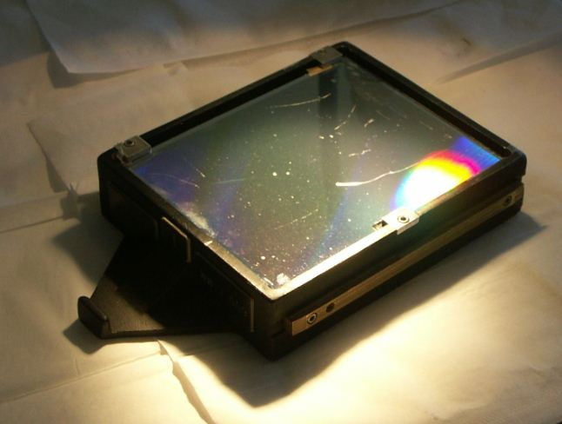 5

6 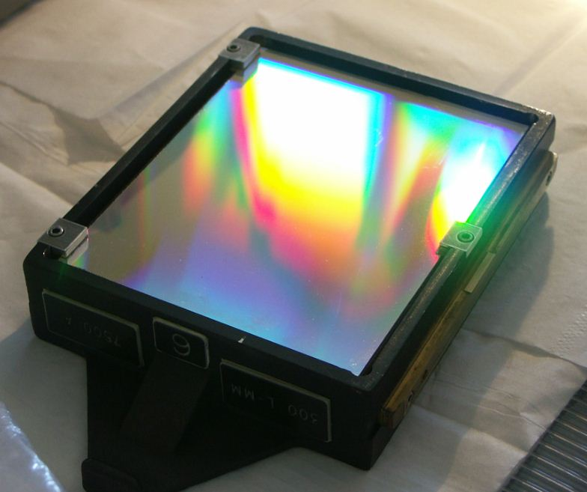 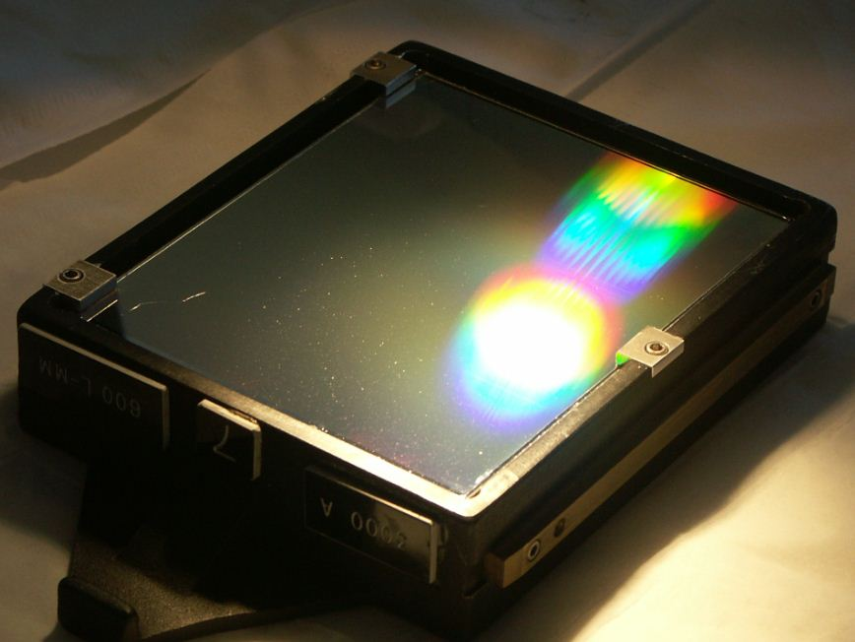 7
The rectangular mirror was robust enough to clean but didn’t show much improvement.
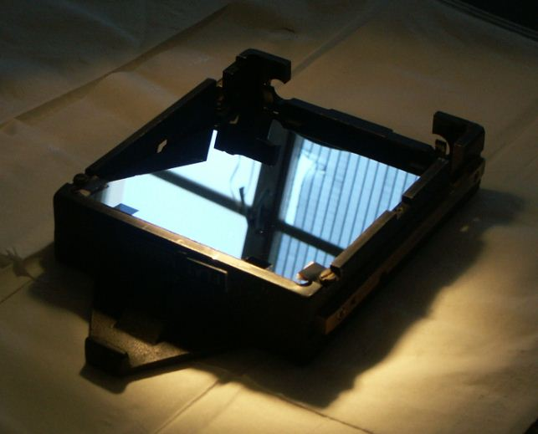

KAST Dichroics
The 4600 A filter was not too bad, except for a fingerprint on the back side of the thick glass. Dave cleaned that off, then cleaned the front side, with little further gain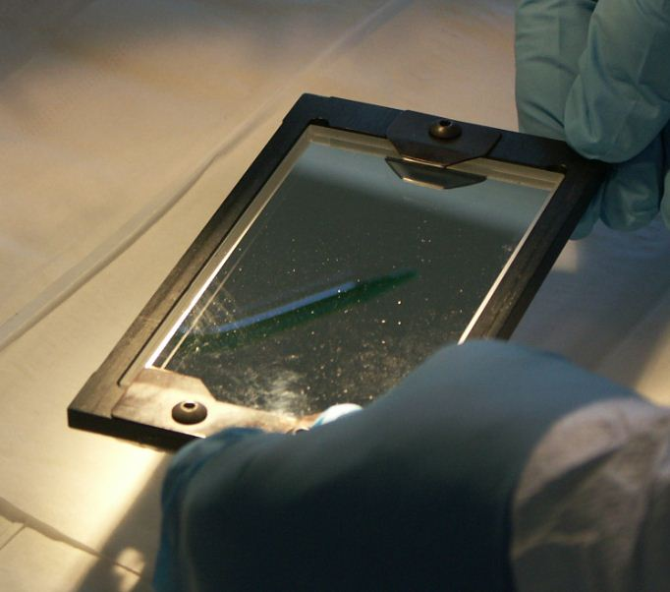 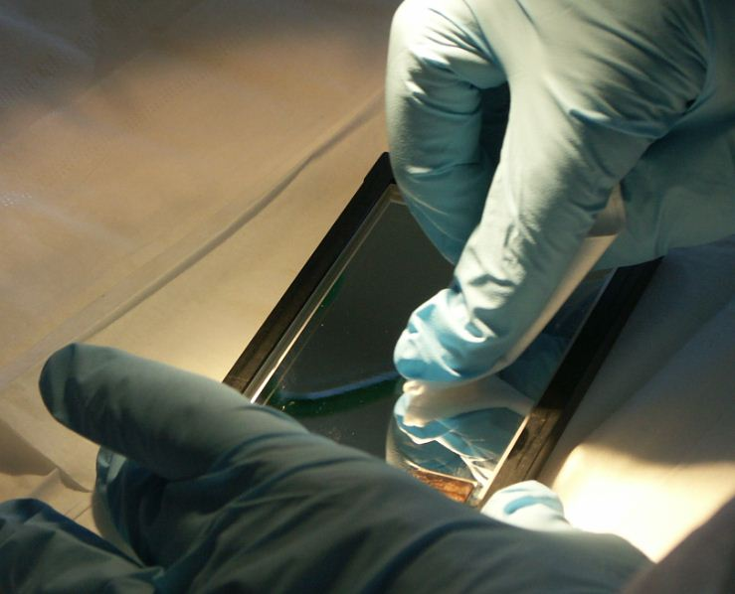

. The 5500 A filter was dusty and dirty. Dave cleaned it with ethanol.
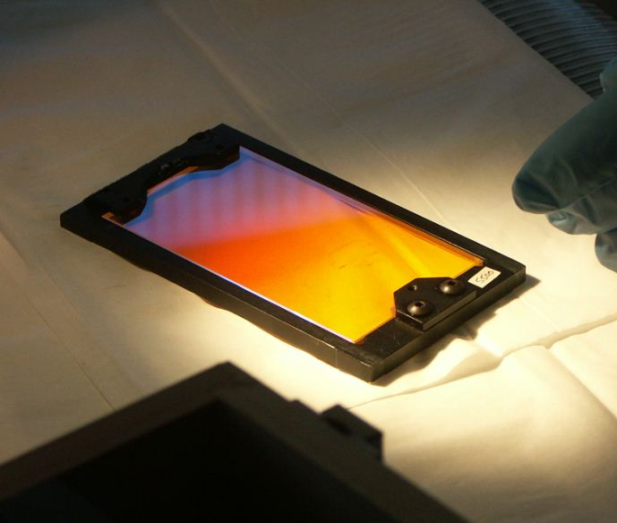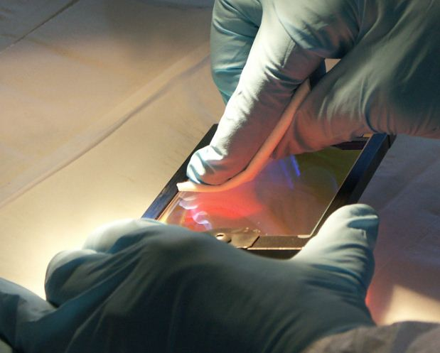

The Red Collimator mirror was very dusty and had some sleeks. Dave cleaned it with breath and ethanol.
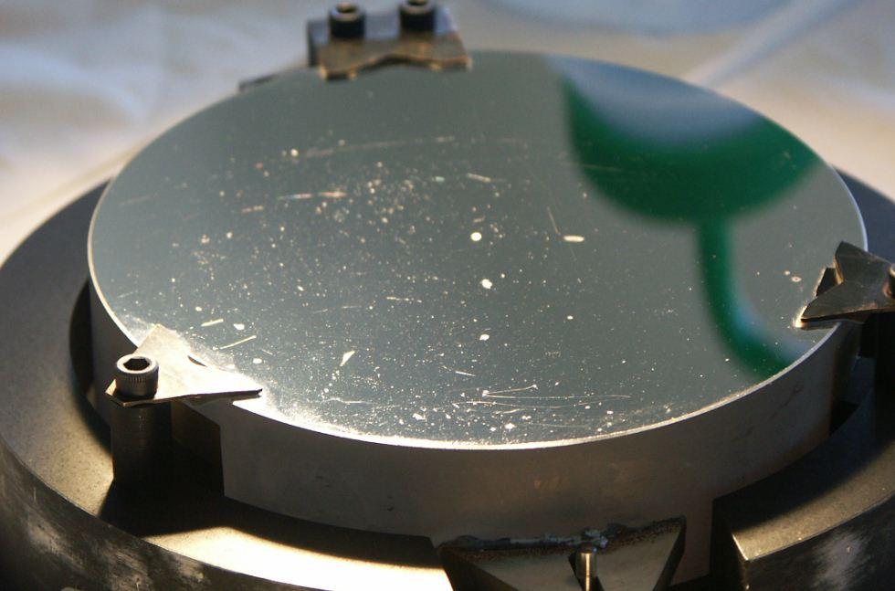
KAST Filter Wheel
There were two surfaces to clean on one side of the wheel; they were both plastic so should only be cleaned with water. When the wheel was turned over there were several accessible filters that snapped easily in and out of the wheel for cleaning.
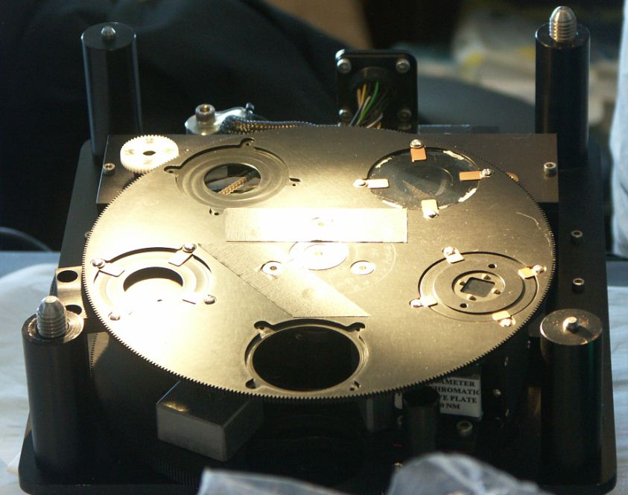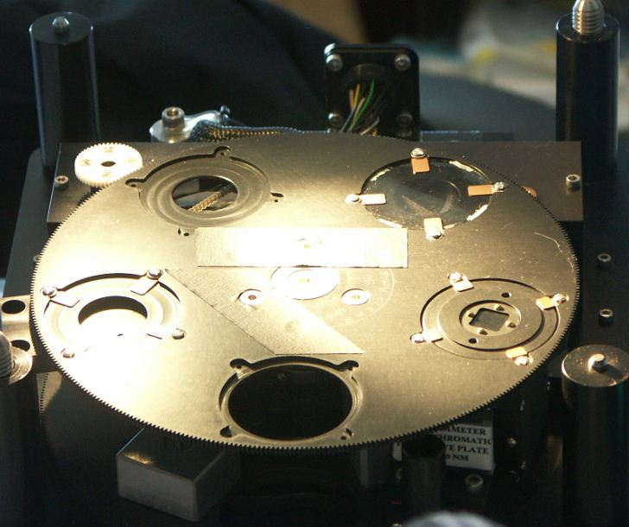

KAST Instrument on Telescope
There were a number of optics that were reachable with the KAST instrument still mounted to the tub beneath the 120” telescope. To the left, looking in, was the blue collimator mirror, which required a little contortion to reach.
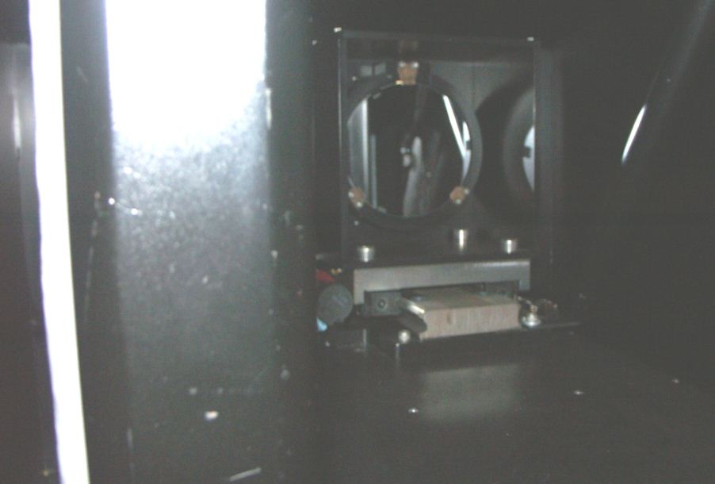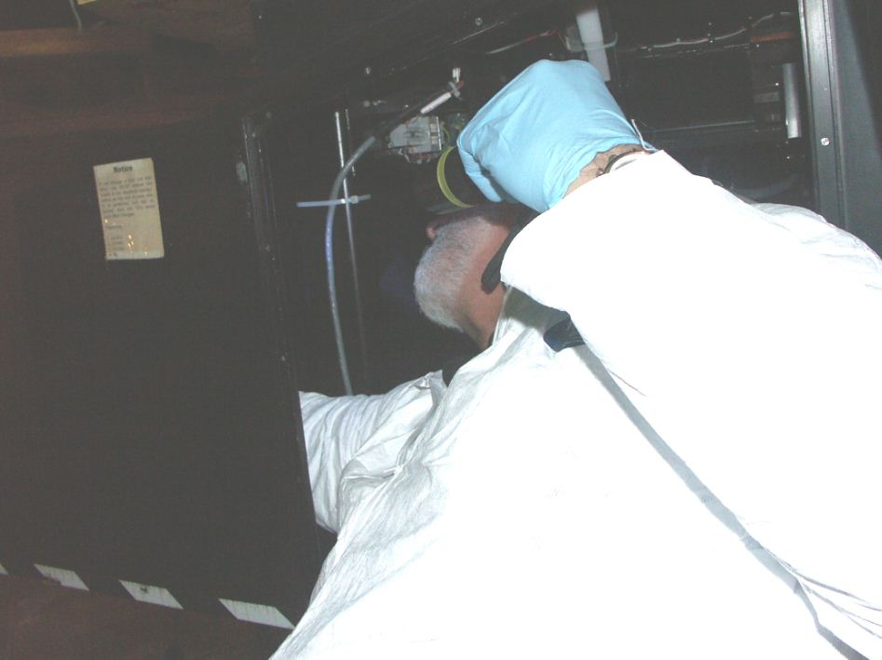

There was a large filter wheel ahead right that could be rotated by hand to clean the filters and also to expose, through an empty filter slot, a cleanable lens.
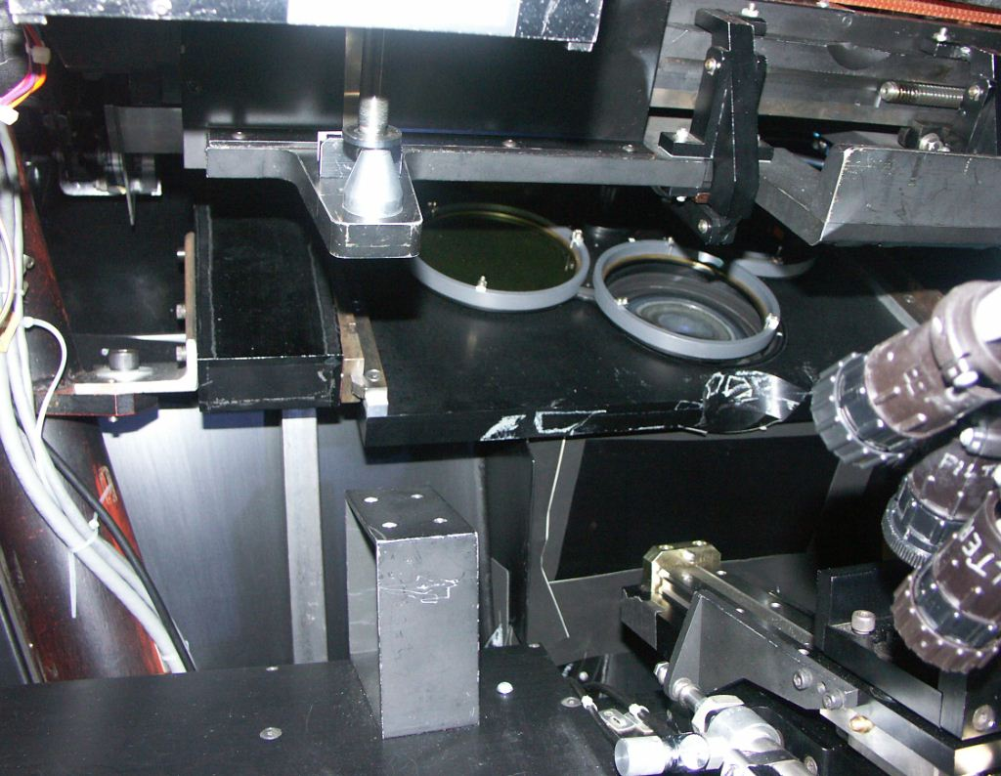

There were also blue grisms (grating/prisms) to the right side that could be inspected and blown off but not cleaned with liquids or physical contact.
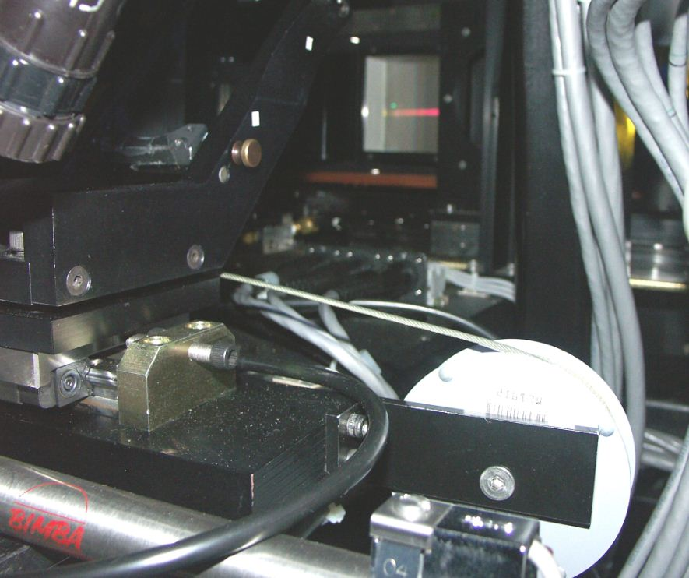

Gemini Instrument
In the anteroom off the main floor of the dome where we often clean KAST optics the Gemini instrument was parked. Dave cleaned one optic, accessible through the round cover in the top surface.
