Mt. Hamilton Optics Cleaning Trip #9
David Hilyard and Brian DuPraw
9/14/11

KAST Gratings
The KAST flat mirror and gratings were examined in a side room of the 120” dome. The mirror had existing sleeks and a smudge that Dave was able to wipe off.
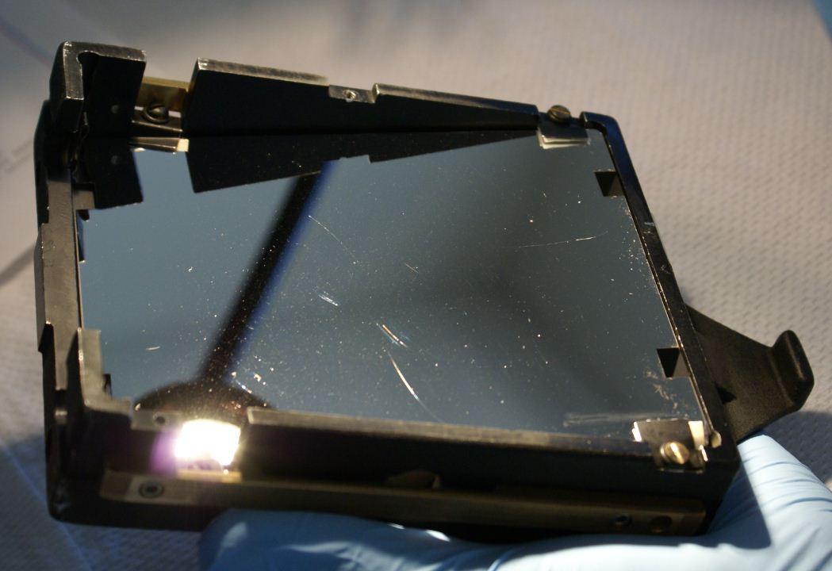

The gratings ranged from terrible to moderately poor, as shown in these photos:
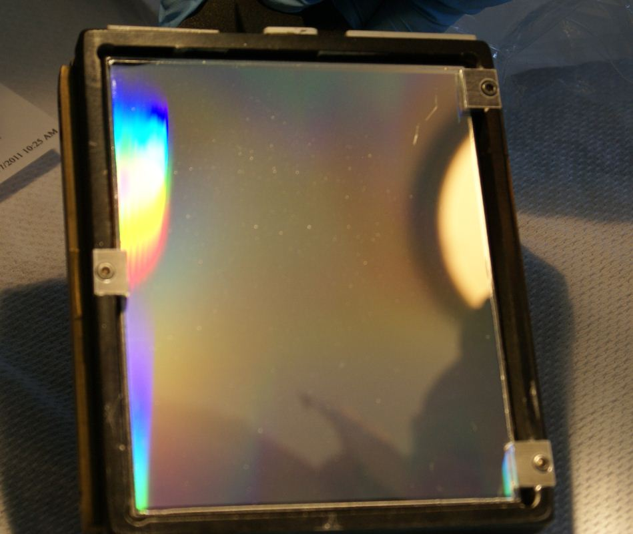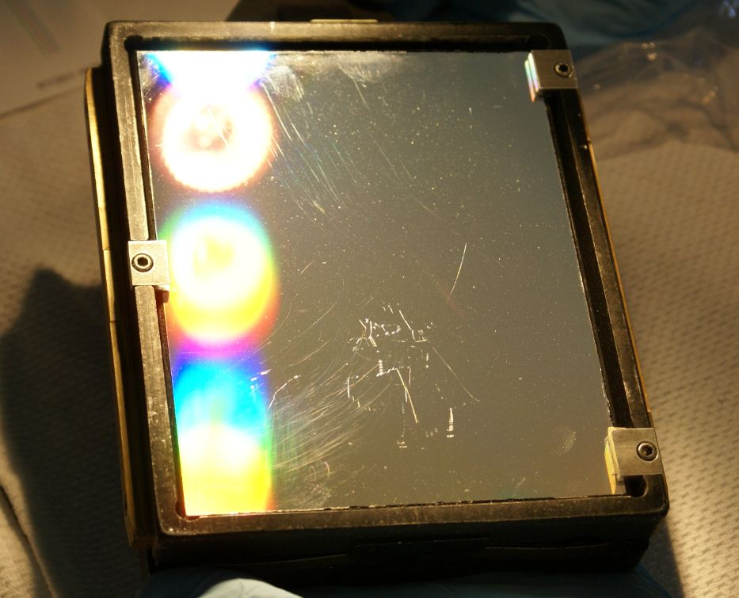
KAST Grating 7 KAST Grating 6

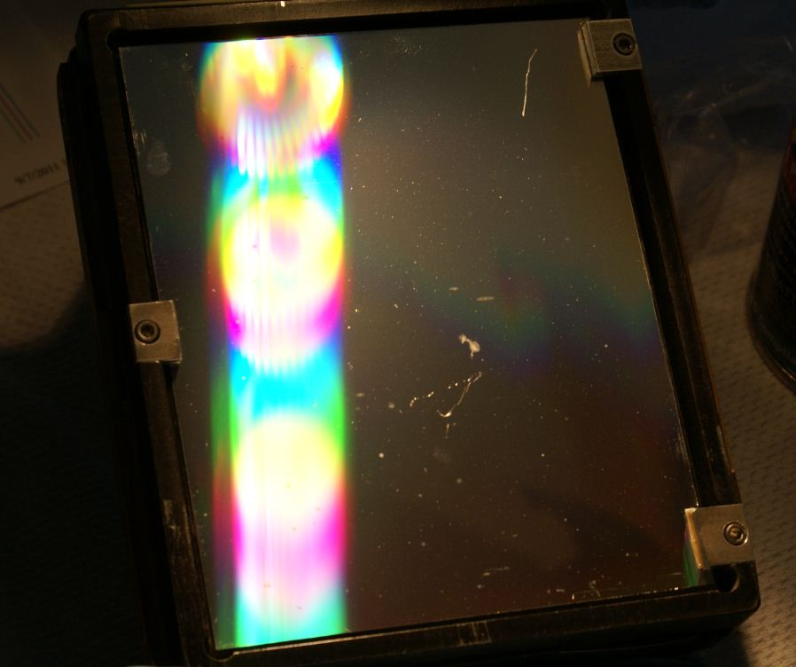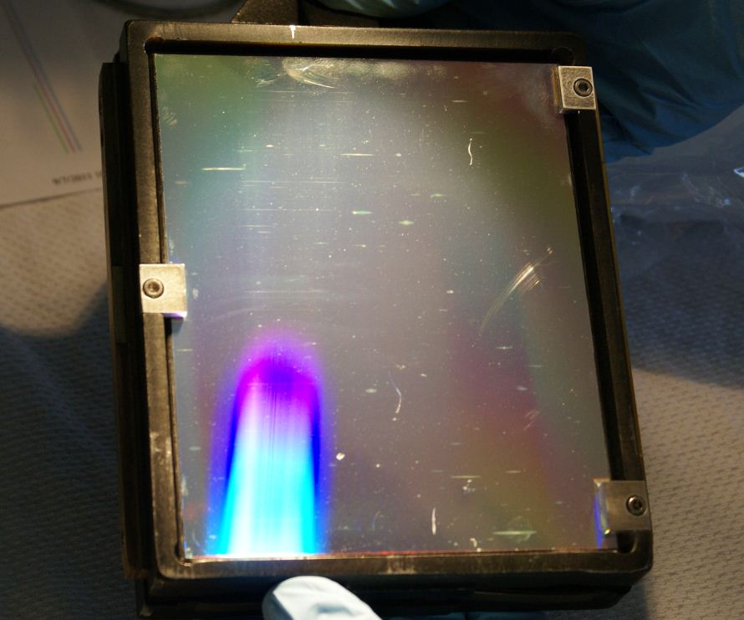
KAST Grating 5 KAST Grating 4

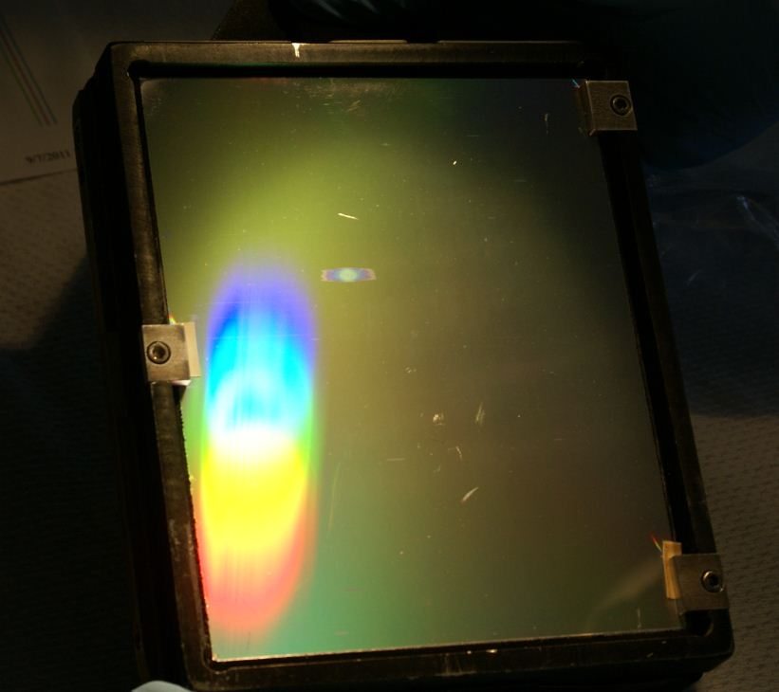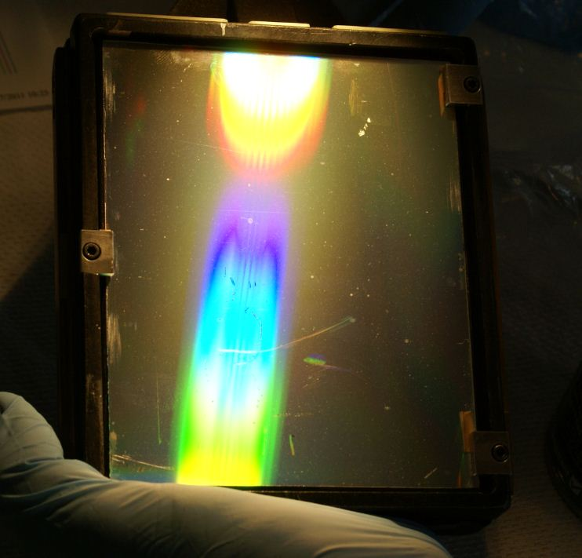
KAST Grating 3 KAST Grating 2

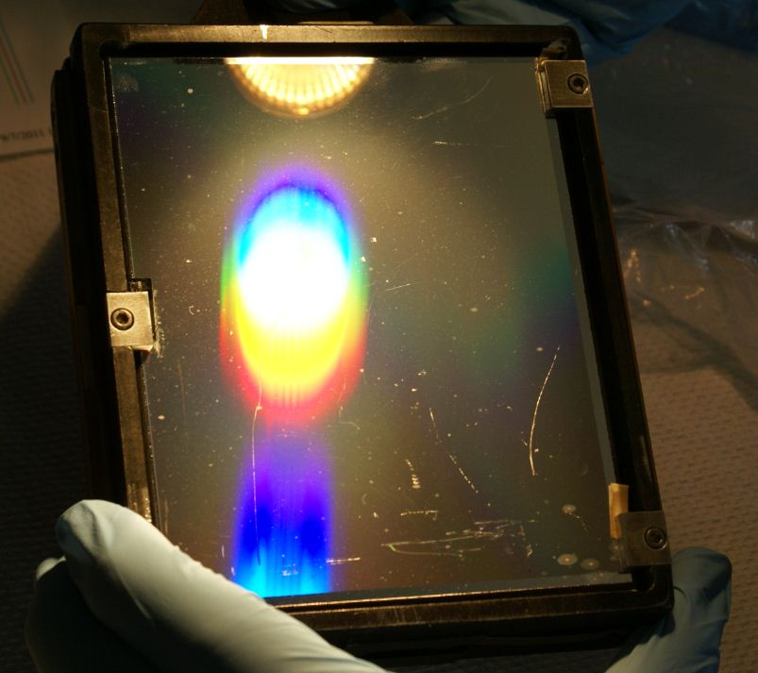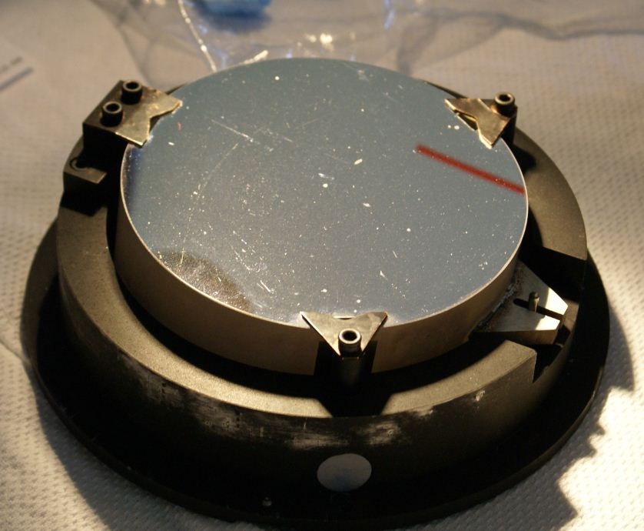
KAST Grating 1 Red Collimator

KAST Dichroics
The KAST dichroics were mostly just dusty and dave clened them with breath and ethanol.

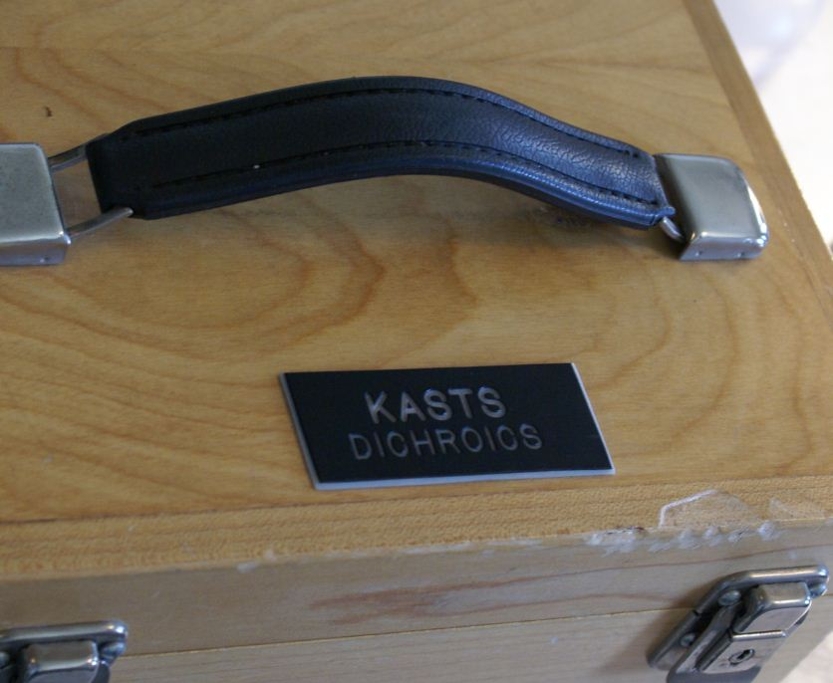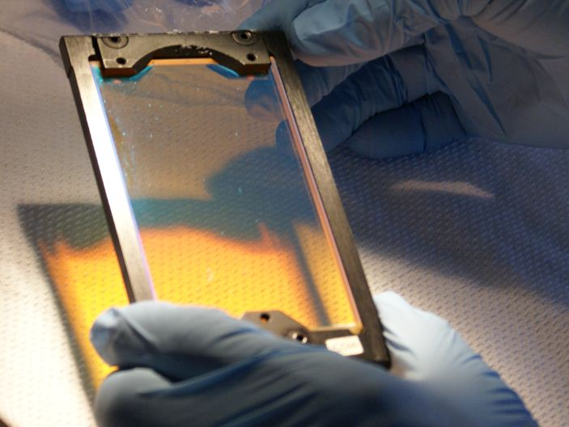

We went up on the lift to the KAST instrument mounted on the bottom of the 120” telescope. Dave blew the dust off some filters in a wheel, turning it by hand. He was able to wipe a lens by reaching through an empty filter slot. Kostas uncovered a camera lens (Blue side?) that Dave was able to clean.

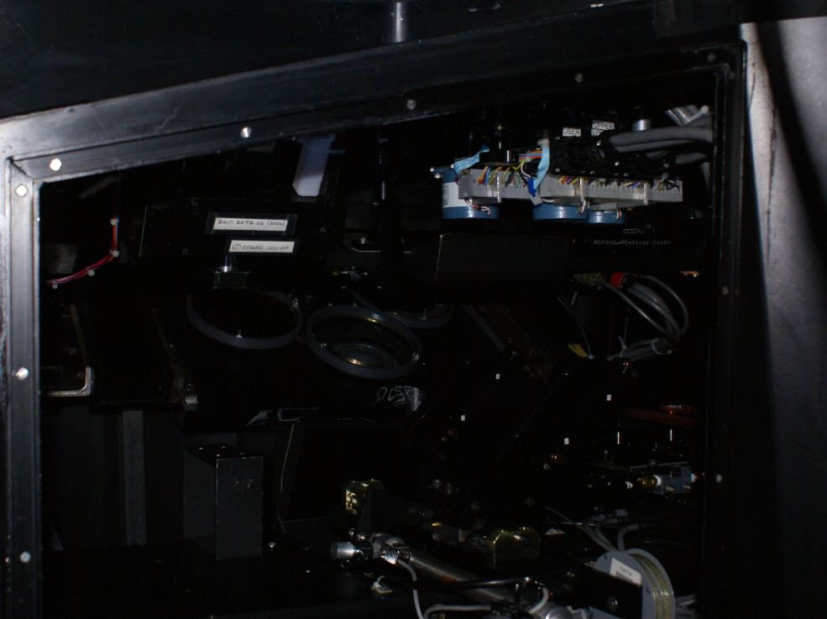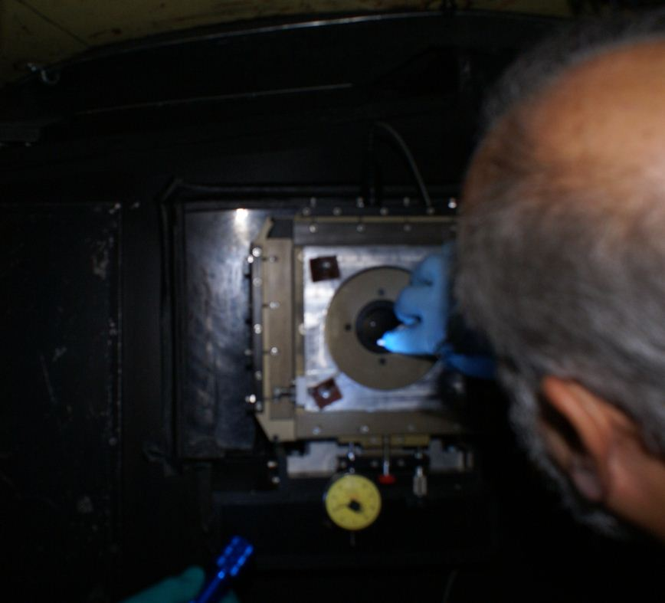

Dewar Nursery
The Dewars on the bench (the nursery) were dusty and Dave cleaned them with ethanol followed by acetone. He cleaned Dewar #9, #8 and the red side camera Dewar, I believe.

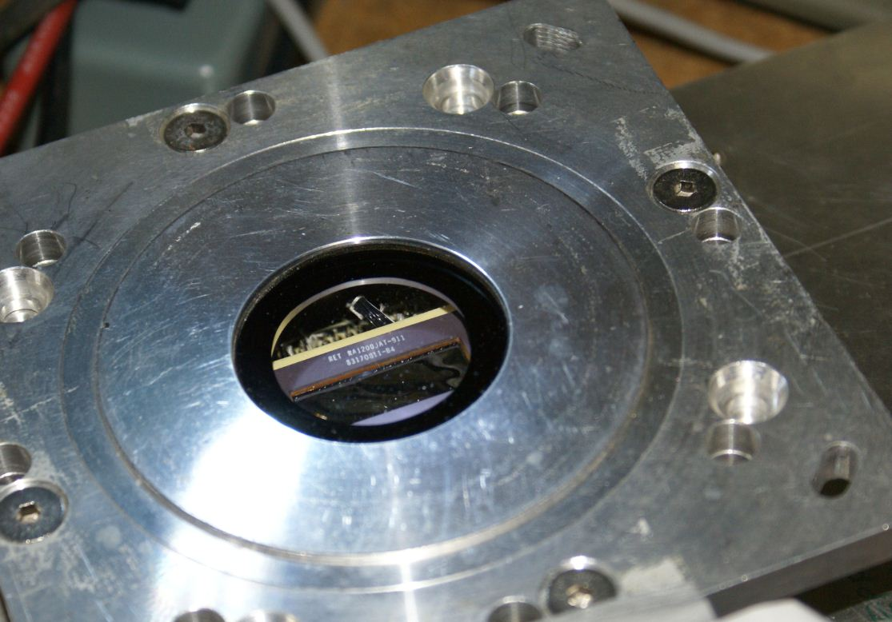

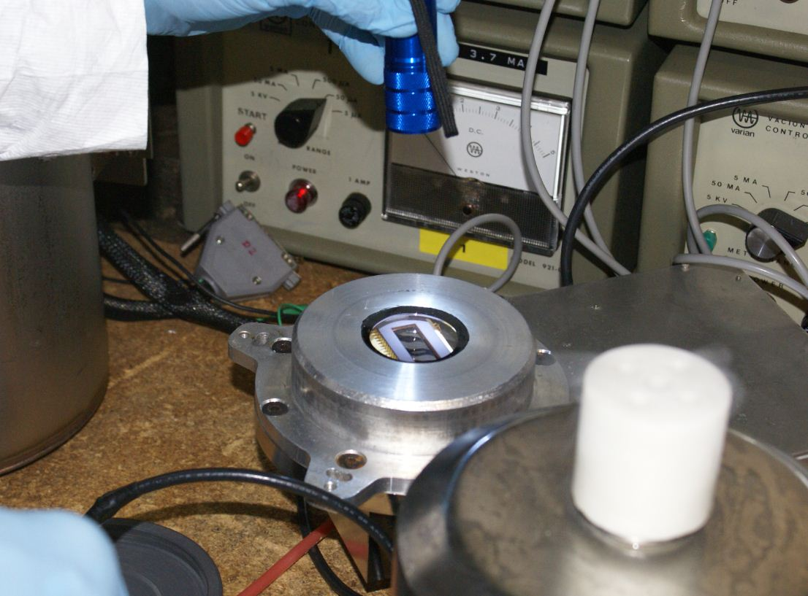

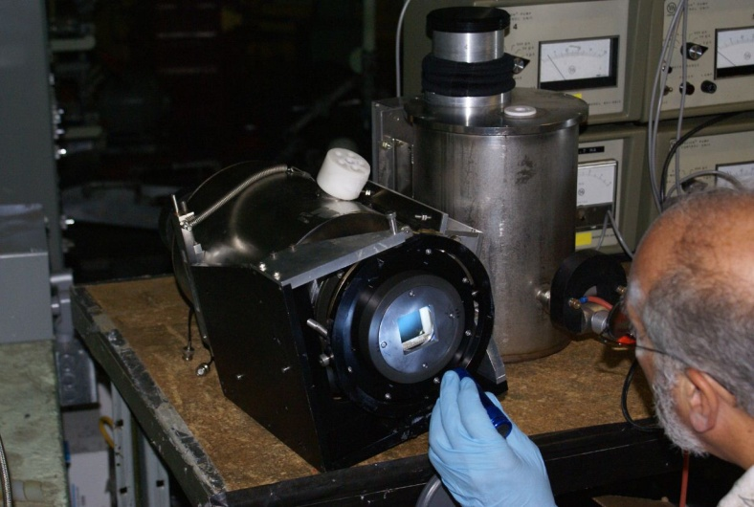

Slit Room
In the slit room Dave blew off the Hamilton guider filters and inspected a small pickoff mirror using an inspection mirror Kostas provided.
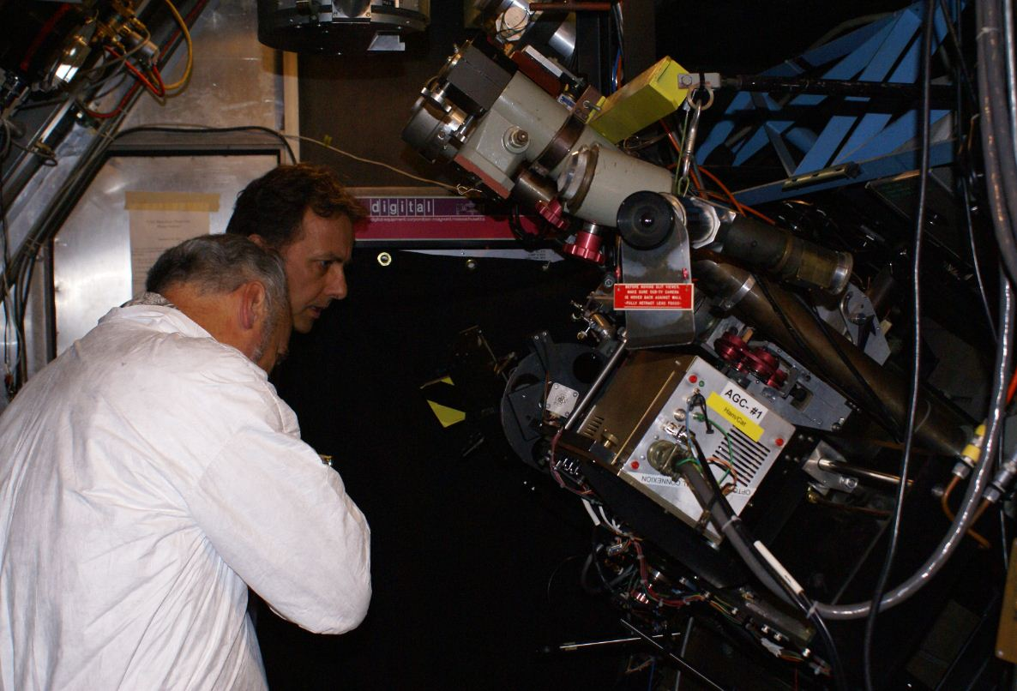

Hamilton Collimator
The collimator mirror, already looking poor on the right side, appears to have developed some new degradation covering maybe 15% of the surface near the top.
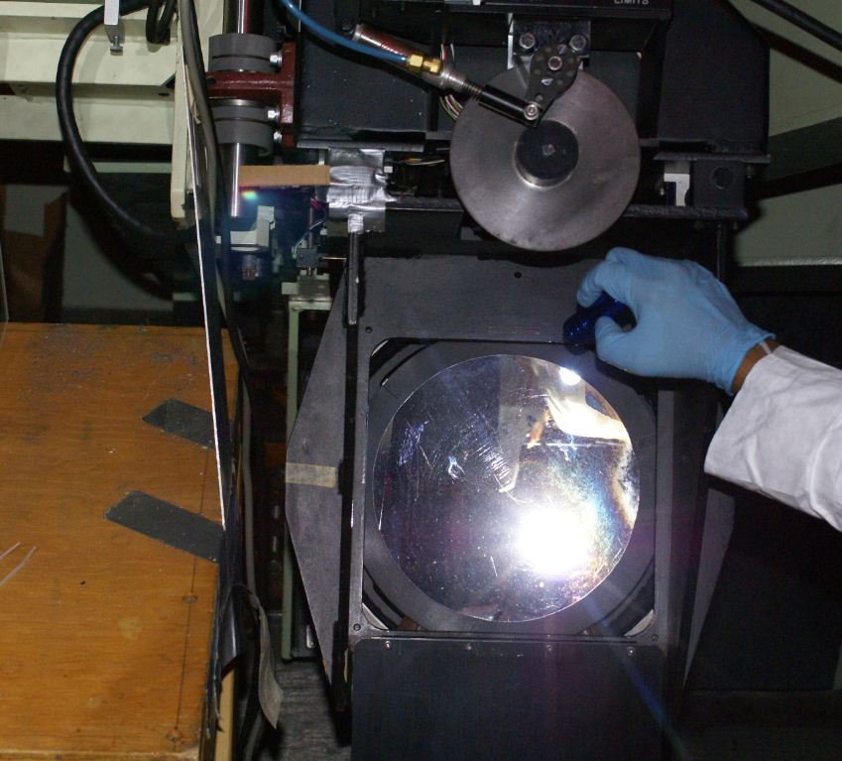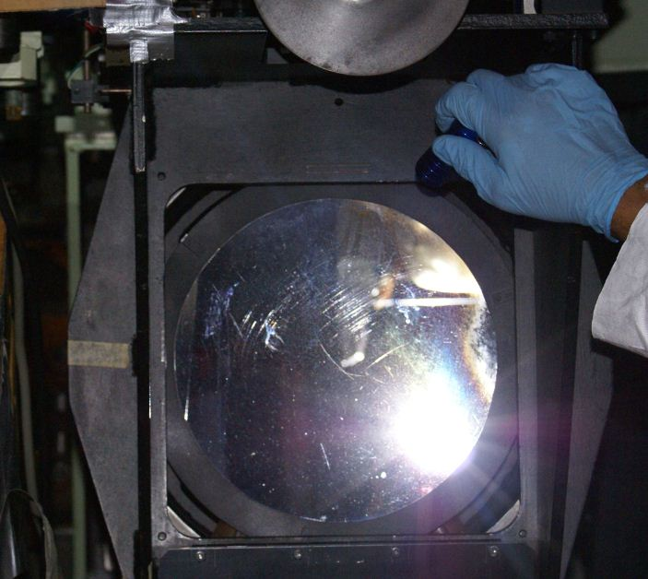

The prisms looked okay but there was a chip in the knife edge of one mirror. In general it was not too bad and Dave blew the dust off what he could.
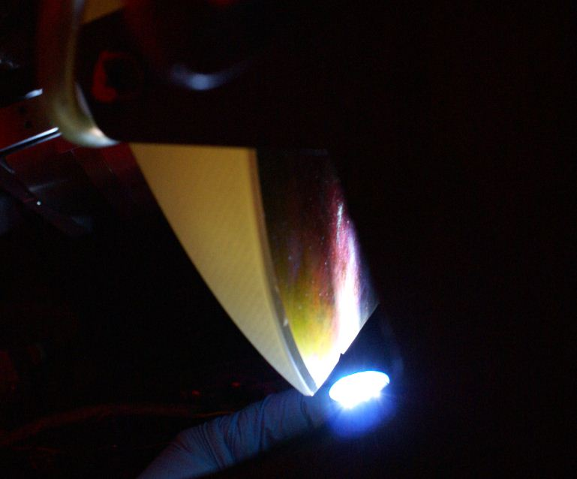

120” Telescope Siderostat
The siderostat, outside the 120” dome, was fairly dirty. Dave cleaned it with distilled water from a spray bottle, and then the distilled water plus ethanol while it was still wet. It cleaned up well, as the before-and-after photos show. Dave started at the top and worked his way down.

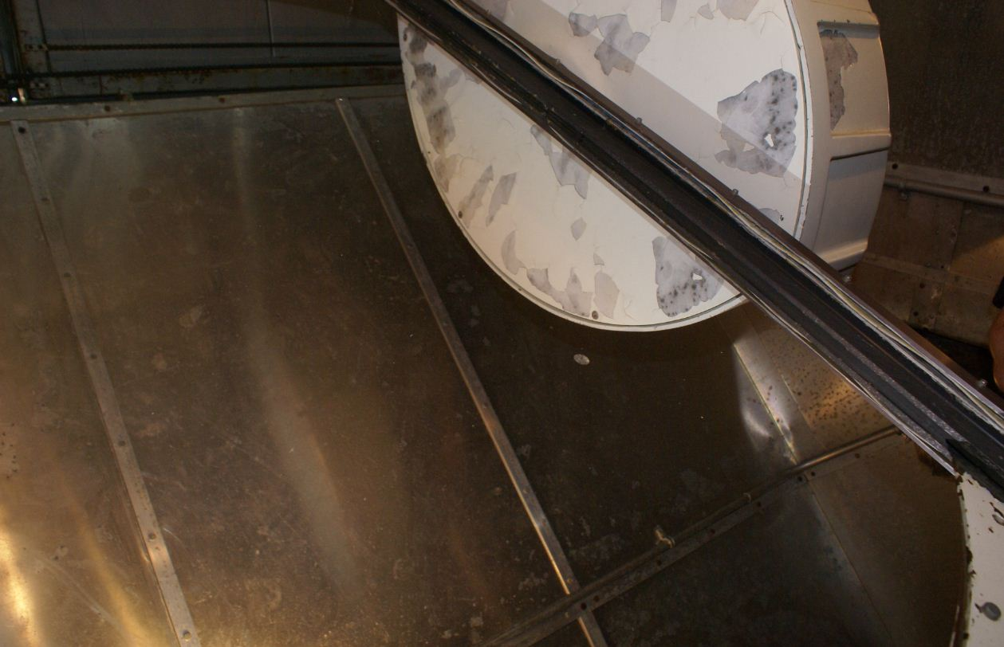

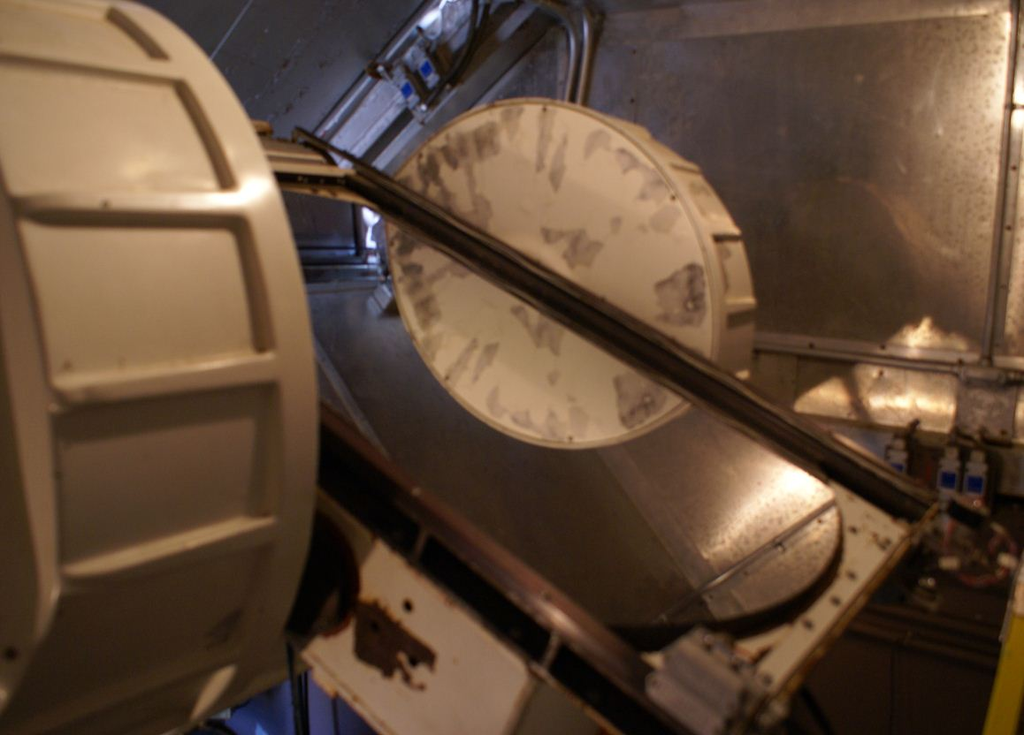

Coude AuxiliaryTelescope (CAT)
Dave cleaned the upward-facing primary mirror, which tends to get dirty quickly.

120” Telescope Cassegrain Secondary
This secondary was known to have surface degradation that was not cleanable. We measured it near the center to have 94% reflection with the blue filter and 88% R with the red (relative to the reference mirror). Near the edge it had 88% reflection with the blue filter and 90% R with the red.

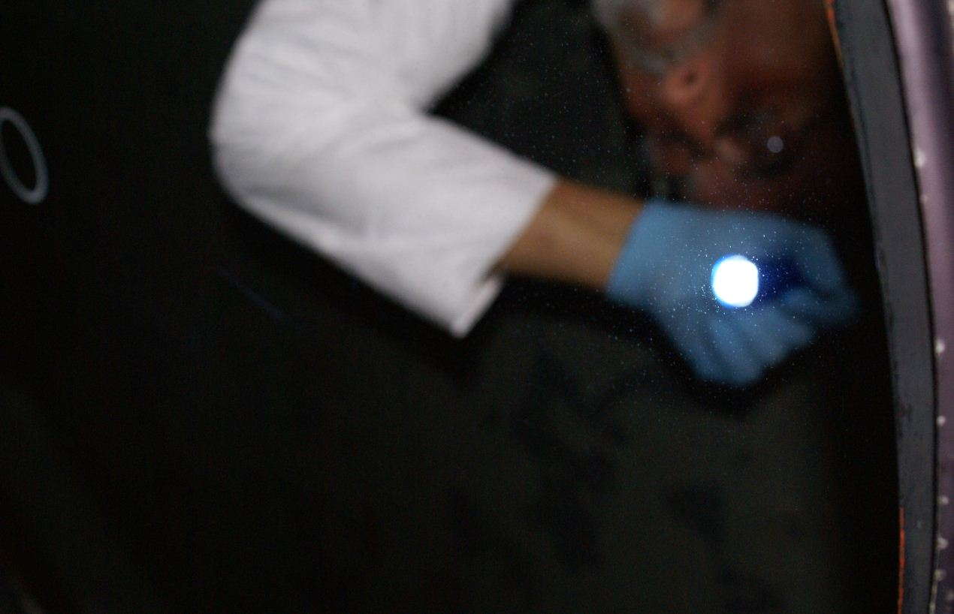

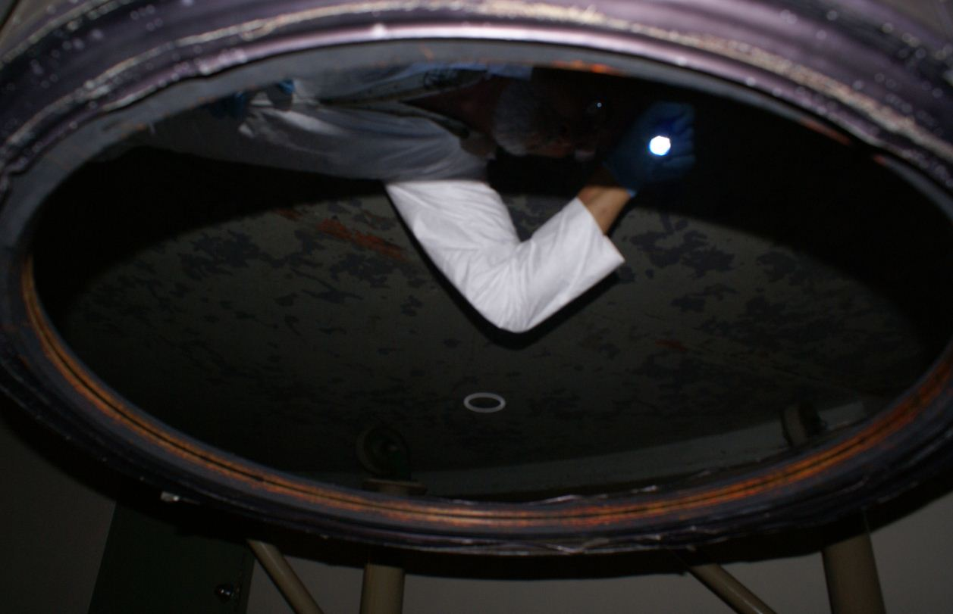

120” Telescope Primary
The primary mirror has been collecting oil spots… there were 16 of significance counted on this trip, more on one side than the other.

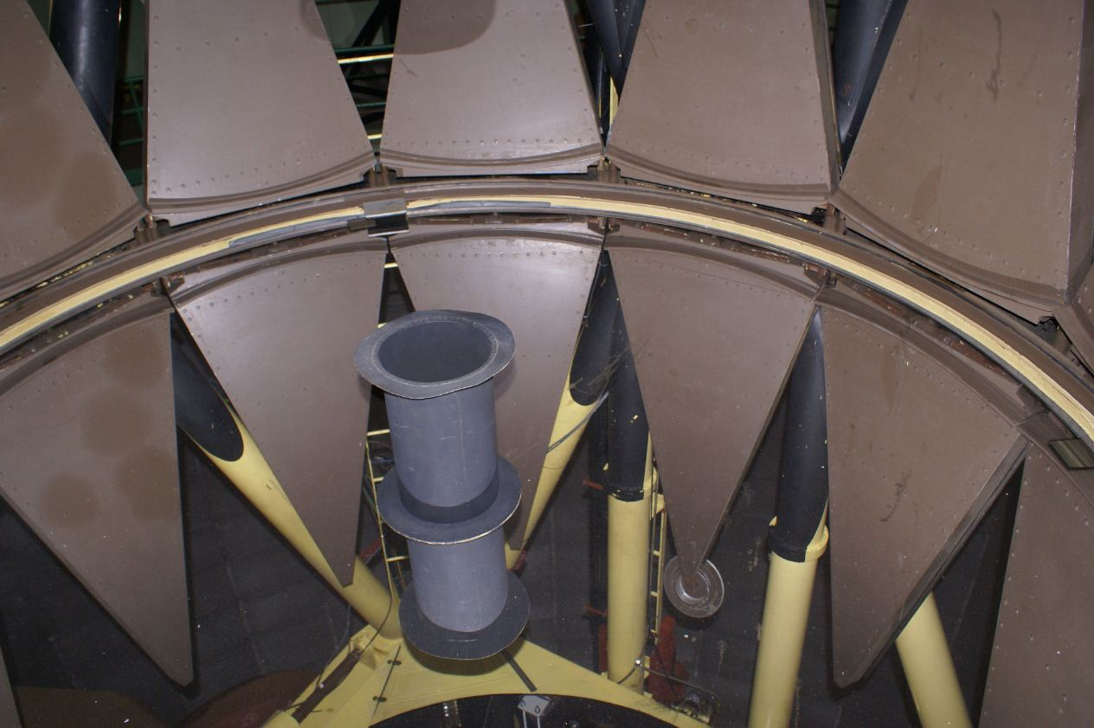

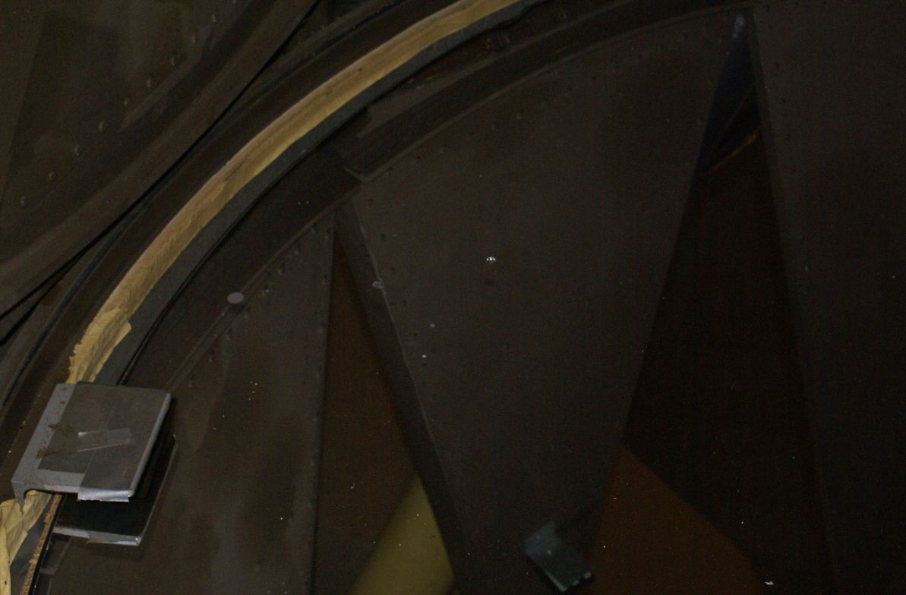

A possible source of the oil on the primary mirror is shown here:
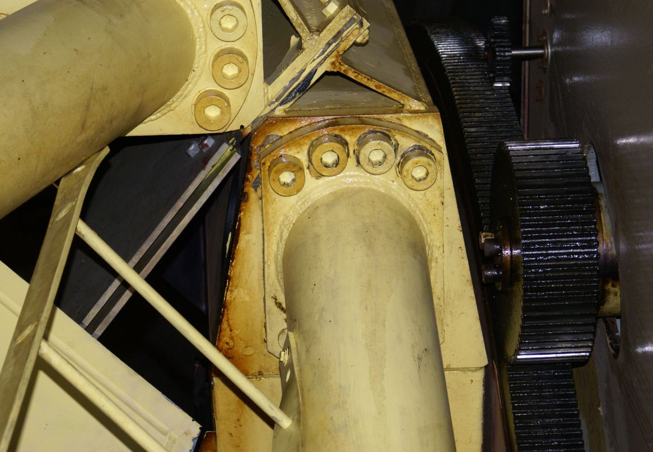

40” Telescope Filters
Donny let us in to the anteroom of the 40” telescope and got out two boxes of filters. Most hadn’t been used since the last time we were there, however, so were in good shape (each was inspected individually). Donny pulled the ones that were mounted on the telescope and brought them to us in the anteroom, as well. In addition, there was an objective and a folding mirror or prism.
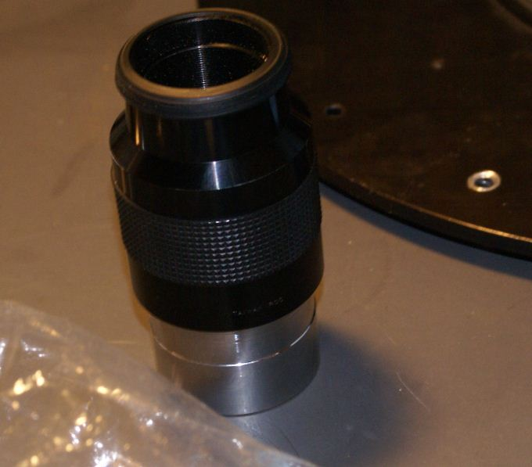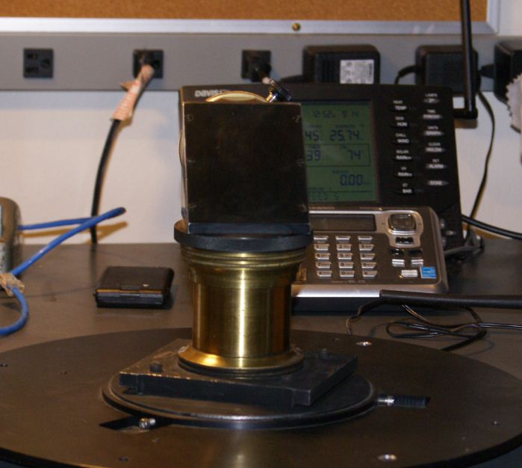

The 40” spectrograph (odd-shaped instrument about 4’ tall) was on the floor. The focusing lens had many fingerprints… Dave was able to access it from the side and move it by turning a wheel. After cleaning with breath and ethanol it was much improved.
The lower portion of the spectrograph contained three grisms (grating-prisms)… too fragile to clean with solvent but improved by blowing them off (see photos).

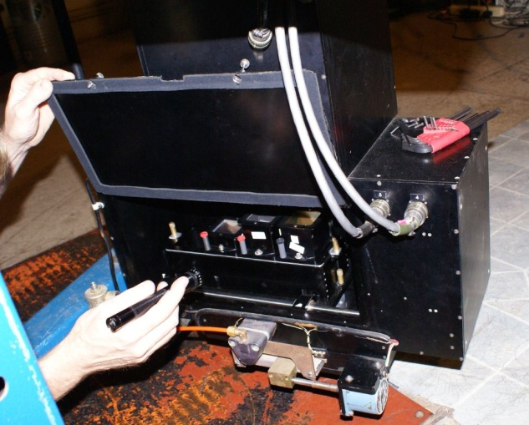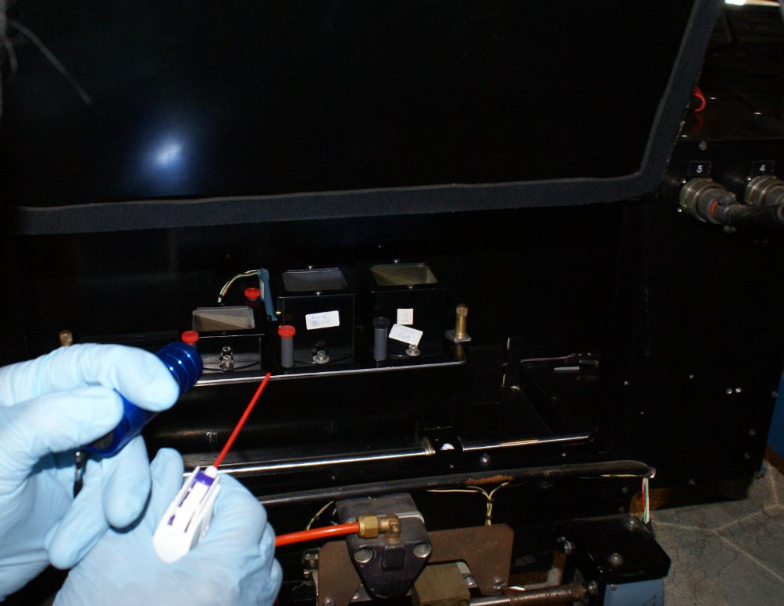

Dave also cleaned several mirrors and lenses located in the tub mounted beneath the 40” primary. One upward-facing rectangular mirror was very dirty.
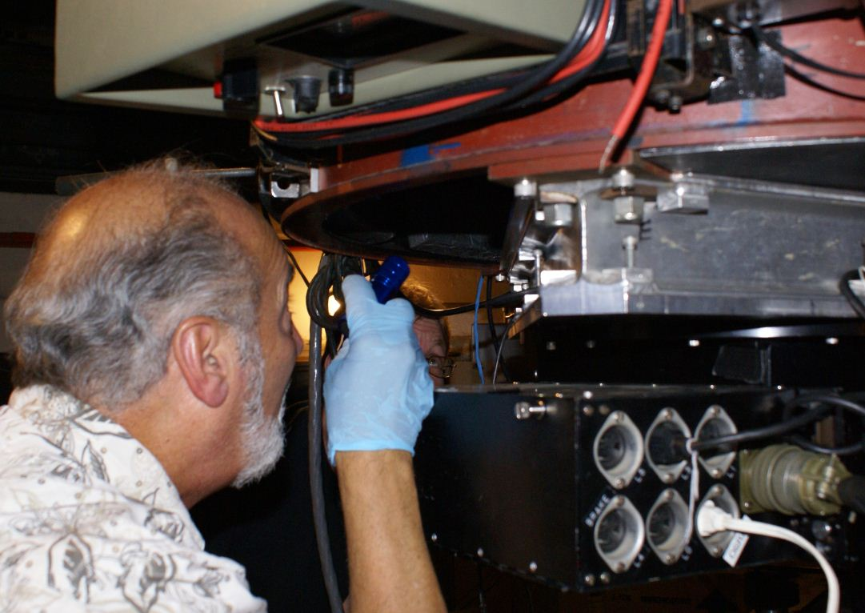

There was also an instrument standing by the dome’s entry-way with a very dirty lens (photos below). Dave cleaned it… a side panel allowed access to the lower surface.

