Mt. Hamilton Optics Cleaning Trip #6
David Hilyard and Brian DuPraw
4/5/11

Coudé #3
The first mirror that we inspected was the Coude #3, a 2’ x 4’ flat which is often on the dome floor but usually covered up. This time it had been made ready for us. It had a dust layer on it and Dave cleaned the whole thing with Orvus/acetone/water, followed by distilled water and then ethanol. It had a very robust coating that did not sleek, and cleaning made a noticeable difference. We measured the reflectivity before and after washing it:

BEFORE AFTER
Red Blue Red Blue
Top 82% 85% 85% 88%
Middle 93 96 92 99
Bottom 84 88 92 89

(numbers are relative to the standard witness kept with the reflectometer)

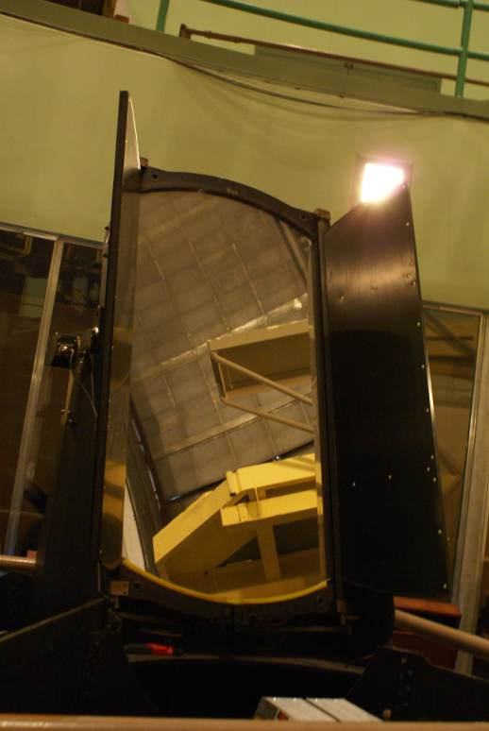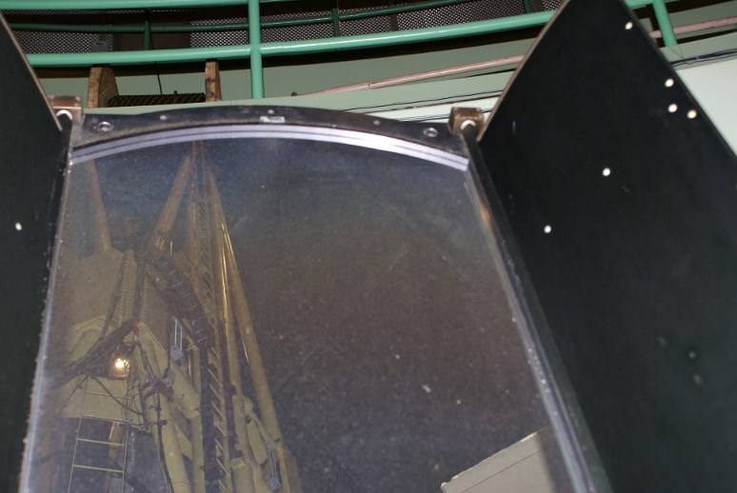
Coude #3 Before Cleaning Coude #3 Before Cleaning

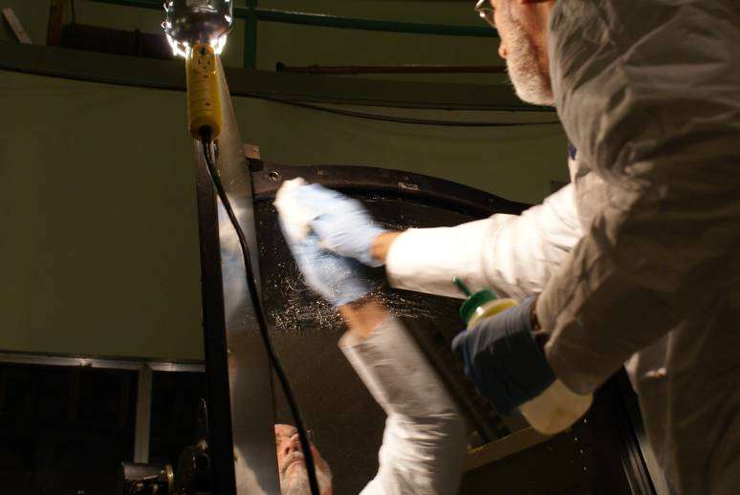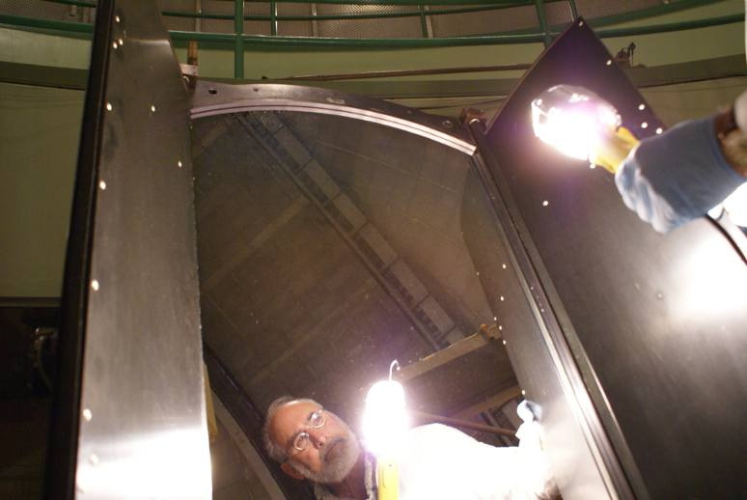
Coude #3 Cleaning Coude #3 After Cleaning

120” Telescope Cassegraine Diagonal Mirrors
There were two Cassegraine diagonal mirrors ready to look at. One was in a frame and labeled “Gemini” and “FliteCam” and that one was cleanable. It had what appeared to be an oil film on it and the ethanol used to clean it beaded up on the surface in an abnormal way. It looked shiny after cleaning, but had what looked like a non-optical surface, sort of orange-peeled. The reflectivity didn’t really change before and after cleaning. It was 77% with the red filter and 72% with the blue (73% after cleaning).

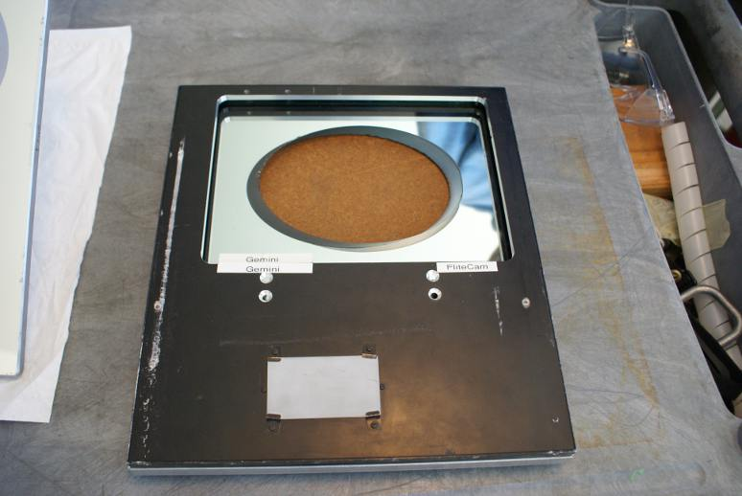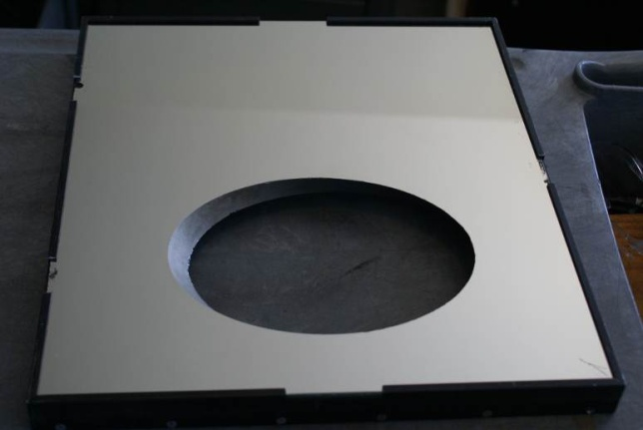

The other Cassegraine diagonal was not in a frame and not marked, but had a few dings and scuffs in the coating. Dave tried to clean it but it sleeked right away, so is not considered cleanable. Its reflectivity was measured to be 84% with the red filter and 95% with the blue (relative to the witness mirror).
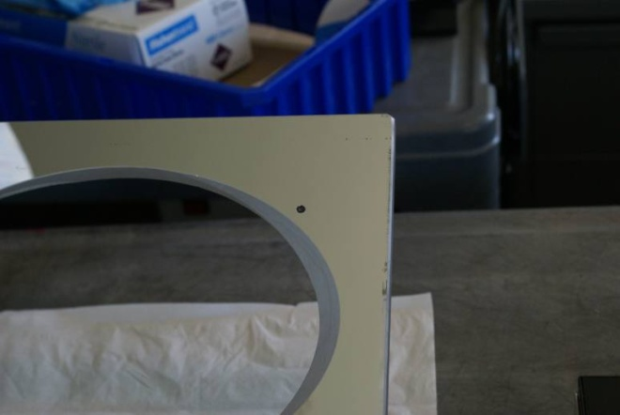

Dewar Windows
We looked at two Dewar assemblies, one labeled Dewar 6 and the other unlabeled but Kostas said it was called “4k” or similar. They had uncoated fused silica windows that ought to be cleanable, at least on the accessible sides. Dave cleaned them with Orvus/Acetone/Water followed by ethanol, and the outsides were much improved. Both had grunge left on the insides of the windows. They were covered afterwards with a folded Kaydry taped in place.
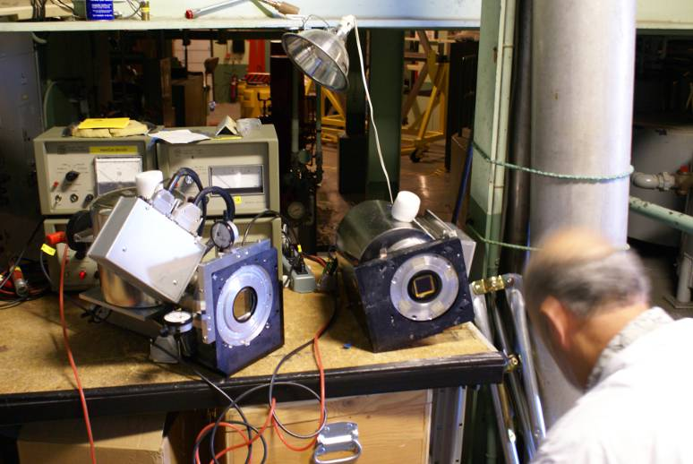
4k Dewar on the left and Dewar #6 on the right

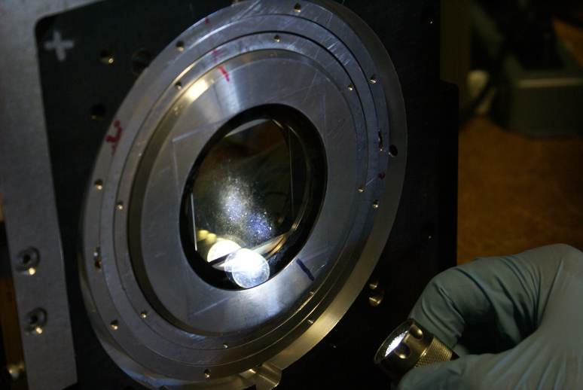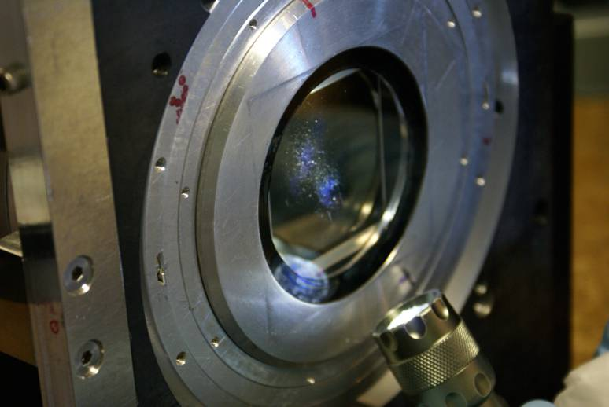
4k Dewar before cleaning 4k Dewar after cleaning
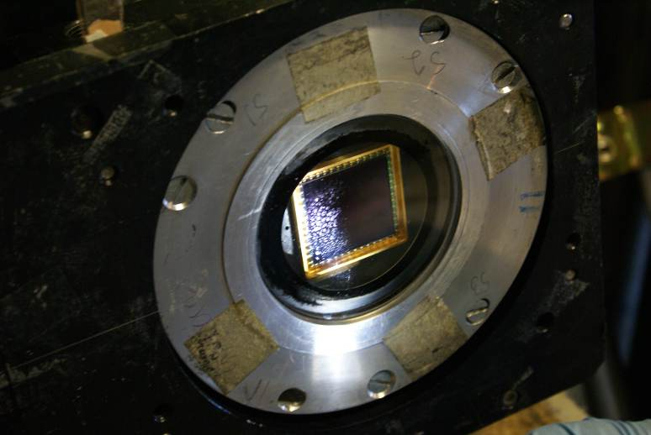
Dewar #6 before cleaning

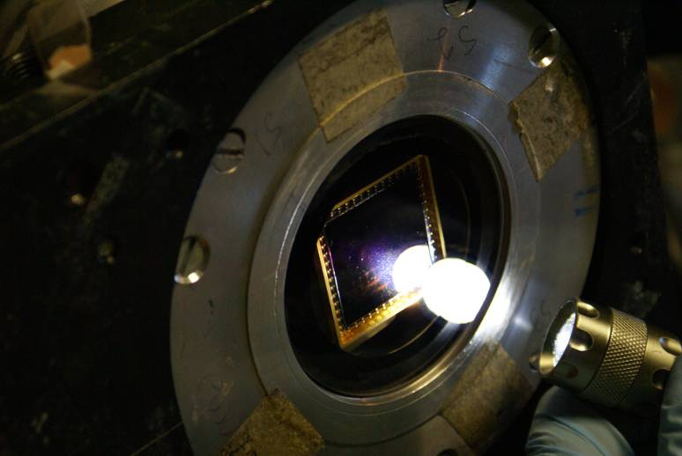
Dewar #6 after cleaning

KAST Red Collimator
Kostas removed the KAST red collimator mirror from the bottom of the equipment mounted below the 120” telescope. There was an outer cover about 12” diameter and then the mirror was mounted to another disk, about 8” diameter. The mirror itself was about 6” diameter. It was too small to get the reflectometer on.
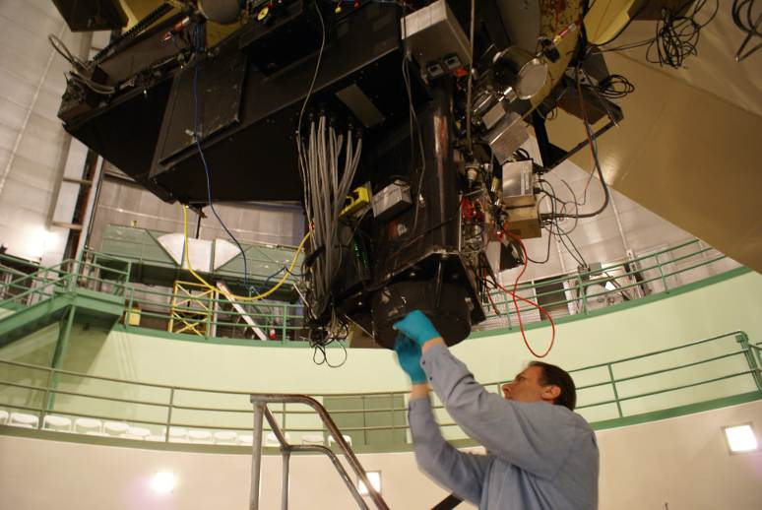

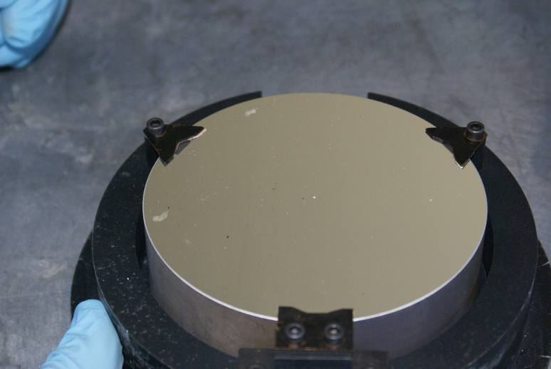

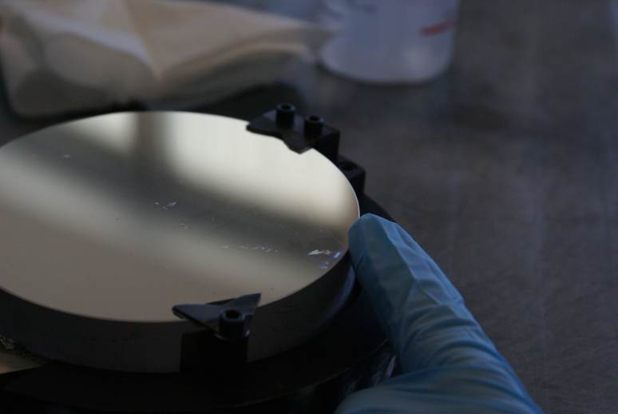
The dirty film had been removed near the pointing finger in this picture.

Dave and Kostas also looked at the diagonal mirror and dichroic D55 filter on the KAST instrument and the 4600 A filter in a wooden box.

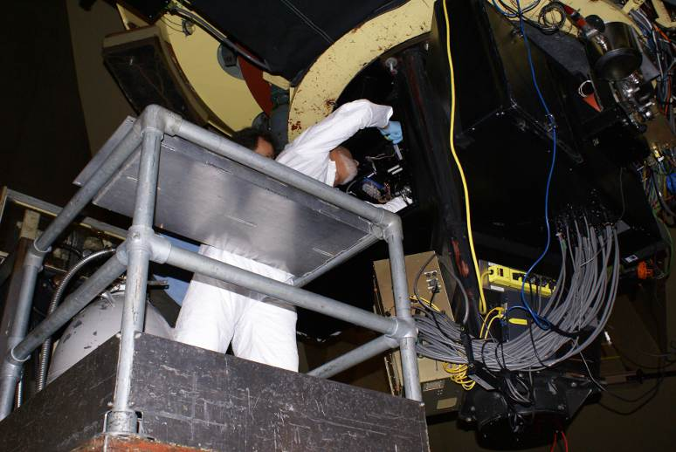

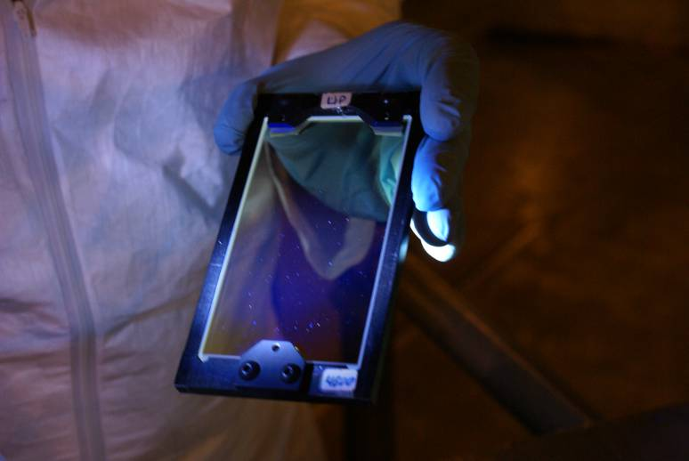

Nickel 40” Telescope Diagonal
Dave cleaned two mirrors that were in boxes in the control room across the hall from the 40” telescope. They were pretty sleeked and dusty to begin with. The “solid diagonal” mirror cleaned up okay except for the sleeks.
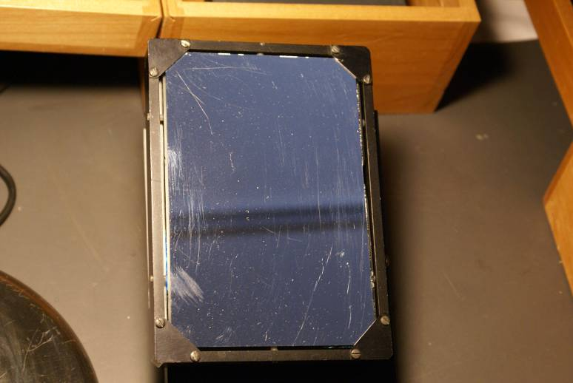

The “offset diagonal” mirror sleeked easily and had scuffed areas.
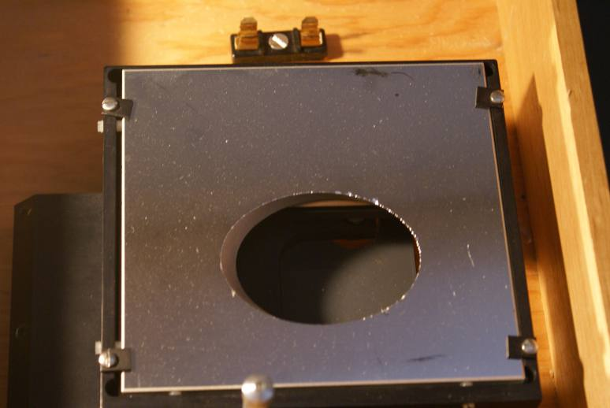

There were also several mirrors mounted in the tub beneath the 40” primary. Only one was able to be removed for cleaning, and removing that one was not easy, either, although it cleaned up okay once removed. Dave cleaned the others in place but with little effect.

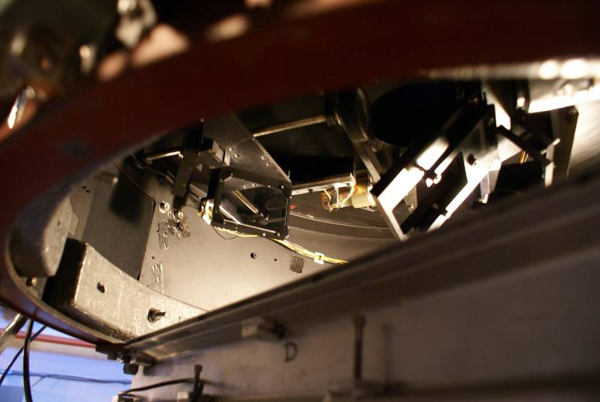

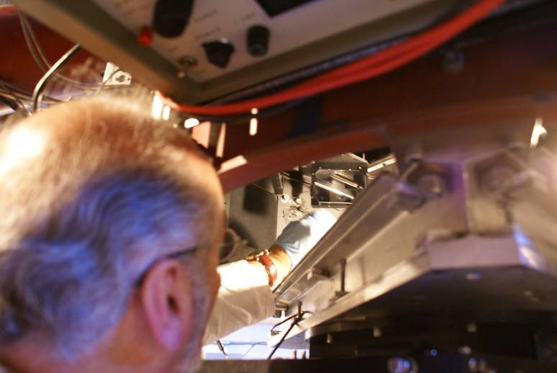

36” Refractor
We looked at the 36” refractor and Dave cleaned the outside surface with ethanol. The inner surface was crizzled, as had been noted before. It’s a slowly-accumulating effect that will require that surface to be re-figured in another 10 or 20 years. The crizzled effect seemed to have a linear component every 8” or so that may have been correlated to the lap mount used (or the tissues on it) when the opposite surface was re-figured by David many years ago.

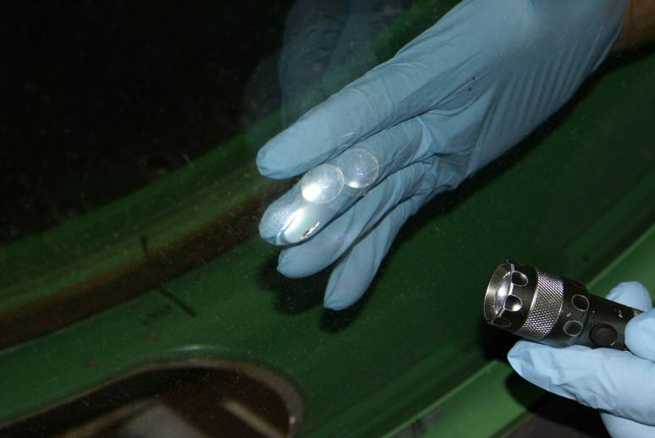
Piece of something between the surfaces.

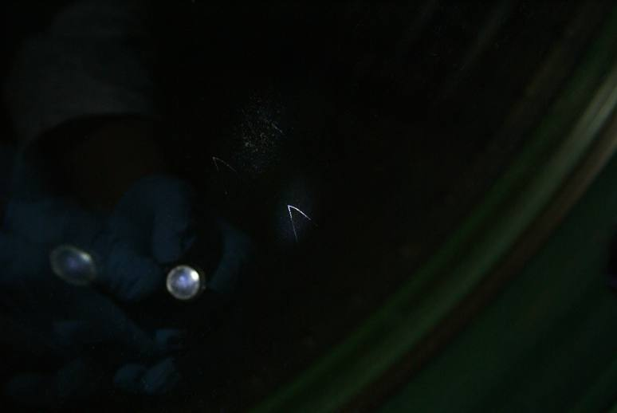
“V”-shaped scratch

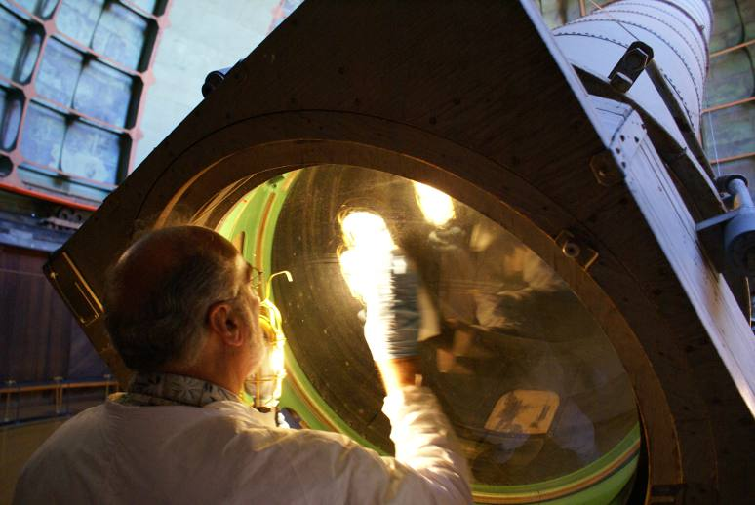
Cleaning outer surface

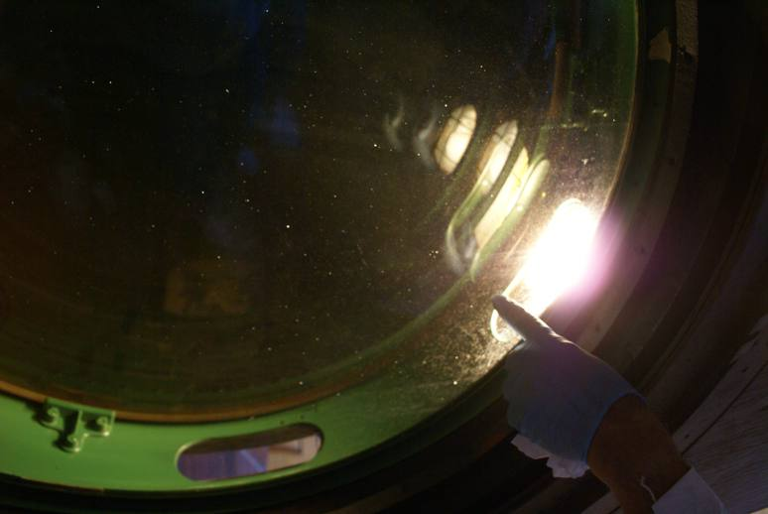
“Crizzled” inner surface has horizontal lines every 8” or so

CAT #1 Siderostat
We inspected this mirror in the shed alongside the 120” dome, but found it to be still clean since the last time it was visited. No improvement would have been made in re-cleaning it.

