Mt. Hamilton Optics Cleaning #5
David Hilyard and Brian DuPraw
3/3/11

This was the fifth of our excursions to Mt. Hamilton to clean whichever optics had been deemed most in need. It had been very cold recently, and Kostas mentioned that they had been having condensation problems. In fact, for several optics that made inspection difficult, as will be discussed below.

PF Cam Filters and Lenses
The Prime Focus Camera itself did not need cleaning. Both the top and bottom lenses had covers, so had been mostly protected since we last AR coated them. We looked at the surfaces of the topmost and bottom-most lenses and both were good.

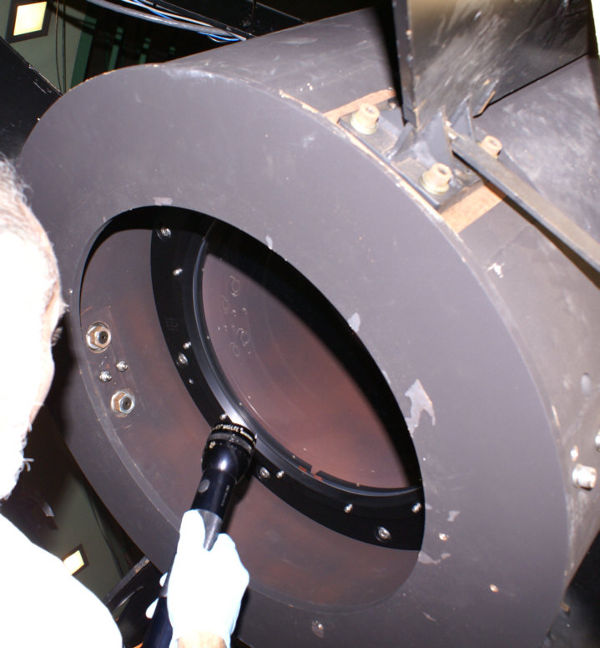
PF Cam Bottom Lens

Dave cleaned two boxes of PF Cam filters. Most of the “Bessel” filters were good, although one marked “660B06” had water spots. Even that one cleaned up okay, though. 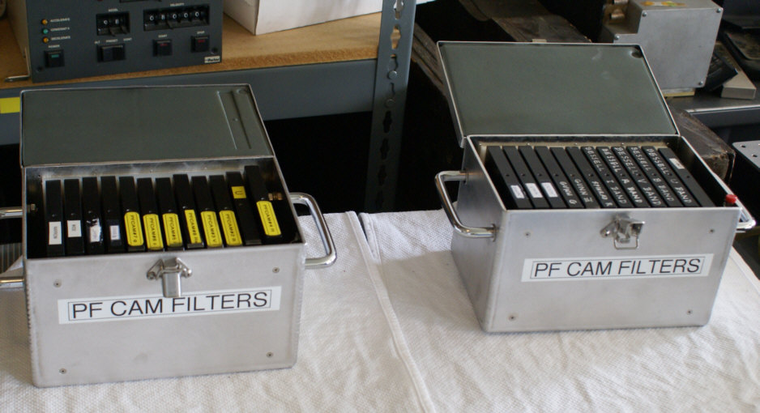

The filters of the other box were cleaned as best as possible:
“U” ….had a couple of 5/8” diameter spots that would not clean up… they looked like an oil or solvent had dropped on the filter.
2B …..(blue) had cracks and crazing along the edge
3……. (green) had sleeks around the perimeter, as though from wiping with a dry tissue
4 ……(orange) had a large crack or two and would not clean up
5I ….. not bad
6…… not bad
7…… good
8Rs... pretty good
“Wide”…a little dusty but not bad
“Narrow”…good

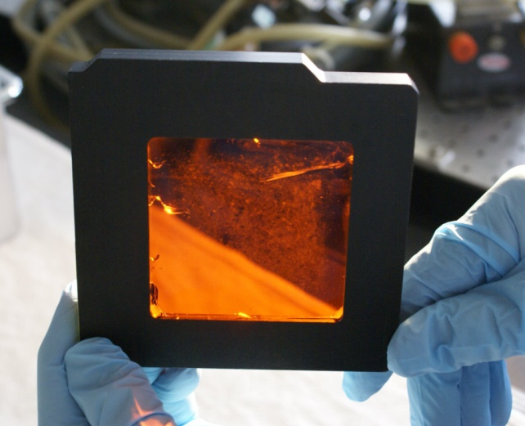
Filter #4 with crack

Coude’ #5
This mirror is upfacing, between the forks of the 120” telescope. While it does have a cover, it is still prone to getting dirty. We found it to be dusty and it had a film, but Dave determined that that was due to his body heat causing condensation on the cold mirror. We measured the reflectivity near the center:

Red: 80%
Blue: 82%
(numbers are relative to the standard witness kept with the reflectometer)

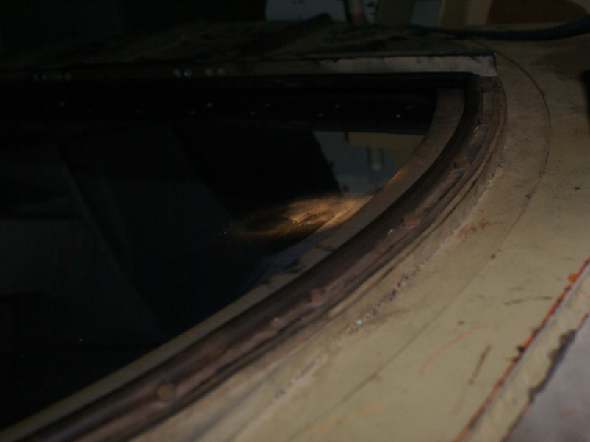
Coude’ #5 condensation or film

Coude’ #4
This mirror is downfacing, attached to a cage above the forks of the 120” telescope. It is also usually covered. Dave tried cleaning a small area with ethanol on a Kaydry but it was hard to tell if it was helping due to the condensation on the cold mirror. We measured the reflectivity twice:

Red: 94% 94%
Blue: 90% 91%
(numbers are relative to the standard witness kept with the reflectometer)

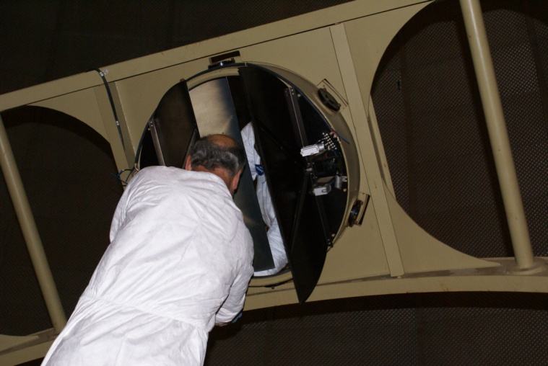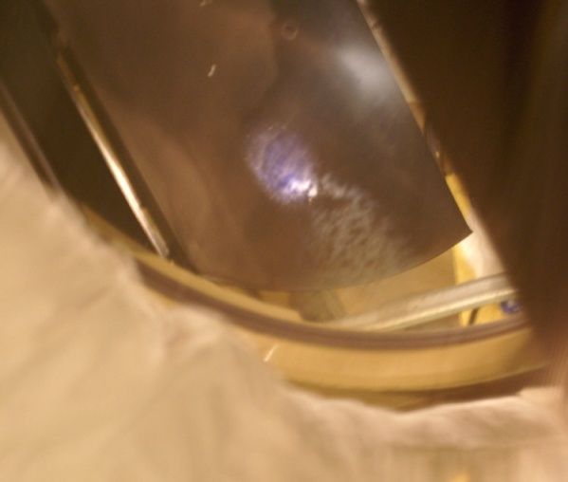

120” Primary
We inspected the 120” primary and found it to be still pretty clean since our last washing of it, with only a couple of nickel-sized oil spots on the surface. We measured the reflectivity twice:

Red: edge: 93% center: 94%
Blue: edge: 92% center: 92%
(numbers are relative to the standard witness kept with the reflectometer)

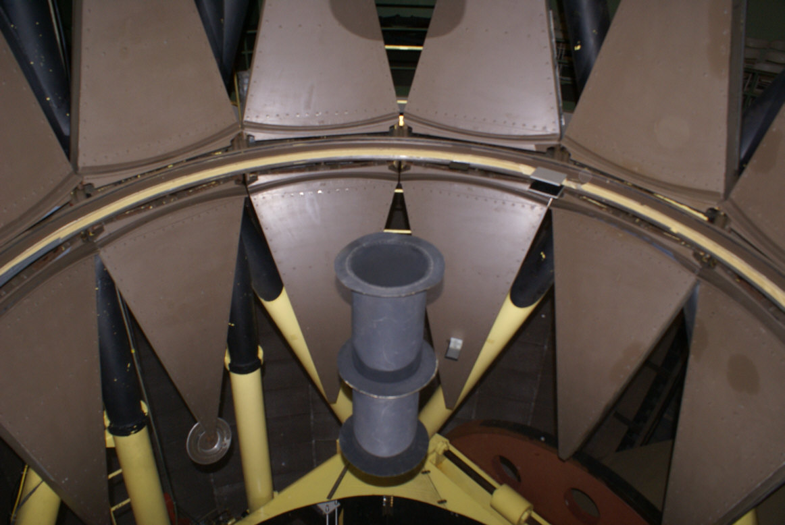

Coude’ #2
This mirror was on the dome floor with the cover off. Dave wiped at it with an ethanol-soaked Kaydry and then waited tens of seconds for the ethanol to evaporate. This made it very difficult to ascertain if the wiping was helping or hurting.

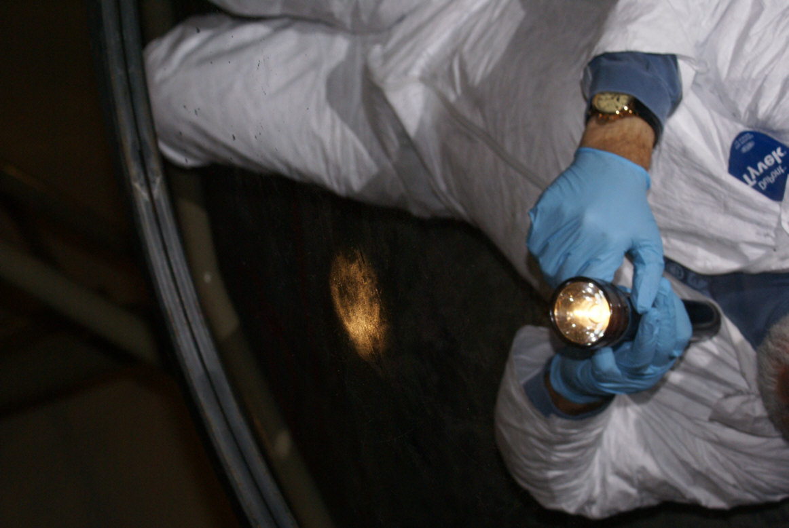

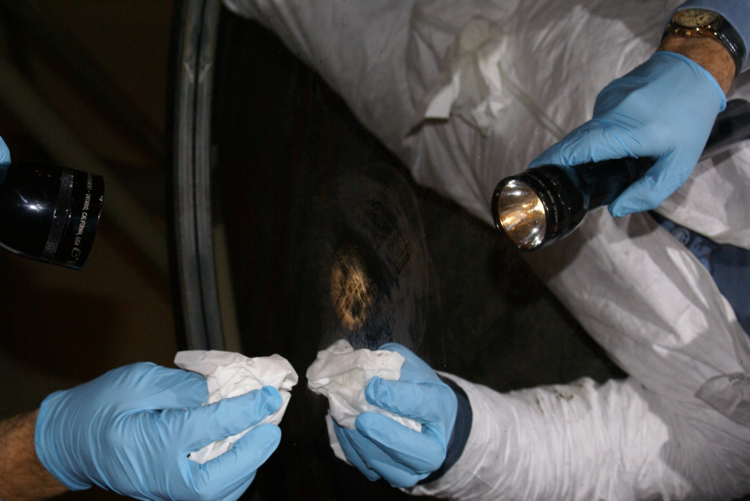
Coude’ #2
Condensation or film

CAT
We looked at the CAT (Coude Auxiliary Telescope) mirrors. The down-facing flat, CAT #2, looked pretty good. We measured the reflectivity:
Red: 90%
Blue: 88%

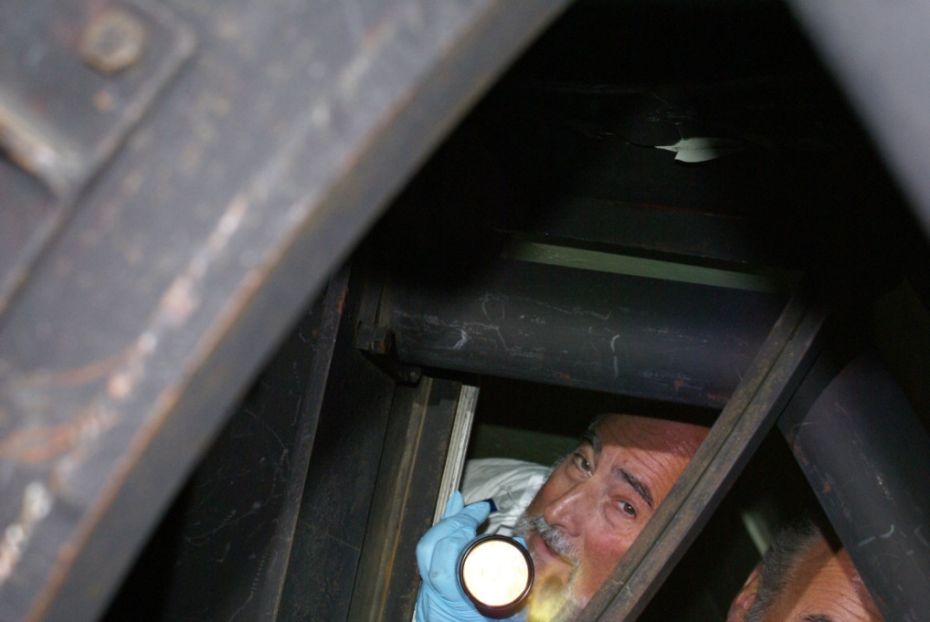

The small, down-facing secondary mirror CAT #4 looked good visually but the reflectivity was very low. It had been measured to be low on previous trips, as well:
Red: 54%
Blue: 64%

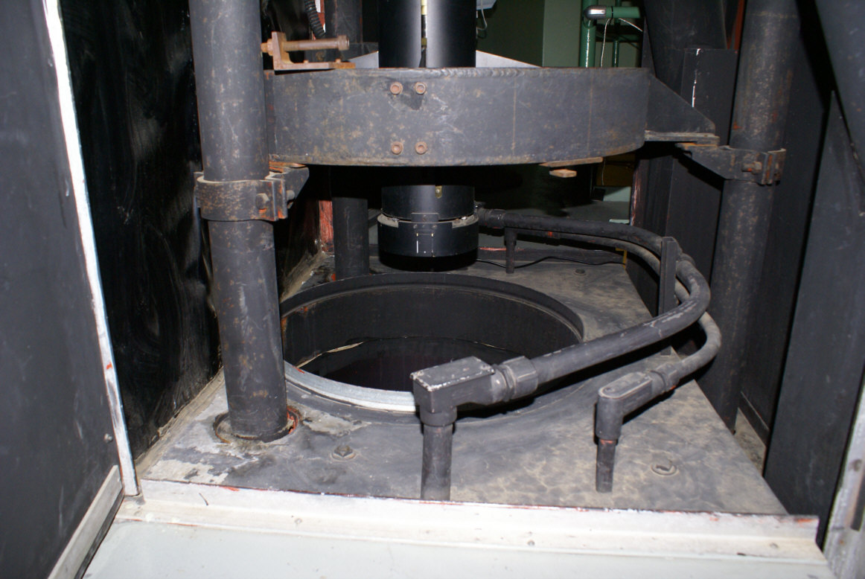
CAT Secondary

The upfacing primary mirror, CAT #3, was very dirty with dust and debris that had rained down on it from above. Dave cleaned it with Orvus/Acetone and distilled water until it was much improved. Access through the small cutout in the annular shield was difficult, but we measured the reflectivity:
Red: 100%
Blue: 97%

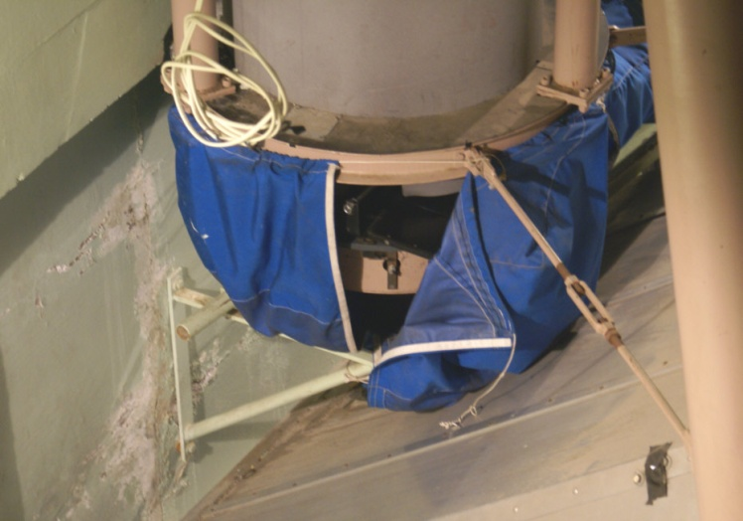

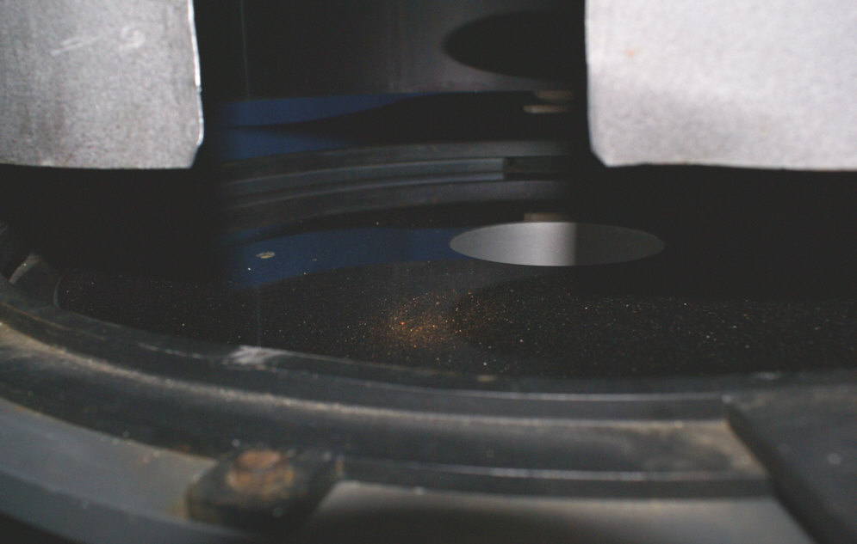

CAT Primary

Slit Room
We looked at a few things in the slit room. On a prior trip we had decided the pick-off mirror needed re-coating and on this visit Dave decided he couldn’t help it by cleaning it. He removed a smudge from the aperture plate. Dave cleaned the chopper wheel and reported that it was quite sleeked.

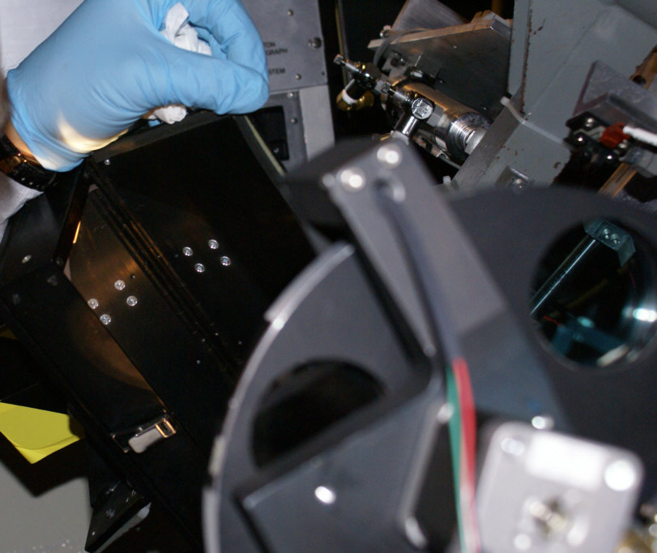
Pick-Off Mirror in slit room

He also cleaned the periscope mirror and recommended that it was not wipeable due to how easily it sleeked.
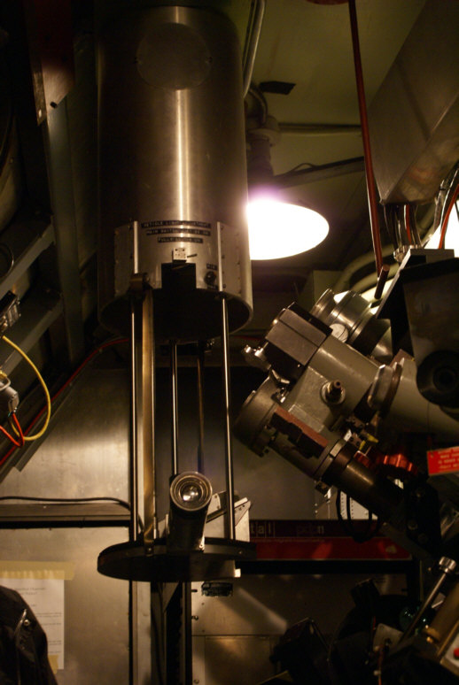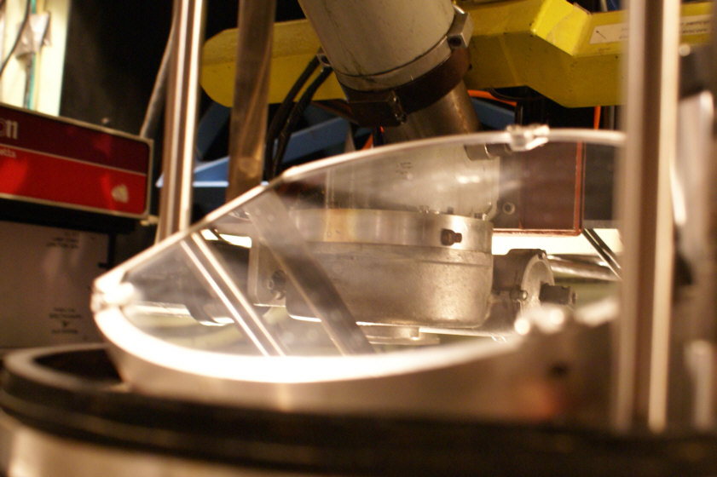

Periscope Mirror
APF
We looked at the APF primary to try to determine the best way to clean it. We thought that standing the mirror vertically with a trough below it would be best for drainage. If we tried to clean it horizontally it would have been a challenge to put a drain in the center hole, particularly because the tertiary mirror is mounted there. We measured the reflectivity in the two marked positions:

Red: Position 1: 85% Position 2: 80%
Blue: Position 1: 77% Position 2: 68%

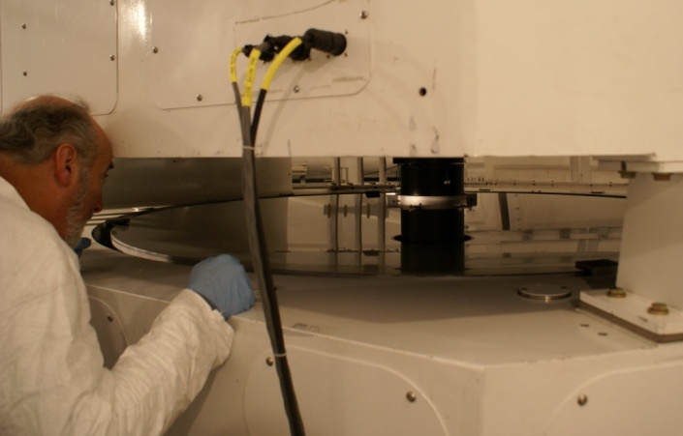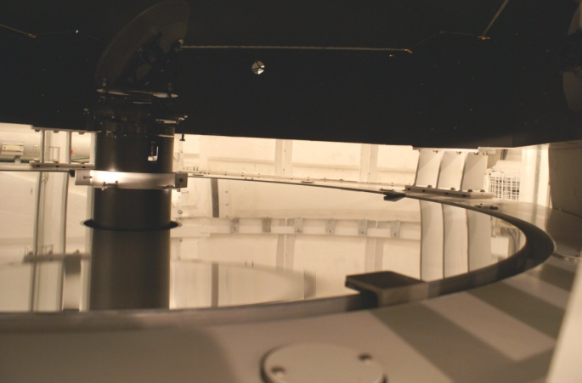

Nickel 40” Reflector
Dave cleaned two boxes of filters using breath and ethanol, including four that Kostas removed from the filter wheel on the telescope. They were all good-to-excellent; just dusty with a few dings. We measured the secondary mirror’s reflectivity:
Red: 82%
Blue: 88%

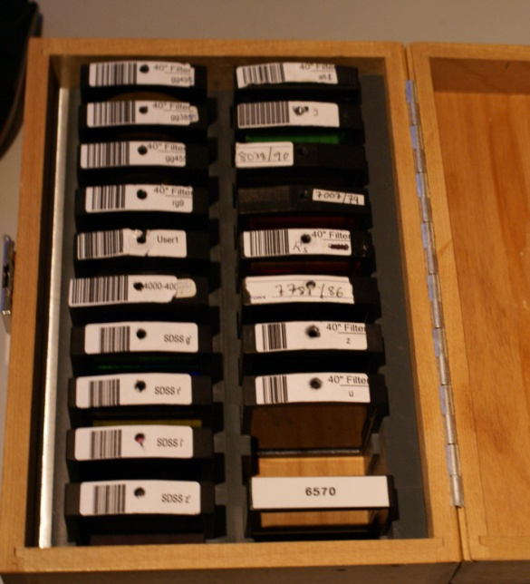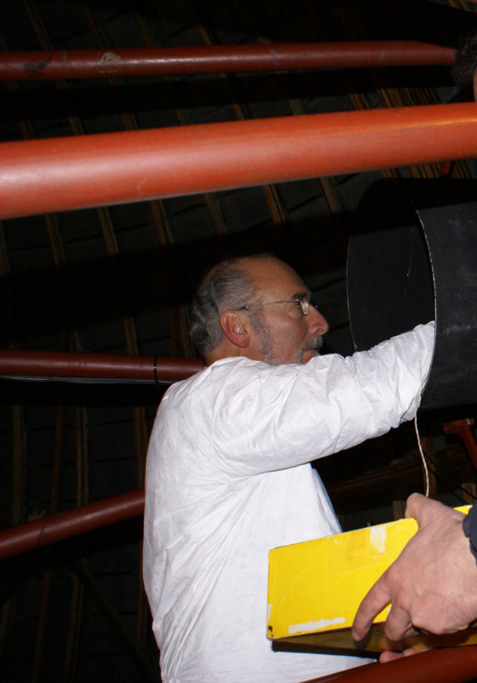

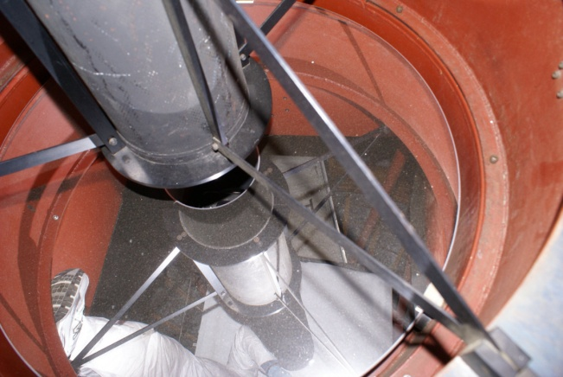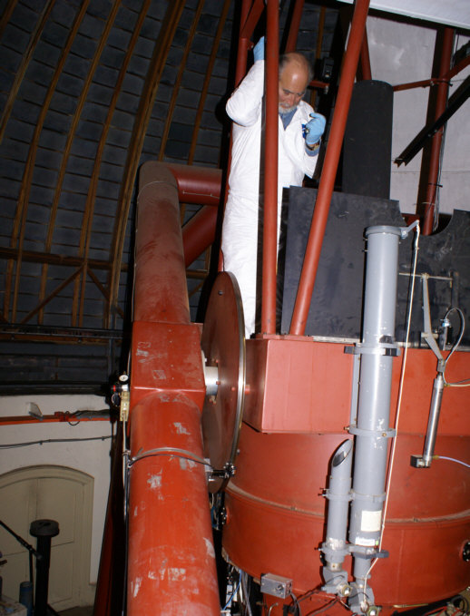

40” Nickel Telescope Primary

To inspect the 40” primary mirror Dave had to climb up one fork and get into the framework surrounding the optic. There was a ledge inside that he could put his feet on. He decided the primary mirror sleeked too easily to be cleanable. Kostas looked up the last coating and found it was bare aluminum. It had dust on it and a few small (dime-sized) dings or else bird poop spots. There also were what might have been fingerprints along one edge.

The primary mirror’s reflectivity was:
Red: 88%
Blue: 87%

