Mt. Hamilton Optics Cleaning
David Hilyard and Brian DuPraw
11/2/10

This was the third trip of our monthly cleaning excursions to Mt. Hamilton to clean whichever optics had been deemed most in need.

3-meter Coude M5
We had seen on our previous trip that this mirror needed cleaning, but issues of fluid drainage and accessibility needed to be considered before beginning. This time Dave cleaned M5, using cloth towels below where he was working to catch any flow before it ran off below.
Kostas demonstrated how to enter the work area inside the forks, stepping backwards into it first with feet placed to the far outsides of the closed mirror cover, and then on the metal hinge centered below the cover. Once Dave was in the work area we handed him the cleaning supplies. He blotted the mirror with Orvus/ water and a spritz of 18 M-ohm distilled water. He followed that up with ethanol and acetone.

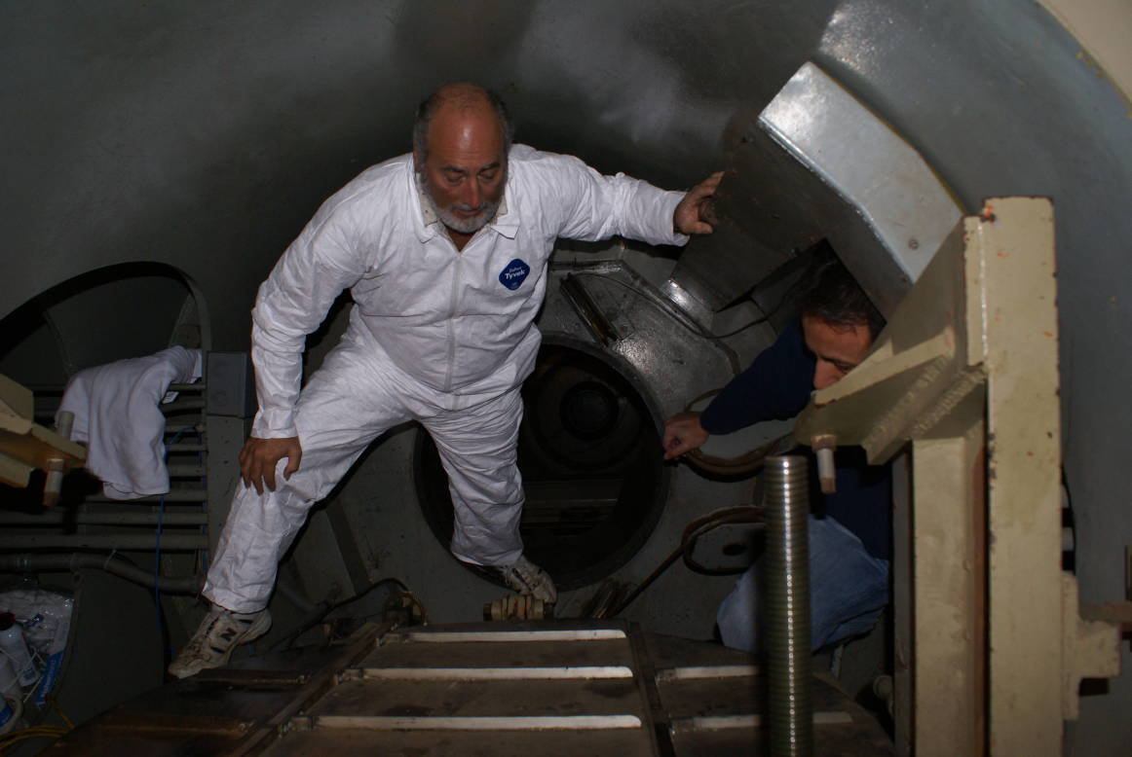

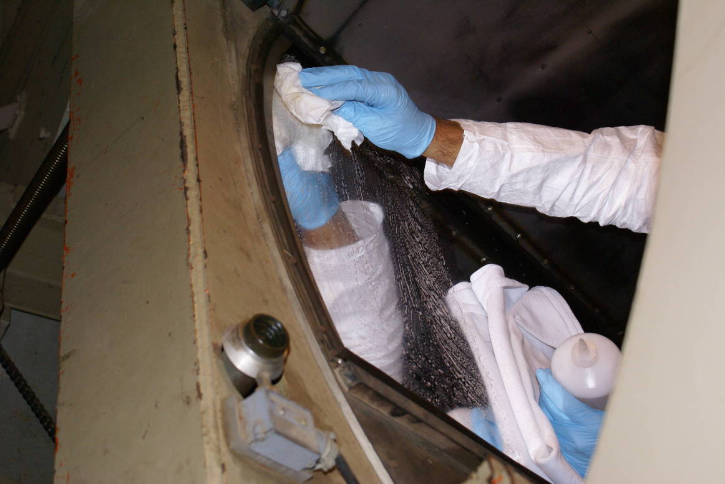

After cleaning, the mirror was greatly improved, although there was an overall cloudiness to the surface that did not come off. There were also four small areas of bird poop that had etched through the coating all the way to the glass; however, they constituted a tiny percentage of the mirror’s area.

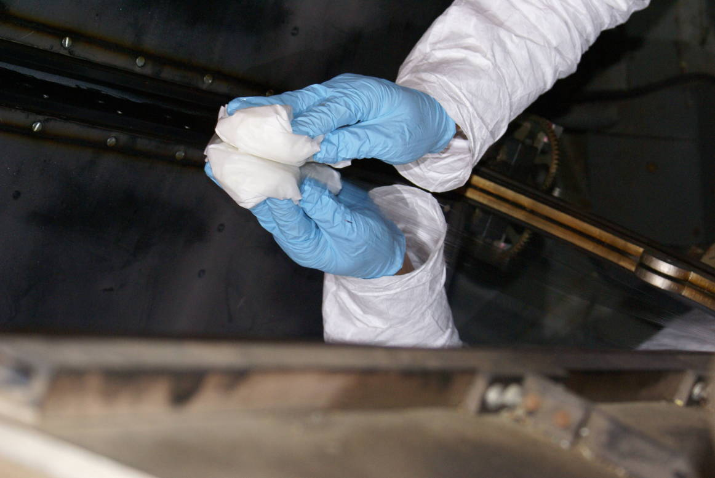

3-meter Coude M4
The Coude M4 downward-facing mirror was lowered to inspection height and Bob opened the cover by turning the motor shafts by hand (electrical power gets disconnected when the cage the mirror is mounted on is lowered). There was a mottled brown tarnished look to large areas of the mirror. Dave tried cleaning along one side but it sleeked easily and didn’t really help the cleanliness. Basically, this mirror’s problems are IN the coating rather than ON it.

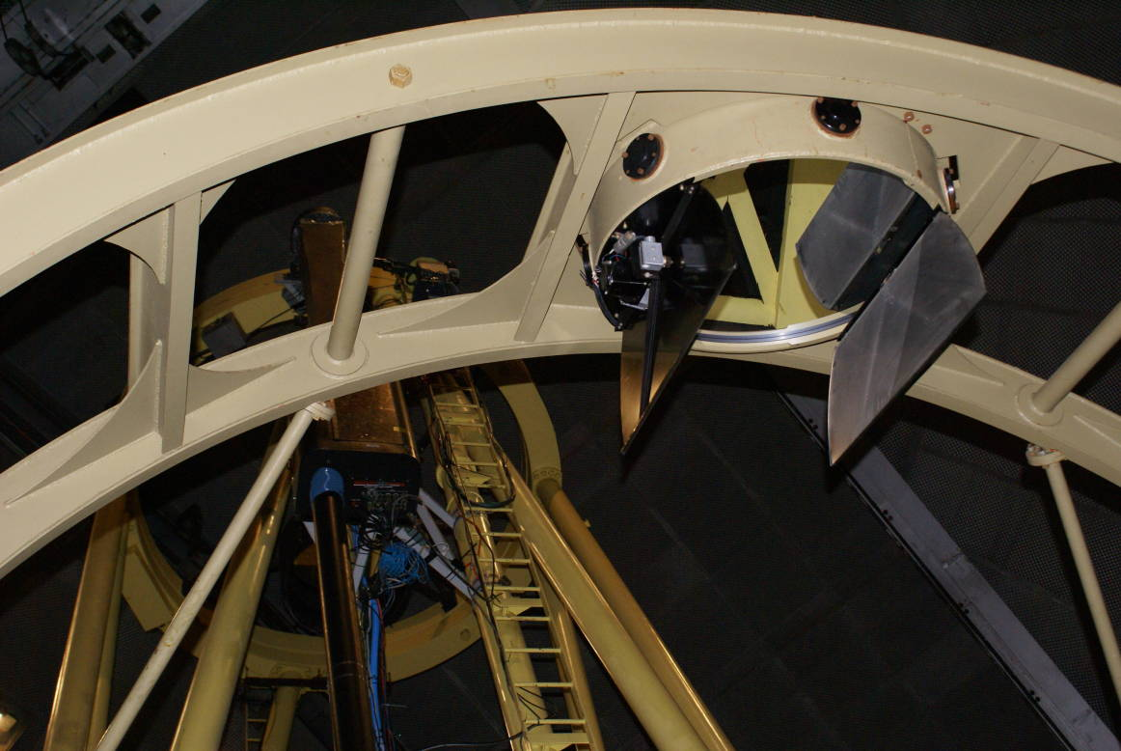

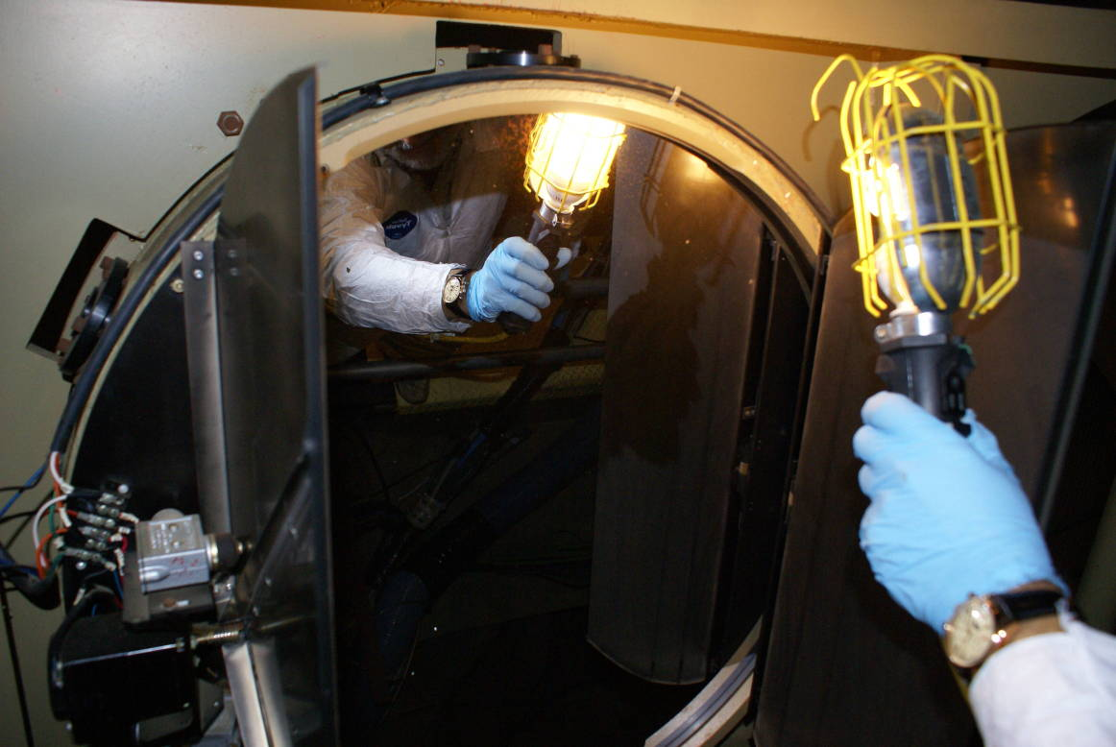
Mottled brown discoloration

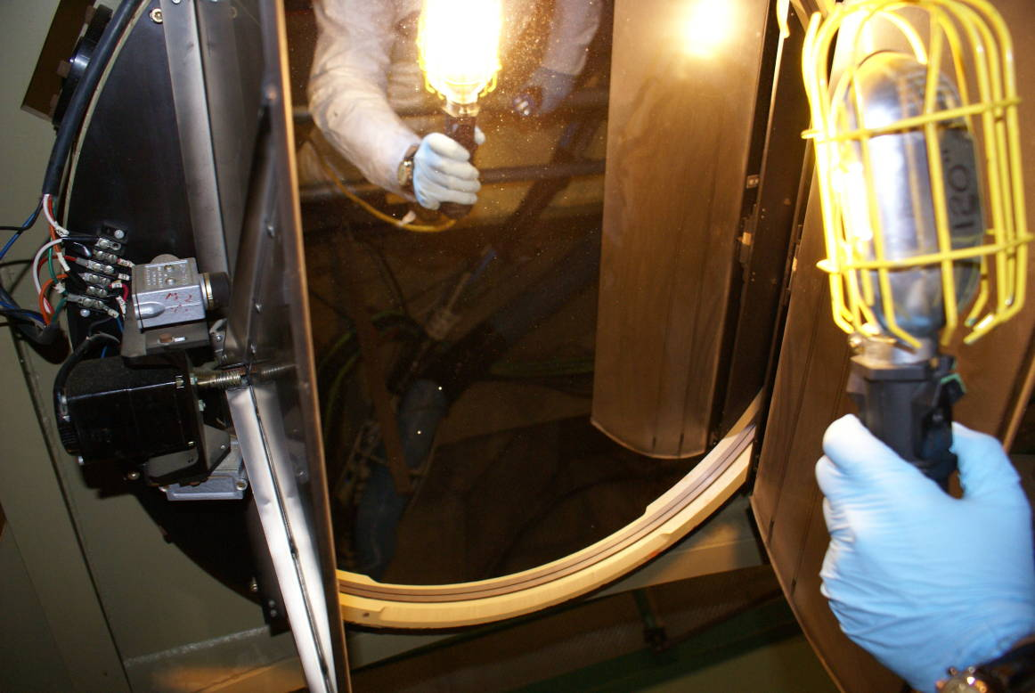

3-meter Coude Secondary
The Coude Secondary was accessible on the dome floor. We crawled under it and Dave cleaned it with Orvus/water followed by ethanol. It survived the cleaning quite well but there were numerous light scratches and pits that cleaning didn’t help. Kostas said the coating use to come off frequently but lasts longer now that it remains covered when not in use.

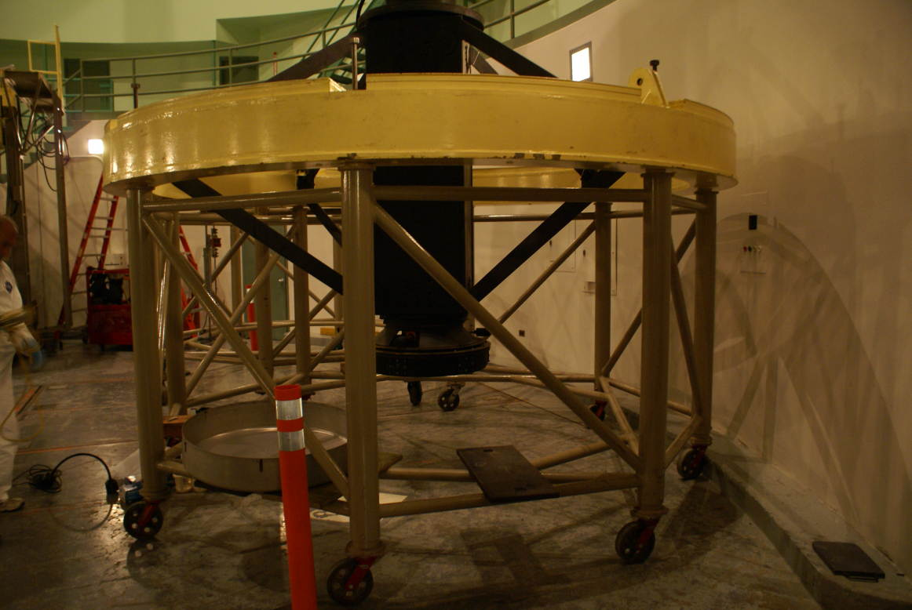

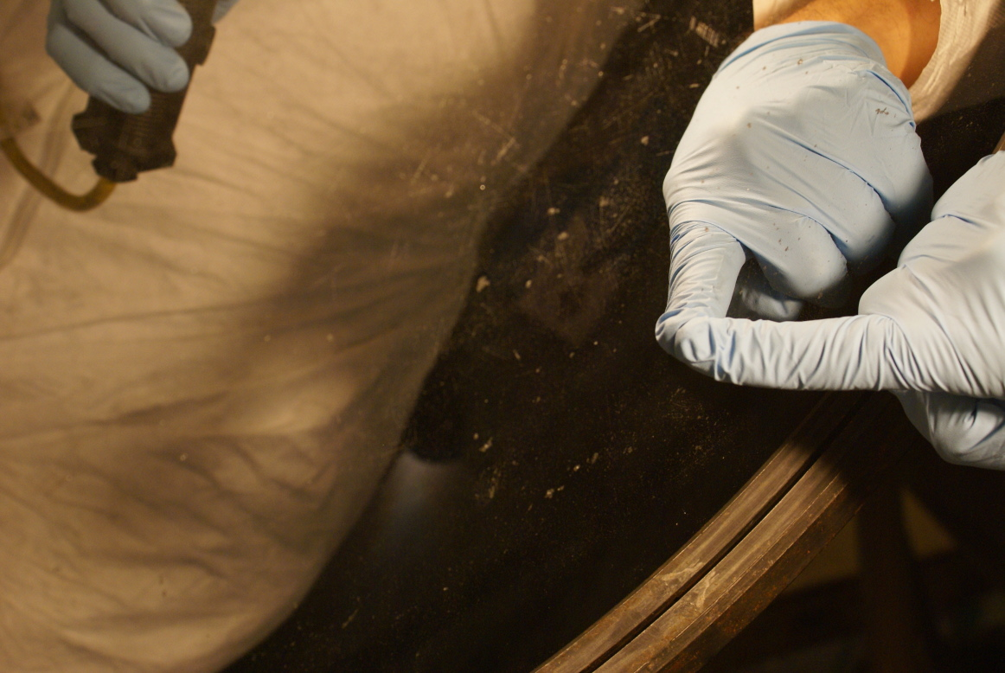
Pits

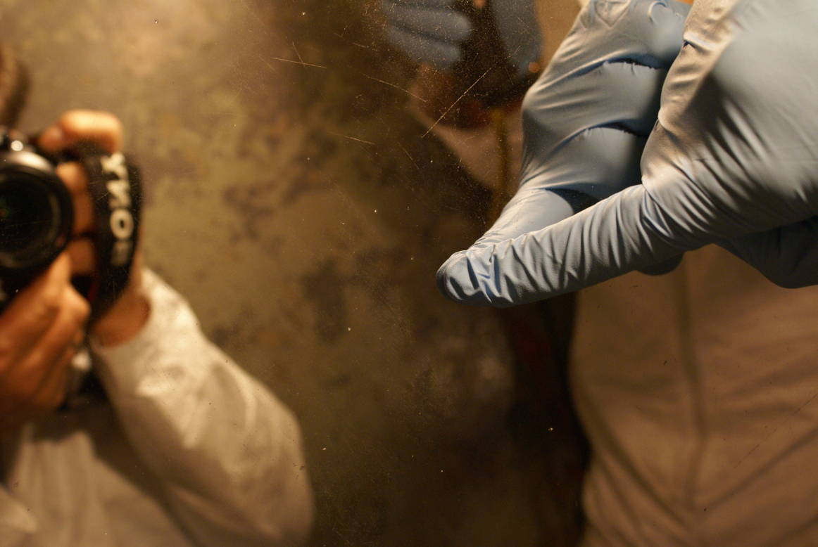
Scratches

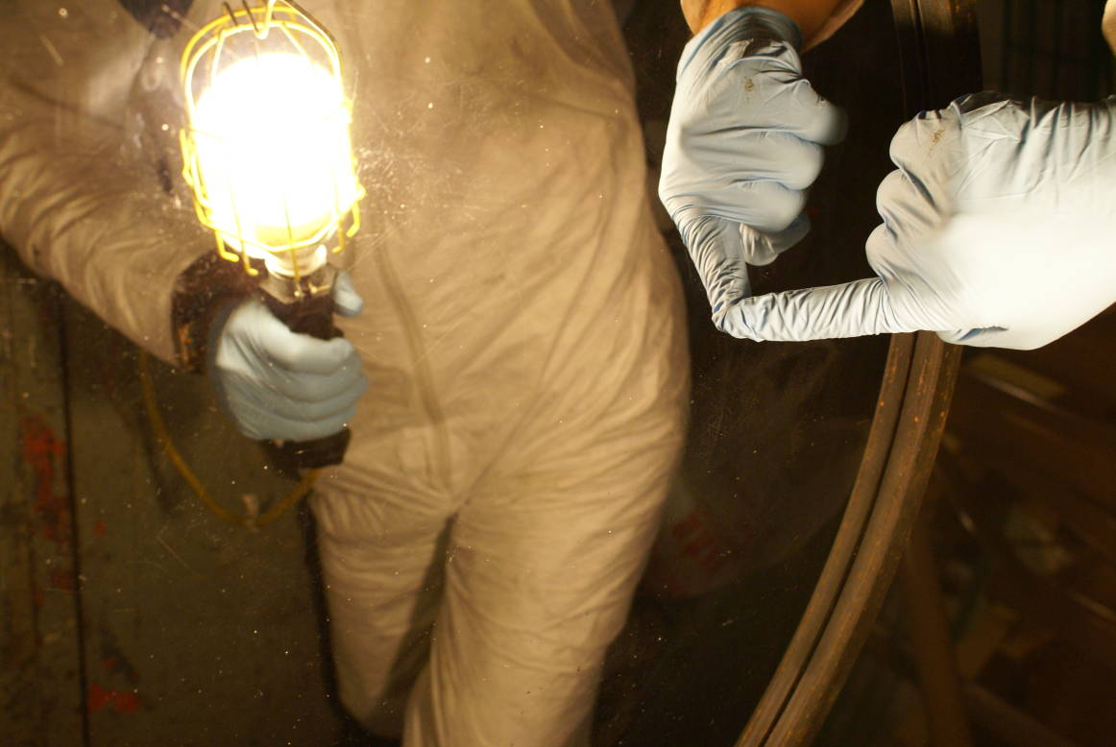
Pits

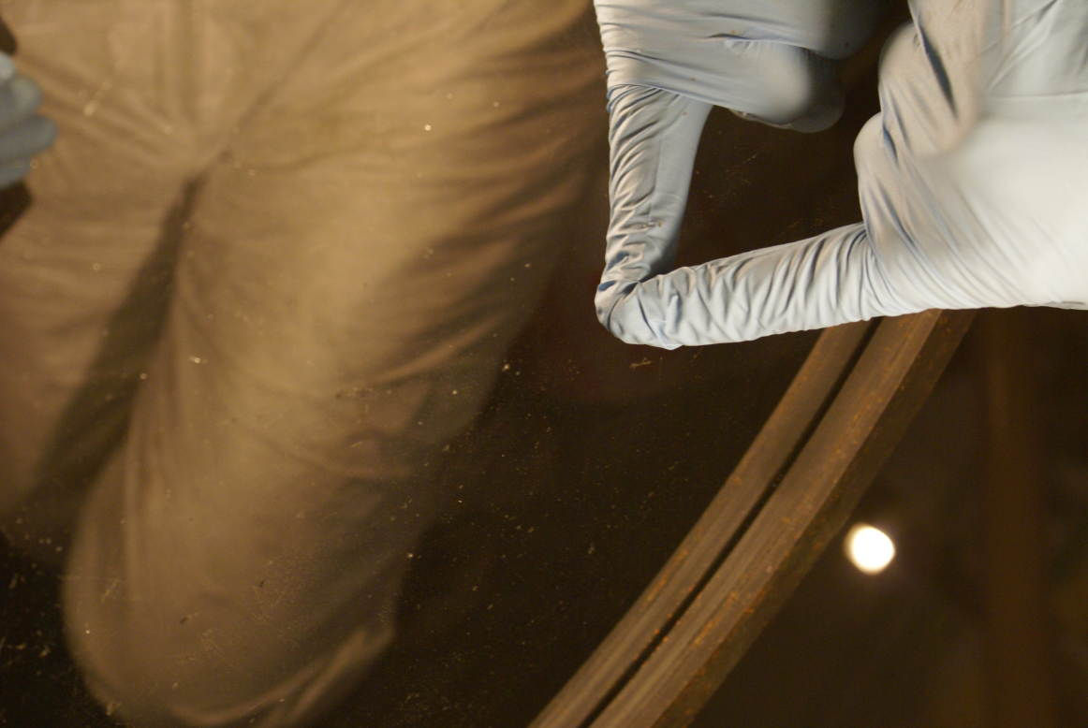
Pits

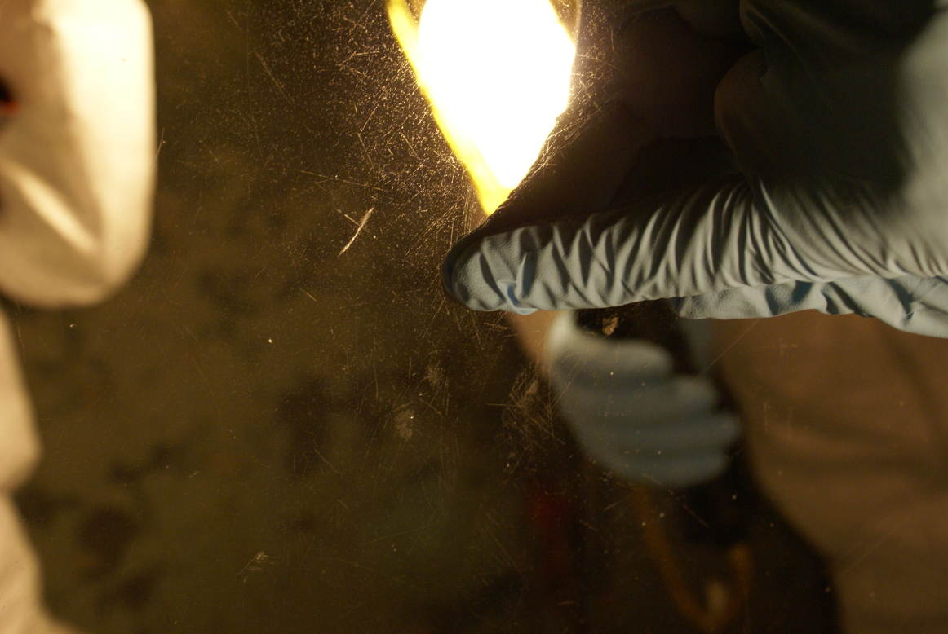

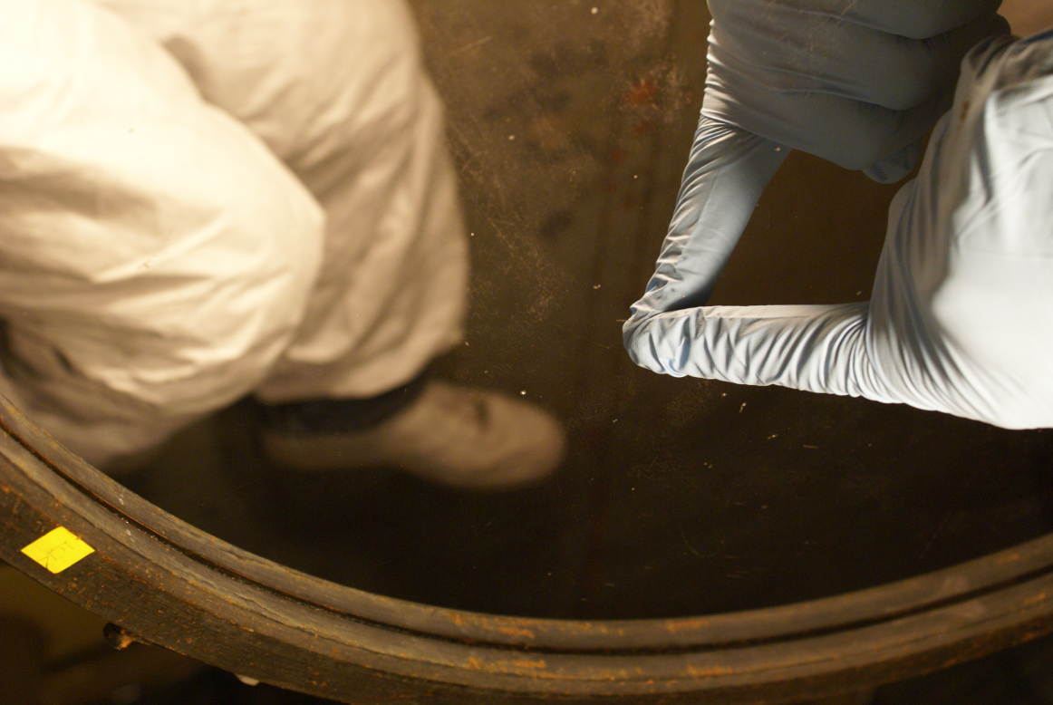

KAST Red Side Filters
The KAST red side filters were accessed by removing a cover on the side of the instrument while it was mounted in position on the 3-meter telescope. They were very dusty and Dave cleaned them with Orvus and water only; solvent was avoided since if any filters happened to be plastic they might have been attacked by it. The wheel could be turned by hand and one filter frame was empty so Dave was able to clean the lens below the wheel. There were two beam splitters that had been cleaned on a prior trip.

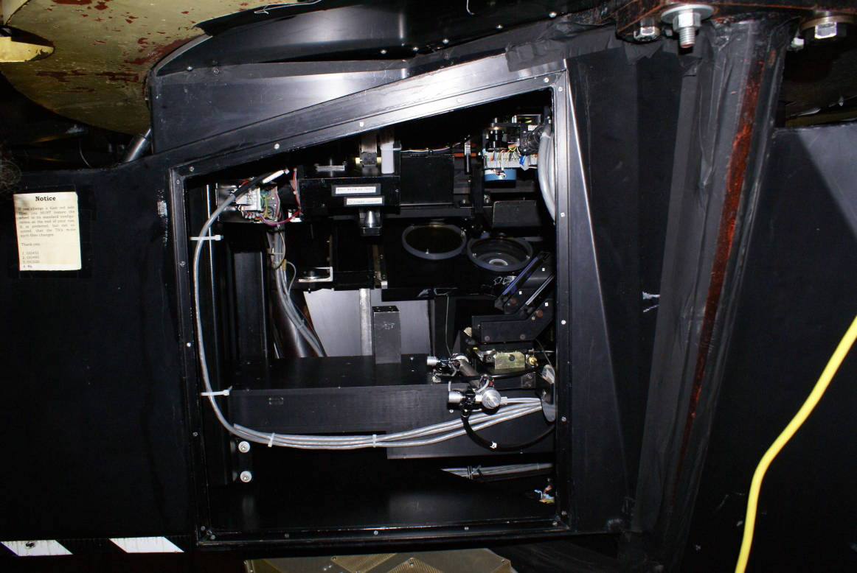
Filter wheel
Beam splitters

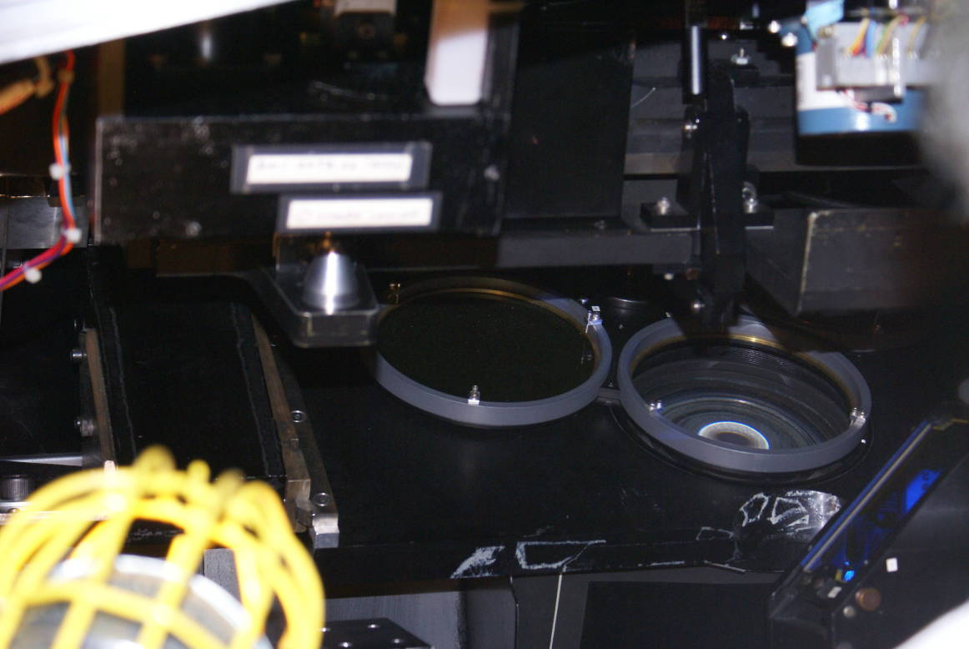
Filter wheel

Hamilton Spectrograph
There was a lens on the Hamilton Spectrograph that had been flagged as needing attention, and it was found to be very dusty. It was next to a mirror that had been found previously to sleek very easily. Dave cleaned the dusty lens. We also examined the collimator, already known to have a large surface defect on the right side, among other coating issues.

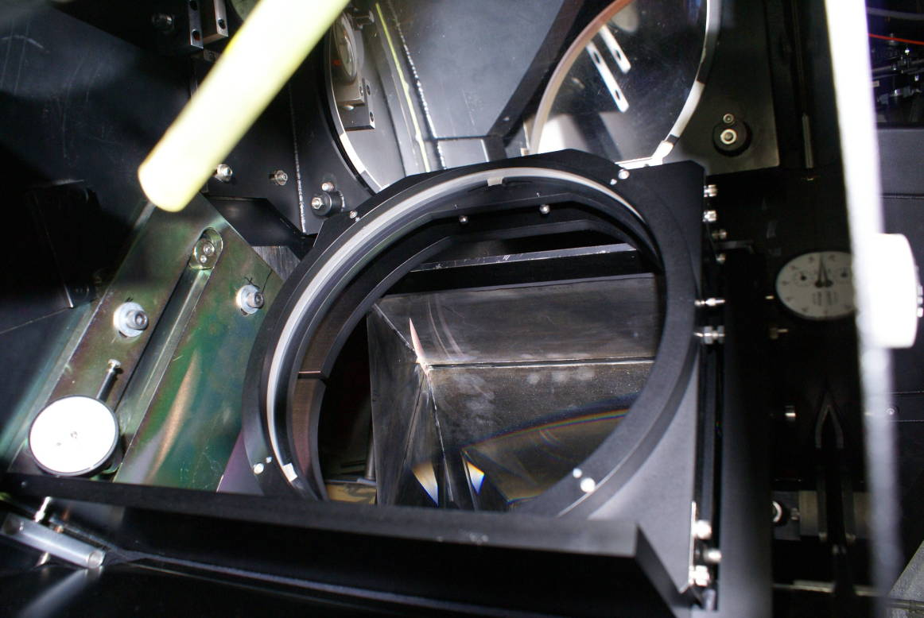
Previously dusty lens
Easily sleeked mirror

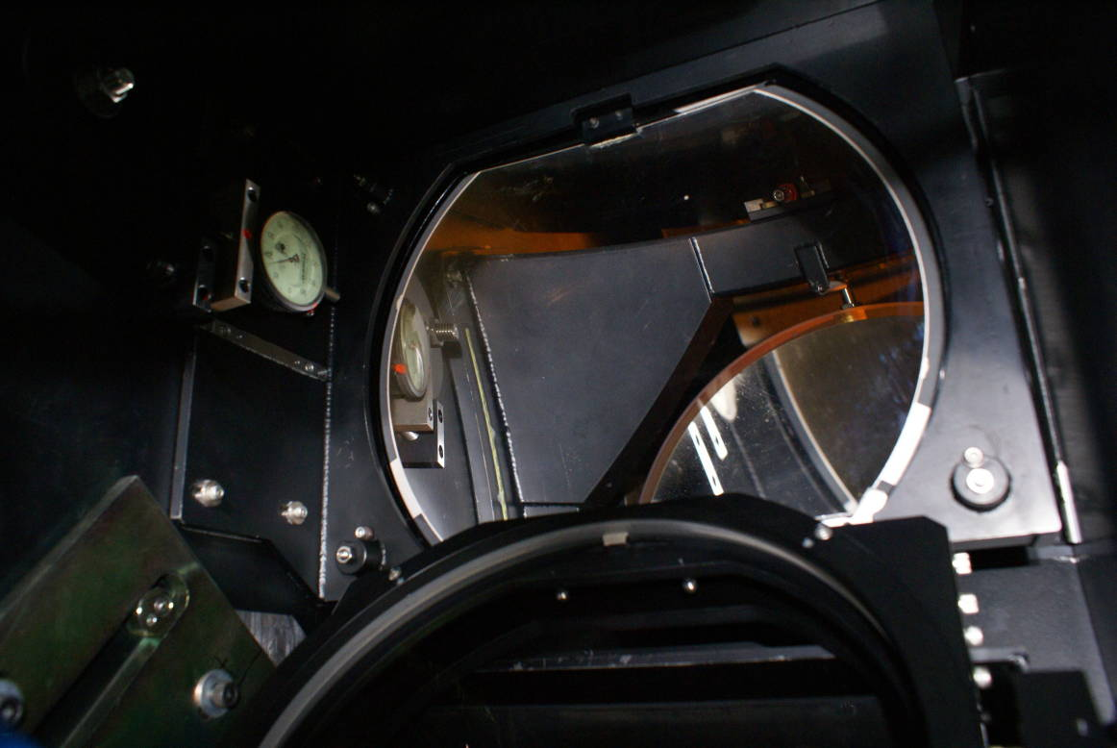
Easily sleeked mirror
Previously dusty lens

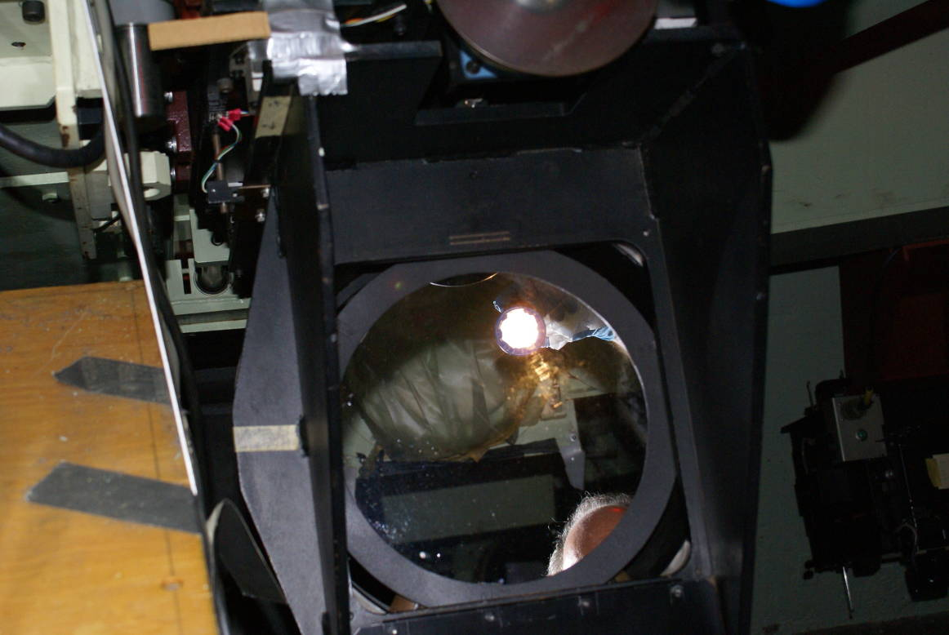
Collimator

36” Refractor Objective
Bob and Kostas raised the floor and tilted the 36” refractor telescope so that the flint/crown objective was at working height. NOTE! The cover should be opened before tilting the telescope, since the cable release is on the opposite end!

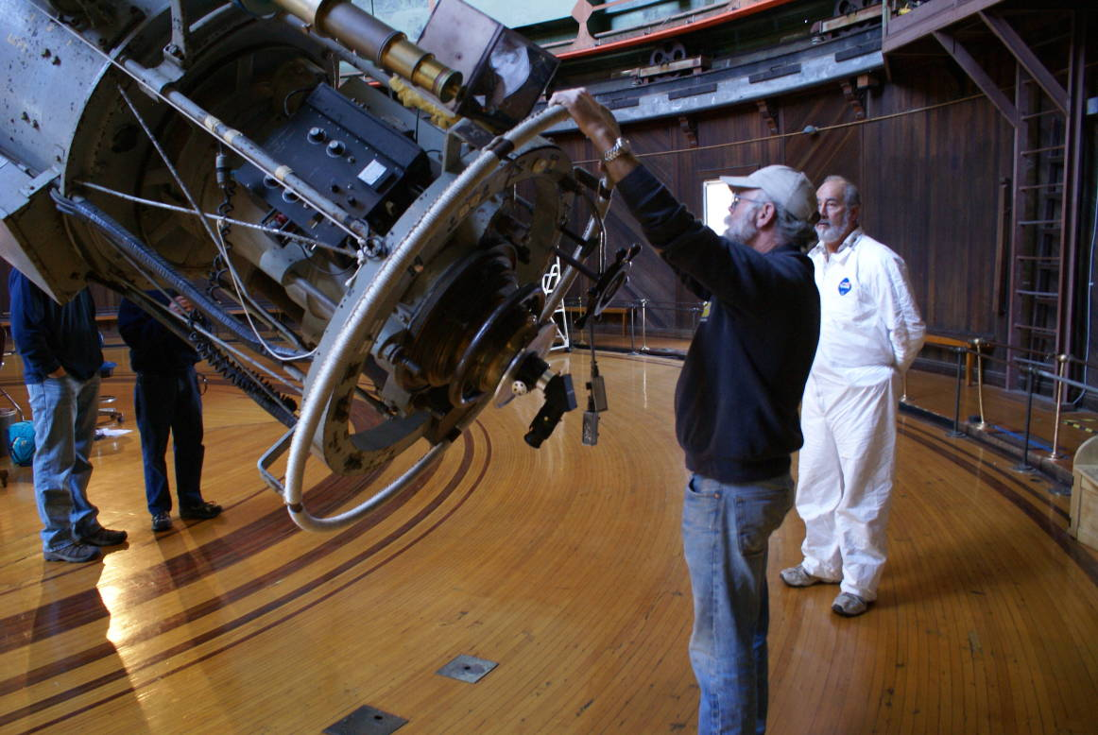
Lens Cover Release

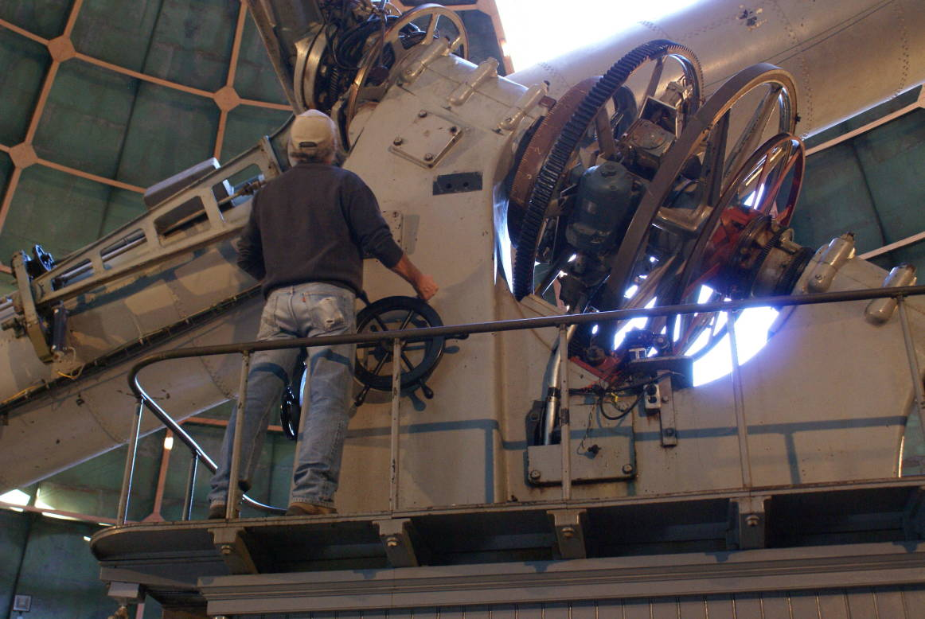

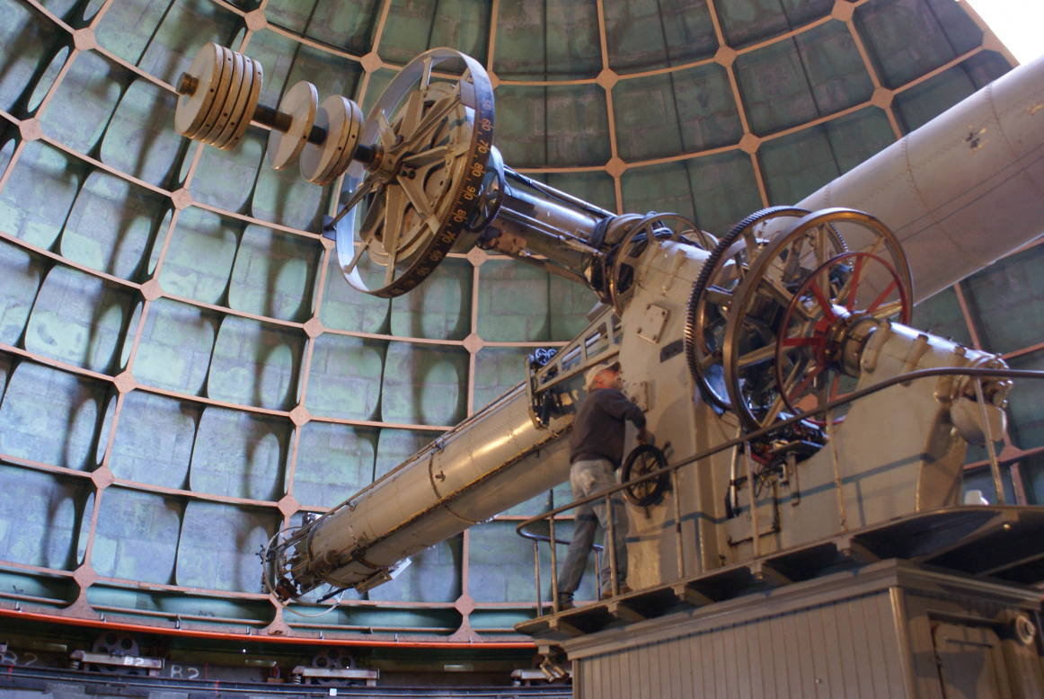

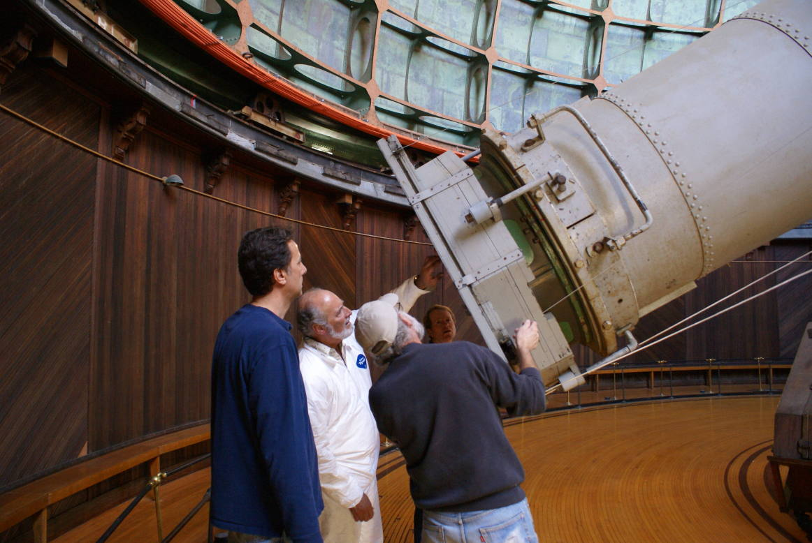

Dave had re-worked the outermost surface of the first lens (the flint lens) in the 1980’s, and at that time had needed to get below some surface crazing. It was apparent that the inner surface of the same lens was now showing similar crazing. It was not thought to be of pressing concern this time due to the large number of years the crazing took to progress. Dave wiped the surfaces of the lenses with 18 M-ohm distilled water followed by ethanol. However, the outer surface of the flint lens had an overall cloudiness that did not clean off.

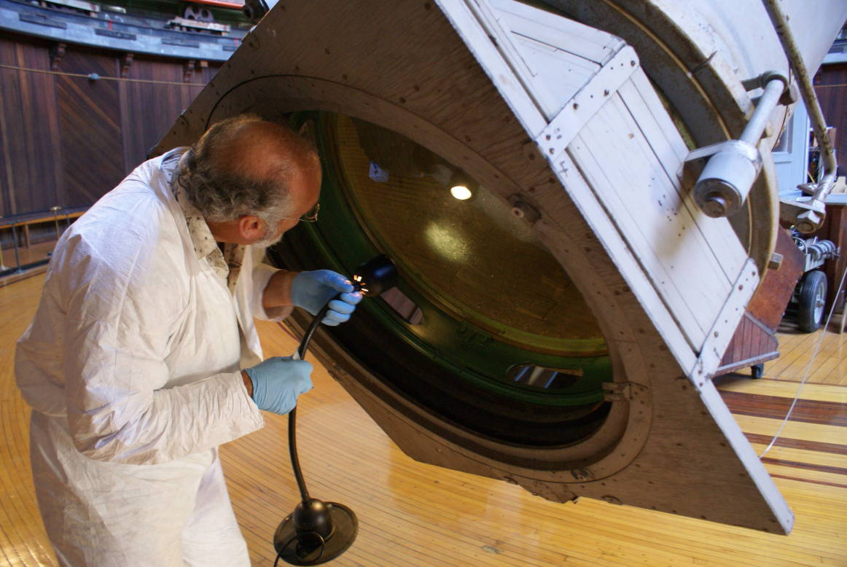

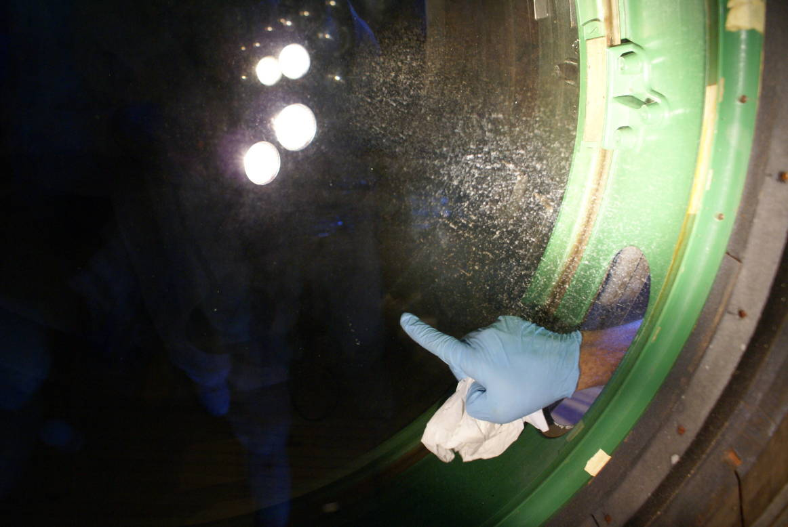
To get at the inner surfaces there was a ring that needed to be slid to uncover the access holes. There were no latches to prevent rotating the ring but it took two people on opposite sides to overcome the friction. There had been a large water-soluble splotch on the accessible surface of the crown glass lens, and Dave was able to clean that off.

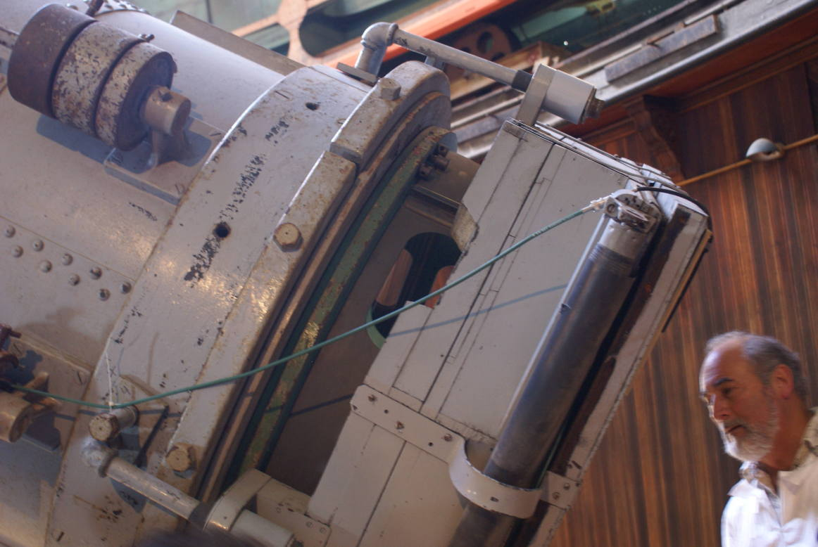
Ring-shaped access hole cover



